Name _________________________ Period _____
Motives for Imperialism
There were many motives (goals/reasons) for European Imperialism Africa and Asia. Countries like Great Britain and France often had more than one motive for colonizing (taking over) other countries. These motives had some positive effects, but often times resulted in poor treatment of natives and the destruction of culture in the colonies they conquered.
Task: You and your group members will be examining primary sources from the Age of Imperialism. When looking at these primary sources, you will:
- Describe what you see
- Determine whether the motive is economic, political, religious, exploratory, or ideological and label it with your symbol designed for your chosen motive.
- Explain why you believe that the primary source is an example of this particular motive.
When you are finished, you will look at all of the primary sources and determine which motive was the most praiseworthy (positive) and which was the least praiseworthy (negative). You will explain your answers in a written paragraph, using evidence that you’ve gathered from the primary sources.

Step 1: Create your symbols for each motive. Try not to make them too complicated!
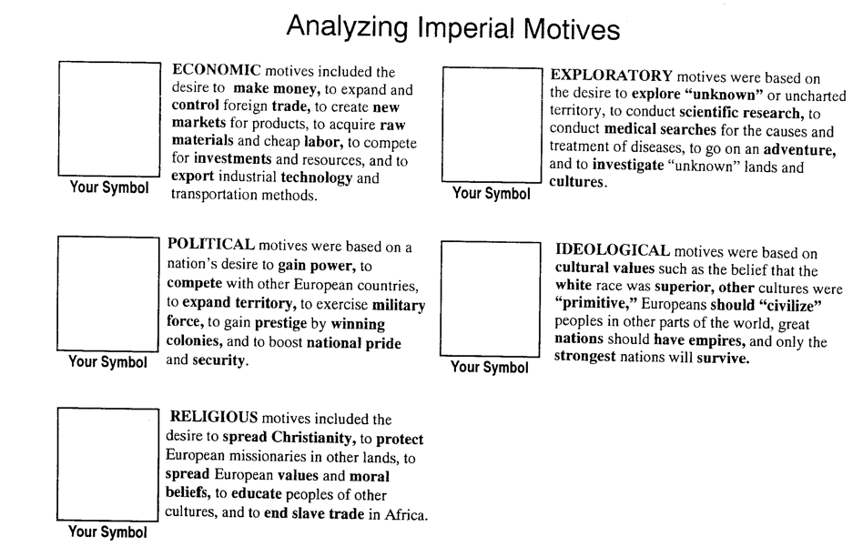

Step 2: Analyze primary sources from the Age of Imperialism.
Primary Source | Describe What you See | Symbol of Motive | Why You Chose This Motive
A
B
C
D
E
F
G
H
I
Step 3: Determine which motive what the most praiseworthy (positive) AND which motive was the least praiseworthy (negative) and why. Explain your answer in at least 5 sentences.

Most Praiseworthy Motive (Positive): ______________________________________________________

Least Praiseworthy Motive (Negative): ____________________________________________________

Explanation:

__________________________________________________________________________________________

__________________________________________________________________________________________

__________________________________________________________________________________________

__________________________________________________________________________________________

__________________________________________________________________________________________

__________________________________________________________________________________________

__________________________________________________________________________________________

__________________________________________________________________________________________

__________________________________________________________________________________________

__________________________________________________________________________________________

__________________________________________________________________________________________

__________________________________________________________________________________________

__________________________________________________________________________________________

__________________________________________________________________________________________

