Document 1: (1915)

Woodrow Wilson: U.S. 'Strict Accountability' Warning to Germany (1915)
“If the commanders of German vessels of war should act upon the presumption that the flag of the United States was not being used in good faith and should destroy on the high seas an American vessel or the lives of American citizens, it would be difficult for the Government of the United States to view the act in any other light than as an indefensible violation of neutral rights, which it would be very hard, indeed, to reconcile with the friendly relations now happily subsisting between the two governments.
If such a deplorable situation should arise, the Imperial German Government can readily appreciate that the Government of the United States would be constrained to hold the Imperial Government of Germany to a strict accountability for such acts of their naval authorities, and to take any steps it might be necessary to take to safeguard American lives and property and to secure to American citizens the full enjoyment of their acknowledged rights on the high seas. . . “

- What does the U.S. Government identify as a violation of neutral rights in its warning to Germany?

- According to President Wilson’s warning, what is the U.S. Government going to Germany accountable for?

- When President Wilson says the U.S. will “take any steps it might be necessary to take to safeguard American lives and property,” what do you think he means?

- From this excerpt, what can you infer is that primary reason the United States would declare war on Germany during WW1?

Document 2: (1917)
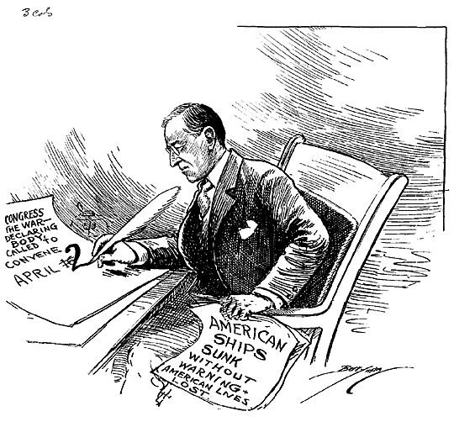
- According to the political cartoon above, what has prompted President Wilson to convene Congress?

- What is his purpose in convening Congress? What date does he request Congress to convene?

Conclusion:

- Describe two other major events involving Germany that affected the United States prior to their entry in World War 1.

- Although other major events angered the American public, what really prompted the United States to enter WW1 by declaring war on Germany?

9. When did the U.S. Congress declare war on Germany?

