**Monroe Doctrine**

* 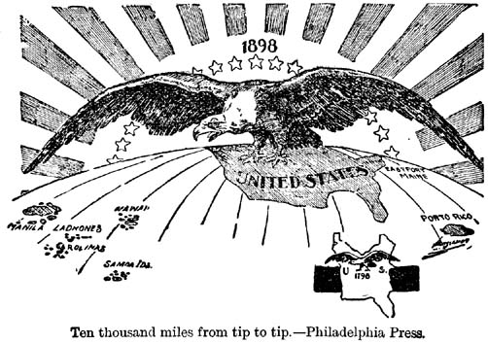1823 – President James Monroe told Europeans not to __________________________________________________________________________.
* After the Civil War, Americans wanted new places to _________________ _______and ___________________________ to.
* Nationalism (___________________________________________________________)

spread.

**Alaska and Hawaii**

* William Seward bought ***Alaska*** from ___________________________: discovered ________________ and _____________________ $$$$$$$$$$
* 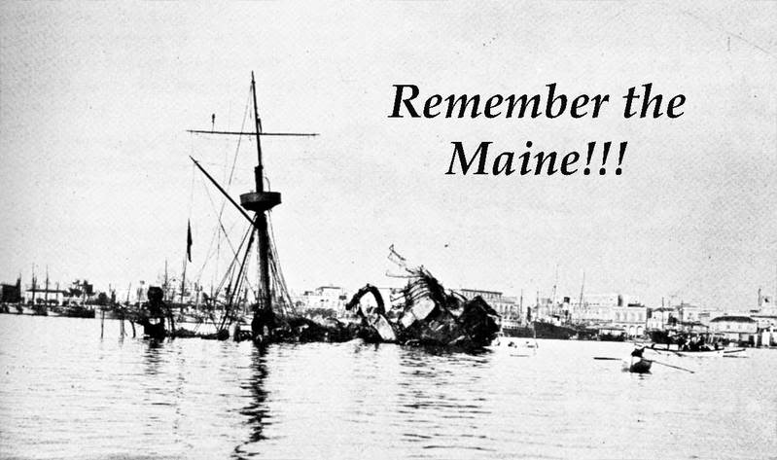1898 – annexed ***Hawaii***: provided __________________________________ and _________________________ for the US Navy.

**War of 1898: United States vs. Spain**

* Late 1800’s, ___________________________ controls __________________________________ and _______________________________________.
* Cuba ______________________________, American reporters write about the ____________________________________________ of Cubans by ________________________.
* ______________________________________________________ – exaggerated __________________________________________ about the events occurring in Cuba to build public support for military action.
* President McKinley sends the __________________________________________ to Cuba to protect _______________________________________.
* The ship is _______________________________________ (260 American sailors die), __________________________________ is blamed.
* Four month war against Spain – US wins ___________________________, ________________________________________, the _____________________________, and becomes a protectorate of __________________________________.

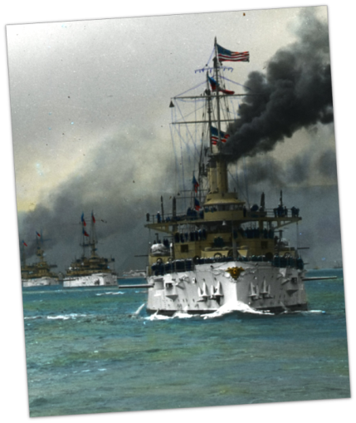

**The Roosevelt Corollary**

* In 1904, President ___________________________________________________ announced the __________________________________________________ which stated the US is an ______________________________________________________________ in the Western Hemisphere, justify the US intervening in any conflicts in _________________________________________________.
* As a show of military and economic power, President Roosevelt sends the U.S. Navy, also known as the __________________________________________________, on a world tour.

**The Panama Canal**

* 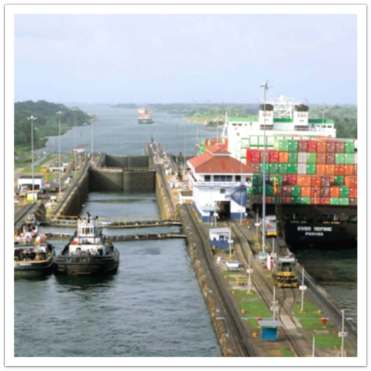U.S. needed a way to get the __________________________ from the _______________________ to _____________________ coast faster.
* Also needed a faster route to trade with ______________________________.
* In 1903, helped Panama get ____________________________________ from _________________________________ in exchange for rights to _________________________________________________________.
* Canal opened in _____________________.

**Japan Modernizes**

* Japan has been _________________________________ since the era of colonization.
* In the 1850’s, the shogun stepped down ending _________________________________________________ that had controlled Japan since the 12th century.
* Commodore __________________________________________ (U.S. Navy) is sent with naval _________________________ warships to Japan to force the Japanese to ____________________________________ with the U.S. (1854)
  + 1. 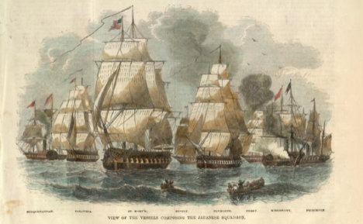Want ___________________ to ________________ steam ships heading to Asia
    2. Want ______________________________________ for shipwrecked Americans
    3. _____________________________ – new markets for goods
* The Japanese ________________________ the massive boats and the threat of attack on the city of ____________________________, agree to ___________________________ with the U.S.

**Modernizing Japan**

* Imperial family takes control, ________________________________ begins studying _______________________________________________________: (known as the ____________________________________________________)
  + 1. Developed a _______________________________________monarchy
    2. Reformed the ________________________ (no more _______________________)
    3. Universal public __________________________
    4. Began _____________________________________
    5. Developed better _______________________________ systems within Japan

**Japanese Control of Korea**

* Korea was under _________________________________ control
* Japan forces Korea to begin ____________________________ (1874)
* 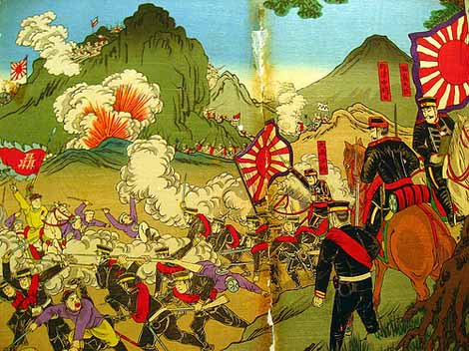_______________________ and _____________________ agree to keep their ____________________________ out of Korea
* Korea begins ______________________ and ________________________ sends in ________________________________.
* Japan sees this as breaking the ________________________________, so they attack in 1894 (a.k.a the ______________________________________________________________)
* Japan destroyed the ____________________ navy, kicked the Chinese out of ______________________________, and gets a foothold _________________________________ (mainland Asia)
* Wanted ____________________ for industry and__________________________________ for trade

**Russo-Japanese War**

* ___________________ and _______________________ are the strongest powers in Asia and both want control of ________________________ in Korea.
* In 1904, Japan _______________________ Russia, destroys the Russian _______________________, and kicks the Russians out of ____________________.
* Russia loses in 1905: _______________________________________________

_____________________________________________________________________

* Establishes Japan as a ___________________________________.

