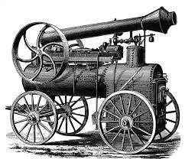TOP TEN Things to know: 7-3, Part 2 The Industrial Revolution
1. What revolution had to come before the Industrial Revolution?_________________________
2. Match each of the following to the correct definition.
_______crop rotation A. fencing off common land to create larger farms
_______seed drill B. positions seed in the soil and covers it
_______stock breeding C. process of rotating crops for fertile soil
_______enclosure movement D. leads to healthier cattle and sheep
3. The Industrial Revolution began in ________________________________. List 3
reasons this nation was the first and draw a picture representing each.

4. Place the following words in the correct boxes –factory system, cottage industry

5. What was the first and most common product made in the factories during the Industrial Revolution?
_________________________________________
6. Complete the graphic organizer using machines that improved textile manufacturing.

Textile
Machines

7. What is urbanization? _____________________________________________________
____________________________________________________________________.
Draw a picture to represent this.

8. What is socialism?_______________________________________________________
_______________________________________________________________________.
Who is considered the father of socialism (pictured below)?____________________________
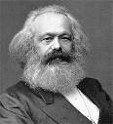

9. Use the following words to complete the sentence. goods, people, James Watt, canals, railroads, transportation
The steam engine was invented by __________________________________. It led to the building of
_______________________ and ____________________________. It also led to an increase of
____________________________ of ______________________and ____________________.

10. List the 3 characteristics of mass production:

