TOP TEN Things To Know: 7-3, Part 1 Political Revolutions
1. List the three main causes of the French Revolution.

List the three classes of French society and who belonged to each class.

2. What event does the picture below represent? ___________________________________
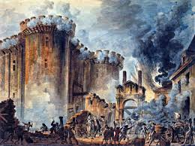
3. What is the name of the machine to the right? ____________________
Who was the leader of the Reign of Terror? ______________________
4. Who became the leader of France after the French Revolution?______________________________
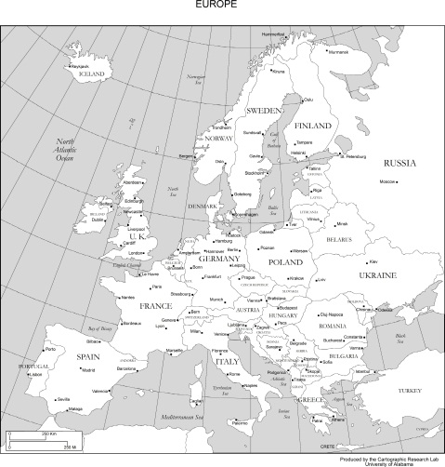
5. Use your chromebook to research and color Napoleon’s French Empire on the map.
6. Latin American Revolutions (match leaders and country/continent)
A. Simon Bolivar ______ Mexico
B. Toussant L’Overture _______Haiti
C. Miguel Hidalgo _______ South America

7. Place the following Latin American social classes in order from highest to lowest in the pyramid below. creoles, peninsulares, Africans/Native Americans, mestizos/ mulattos
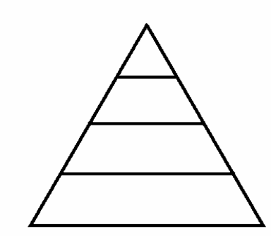

- 8. Define Nationalism

9. How did the Napoleonic Wars impact nationalism in Europe?

10. Nationalist movements—Leaders and countries.
A. Otto von Bismark ____unified northern Italy
B. Giuseppe Garabaldi ____unified Germany using “blood and iron”
C. Camillo di Cavour ____unified southern Italy
D. King Victor Emmanuel II ____first leader of unified Italy

