- List 5 things that happened as a result of the collapse of the USSR.
“Top 10” Things to Know 7-6 20th Century

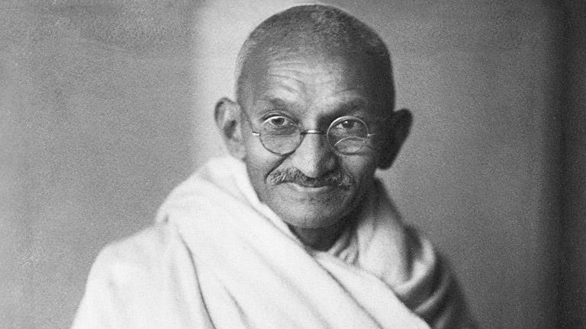
- Answer the following questions about the man pictured to the right.
Name: ______________________________
He led the independence movement in _________________________.
He believed in _________________________________________.
He led the _______________________ to protest British taxation.

- Label the following countries on the map below. India, Pakistan
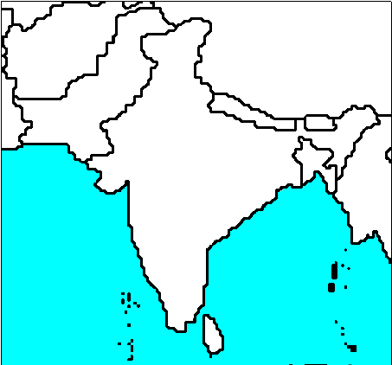
When India was granted independence, _____________________ was created for the Muslims and India was created for the ________________.

- Answer the following questions about the nation pictured to the right.
Name of country:_____________________________
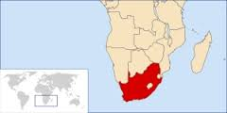
_____________________ was a severe segregation policy in
this country. _______________________________ led the
movement against this policy. He was arrested and served 30
years in jail as a political prisoner.

- In 1948, ______________________ was created as a homeland for the Jews. The UN split the country of _____________________ to create this nation. Fighting between Jews and Arabs began immediately. In the ______________________________________ in 1967, Israel tripled its territory.
The _____________________________________________ were the first major peace agreement in this region. It was between ______________ and Israel. It recognizes Israel as an independent nation and returns the Sinai Peninsula to Egypt.
The ______________ Peace Accords were signed by Israel and _______________________. These accords give Palestinians the areas of __________________________ and ____________________________.

- On _____________________________________, terrorist hijacked four airplanes and crashed them into the ________________________ in New York City and the __________________________ in Washington, D.C. These attacks were planned the terrorist network ___________ and their leader _________________________. As a result of these attacks, President George W. Bush declared a ‘global’ ______________________________________________ and the United Stated invaded the country of _________________________.
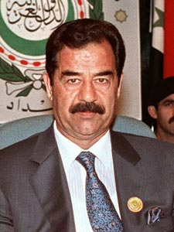
- Who is person pictured to the right?_____________________________
He was the leader of __________________________.
In 1991, Iraq invaded ________________________ which started the ____________________________ War.
In 2002, the United States began investigations in Iraq for ______________________________________. The United Stated invaded _____________ in ________________________. This was called Operation ________________________________________ Saddam Hussein was captured by the United States in December 2003, put on trial, and was _______________________.

- After WWI, women around the world were granted the right to vote (___________________). Women in societies dominated by _______________________ still face discrimination and abuse today.

- List 2 things that have caused damage to the environment.

Define:
Green Revolution-
Kyoto Protocal-

- List 5 technological advancements that have led to an increase in communication worldwide.

These technologies have led to an interdependent ________________________ economy.

