“Top 10” Things to Know 7-5 Cold War
- The _______________________ was a war of words and actions. The Soviet Union wanted to spread ______________________, while the United States wanted to ___________ the spread of communism and promote ________________________. Both countries competed for global power by building up their military strength. This was called the _______________ race.
- Determine whether the following terms or events were associated with soviet policy or U.S. policy. Write “C” for communist or “D” for democratic in the blank.
____ satellite states
____ policy of containment
____ Truman Doctrine
____ Warsaw Pact
____ NATO
____ Berlin Airlift
____ Berlin Blockade
____ Berlin Wall
- British Prime Minister ____________________________________ described the invisible political line separating Europe into the democratic West and the communist East as the “_________________________________________”

- _______________________________ brought communism to China in 1949.

- The ____________________ War and the _____________________ War were “hot” extensions of the Cold War. Both conflicts divided these countries into ___________________________ zones in the North and ____________________ zones in the South.

Korea remained divided at the _______________________ and ended in a ceasefire.

Vietnam was divided at the __________________ parallel, but became a _________________________ country when the war ended.
- The picture below represents the ______________________________.
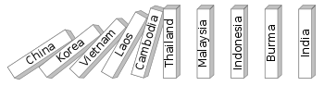

Explain:

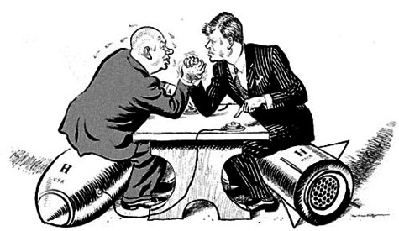

The political cartoon above symbolizes the ________________________________. The man on the left is _______________________, the leader of the _____________. The man on the right is _______________________, the leader of the ____________. _______________________ was the leader of Cuba. _________________________ were placed on Cuba aimed at the U.S. Nuclear _____________ was avoided when an agreement was reached between the U.S. and USSR.

- The soviets stunned the world when they launched __________________, the first satellite into space. This event started the _______________ Race. The U.S. responded by creating NASA and the _______________ project. In 1969, America won the Space Race when _______________________________________ walked on the ______________.

- List the 4 things that led to the collapse of the USSR.

- Label the pictures below of the leaders who helped end the Cold War.
