The Amazing Race

Congratulations! You have just been hired for your dream job as a producer on one of our country’s top rated reality shows, THE AMAZING RACE. As you know, The Amazing Race takes teams of two in a race around the world, and participants are faced with a challenge at each destination. The show is popular because viewers get to travel the world, seeing and experiencing many places from the comfort of their own couch.

Your primary role as a new producer is to plan the upcoming season for the show. The theme for next season’s race is “The Modern World History Challenge”. In keeping with this theme, you have been tasked with outlining each of the episodes in the new season, including where the teams will travel in each episode and what cultural/historical encounters that teams will have at each destination.

As you begin planning the season with your production team and design experiences for The Amazing Race participants around the theme, you need to consider the following requirements that CBS network has in place for each of the episodes.

1. A season has 10 episodes.

2. Each episode begins with the participants’ arrival at a new location. You need choose a location to send the teams somewhere in the world that is relevant to a topic we have studied this year in class. You need to consider whether participants will be flying, riding a train, riding in a bus/taxi, or taking a boat to get to their destination. You will need to list their departure cities and arrival cities. You must check to make sure your transportation mode is available at your arrival and departure locations. (For example, there is not an airport in Normandy, France, so your participants may need to fly to Paris, and then take a train or bus to Normandy.) Be mindful of how much time the participants spend in travel. Be logical about their destinations. You don’t want them to zig-zag back and forth across the globe! The exhaustion from the jet lag that occurs when you travel across different time zones will only frustrate the show’s participants.

3. After you have selected your destination, you must choose accommodations for the participants. You might consider a hotel, inn, hostel, or bed and breakfast. You need the specific name of place to stay for the episode layout you give to the Network producers.

4. Once you have selected a destination for each episode, you need to determine what cultural/historical location within the city/country the participants will be visiting. It must be related to something you learned in Social studies this year. For example, if you had teams visit France, you might have them check-in for a task at the Palace of Versailles outside of Paris to see where Louis XIV lived during his time as an absolute monarch. Or, you might send teams to Normandy on the coast of France to see where the D-Day invasion during World War 2 took place.

You can plan for your teams to visit a monument, palace, battlefield, museum, or other notable area at each day’s destination, but it must be relevant to an event or person from exploration days until the present..

5. Since you are pitching your ideas to network executives, you must justify why this is important to modern world history. You need to write 5-7 sentences about why this location is historically significant. Remember, it must be relevant to 7th grade Social studies. While the Egyptian pyramids are important, they are not significant to the 7th grade standards of learning.

6. In order to help network executives at CBS to visualize the locations you have selected for travel, you need to provide a picture of each destination teams will visit during each episode. For example, if my teams are visiting London, England, I might send them to the Parliament building to see where the British monarchs met with members of Parliament after the kings and queens in England changed from being absolute monarchs to constitutional monarchs.

The CBS Network executives are eager to begin making plans for next season’s shows, so they are anxious to see your outline for the next season’s episodes. Because you will be presenting these ideas to them (your classmates) at a network production meeting, you need to outline your ideas in a Google Presentation. You and your production team must meet the deadline of ____________ for the presentation of your ideas. Meeting this deadline is crucial because you are not paid your salary until your work is completed. You will receive $“100”,000 (points) for the completion of the entire 10 episode season, or $”10”,000 (points) per episode that you design. You may be eligible for an additional $”20”,000 (points) if you provide up to two additional filming options in case the network executives decide to extend the 10 episode season.

Sample Episode Outline

Departure Location: Taipei City, Taiwan

Arrival Location: Seoul, South Korea

Mode of Transportation: Airplane

Accommodations/Lodging: The Westin Chosun, Seoul

Location for Filming: War Memorial of Korea, Seoul

Why this location has been selected:
Prior to and during World War two, the Korean peninsula was occupied by the Japanese. After World War Two ended, the United states occupied the southern half of the Korean peninsula, while the Soviet Union was given the northern half. The peninsula was divided at the 38th parallel. Over time, communists from the Soviet Union and China spread the ideas in North Korea in hopes of making all of Korea communist. This led to a war with the United States helping the South Koreans. The war ended in a stalemate, and the country remains divided at the 38th parallel. North Korea is communist, and South Korea is a democracy.

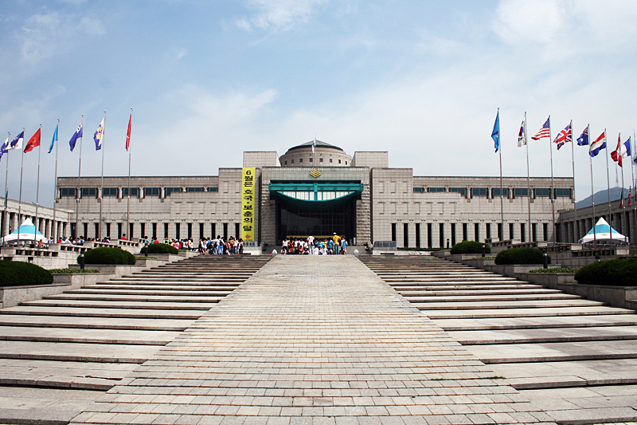

Travel Destinations for Consideration:

Europe:

England
France
Italy
Austria
Germany
Poland
Russia
Spain
Portugal
Hungary
Czechoslovakia
Belgium
Netherlands
Yugoslavia

The Americas:

United States (Hawaii)
Haiti
Mexico
Brazil
Cuba
Bolivia
Panama
Puerto Rico

Africa:

Egypt
Ethiopia
South Africa
Liberia
Ghana
Kenya
Algeria

The Middle East:

Israel
Pakistan
Iraq
Iran
Afghanistan

Asia:

China
Japan
Thailand (Siam)
Vietnam
Philippines
Korea (North And South)
Bangladesh
India
Australia
Taiwan

