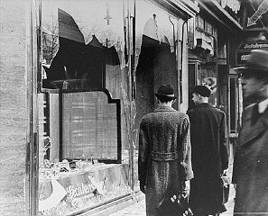
The Holocaust
- Hitler wants a ________________________ of people (Aryans).
- Targeted Jews, Slavs, Soviets, Poles, homosexuals, and the handicapped for extermination.
- Hitler took several steps to exterminate the Jews:
  - Passed the __________________________________ (1935)
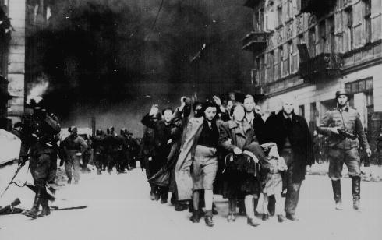
  - Kristallnacht -“_______________________________________” (November 9, 1938) - Nazi troops attacked Jewish ___________________, ________________, and ________________, killing 100 Jews.
The Holocaust
  - Forced the Jews into ______________________ (closed neighborhoods)
  - Liquidated the neighborhoods by sending Jews on ________________________ to ________________________________ camps (work camp) or to a _______________ camp – “_______________________________________”
  - Most concentration camps were in ________________ and __________________.
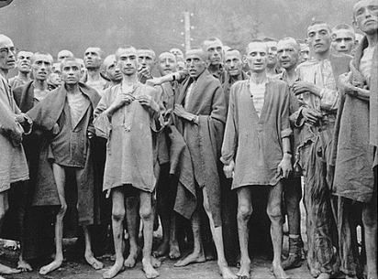
  - At the camps, Jews were ____________________ by SS doctors. The ________________ (mostly men) or ____________________________ (ex. seamstress, cobbler) were allowed to live.
The Holocaust
- ___________________ is the ______________________ of people.
- Over _________________________ people in all died. ______________________ Jews died, including over a ____________________ kids. _________________________ Jews survived.
- Those who were not sent to an immediate death were used as __________________________ or for __________________________________.
- ___________________________ was the largest death camp: (around 2,000,000 died there).
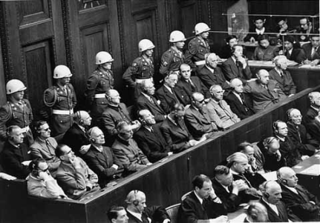
Nuremburg Trials
- In 1945-1946, ________ Nazis were charged with “____________________________________________________.”
- Trial was conducted by an International Military Tribunal made of 23 countries.
- Ten Nazis were hanged and they were cremated at a concentration camp.
- Support for a Jewish state/homeland (______________________) increased after the war. _____________________ is founded in ___________.
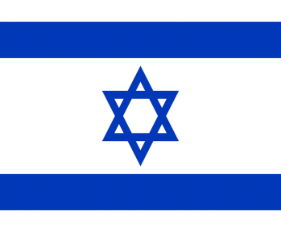
The Universal Declaration of Human Rights
- Developed in 1948 by the __________________________ in response to the atrocities in WW2.
- Sets _________________________ standards for all nations, including rights that ___________________________ should have.
- ______________________________________ because of the debate over how much outside countries should be involved in the affairs of a sovereign nation.

Creation of Israel
- ________________________________ is divided into a _________________ state and __________________________ state, with ________________________ as an international city.
- Angered, Palestinians ________________________________. Israel wins and claims ____________ of the Palestinian land. (Fight wars in 1956, 1967, 1973).

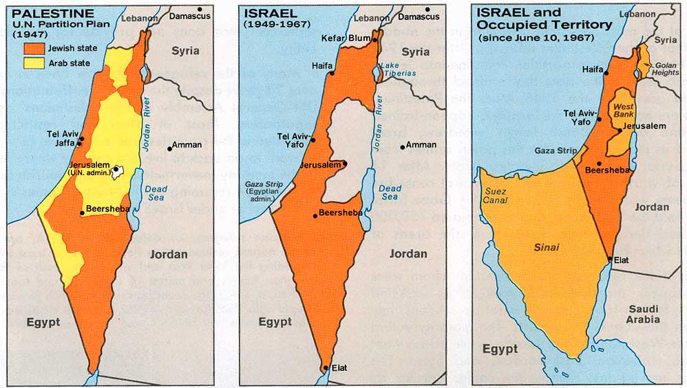
Suez Crisis of 1956
- Egyptian President Nassar wants to _________________________________________________ in the region.
- He took control of the ______________________________ from the British by force in 1956.
- The ________________, ____________________, and ____________________ attack.
- The U.S. and the Soviet Union pressure the British, French, and Israeli’s to ___________________________________. Egypt keeps the canal.
- Builds __________________________________ (Arab Unity).
Six Day War and Yom Kippur War
- In 1964, the _______________________________________________________ (PLO) is formed, Yassir _________________ is leader.
- In 1967, the PLO wants to _______________________________________ from Israel using military force with ______________ from other ________________________________.
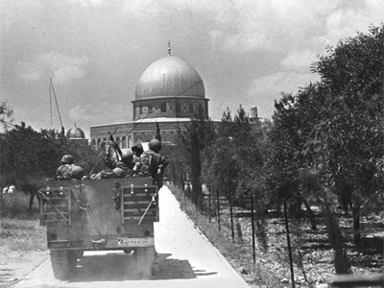
- Israel attacks _________________, __________________, _____________, and ________________ first, wiping out the majority of Egypt’s air force, and capturing the Sinai Peninsula, the West Bank of the Jordan River, the Golan Heights, and Jerusalem.
- In 1973, the Arabs ____________________________________ Israel. The U.S. joins on Israel’s side angering the Arabs. The United Nations arranged a __________________________.
Lasting Peace?
- _______________________________________ (1979) – Egypt finally ____________________________________ as a country, receives the Sinai Peninsula from Israel. (Egyptian President is assassinated by an Islamic extremists upset by the peace agreement.)
- Palestinians launched the ____________________________ (uprising) in 1987 – a series of _________________________________ against Israel.
- _________________________________________ (1993) – Israel gives _______________________________________ in the West Bank and Gaza Strip. (Israeli Prime Minister Yitzhak Rabin was assassinated by a Jewish extremist).
