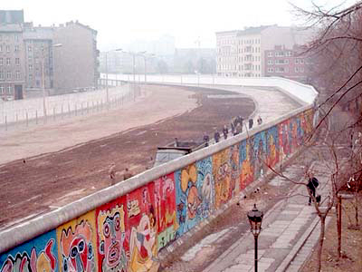**Behind the Iron Curtain**

* Winston Churchill called the separation of Western and Eastern Europe the ______________________________________.
* The living conditions in the _________________ (______________________) were so much better than in the ____________ (____________________), many people attempted to defect to the West.
* The ____________________________ was built in 1961 – becomes the symbol for the Cold War.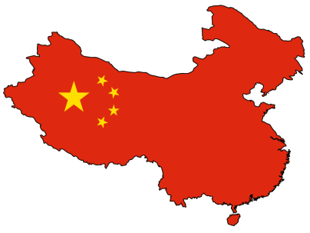

**China**

* ___________________________________ (Communist) and __________________________________ (Nationalist) are leading a _____________________ in China before and after WW2.
* The ______________________________________in 1949 and renamed China, “____________________________________________________” with Chairman Mao as the leader.
* 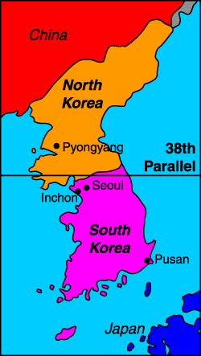Chiang Kai-shek fled to __________________________ and called it the “________________________________________.”
* The U.S. recognized both governments in 1972.

**Korea**

* After the Japanese were kicked out after WW2, ___________________________ was divided at the _______________________________ (latitude). The __________________ backed the ________________, and __________________ countries backed the ______________________.
* The Korean War began in 1950 when ___________________________________ invaded _________________________________________ in hopes of uniting the country ________________________________________.
* The War ends in a ______________________________ in 1953. Korea _____________________________________________ at the 38th parallel.

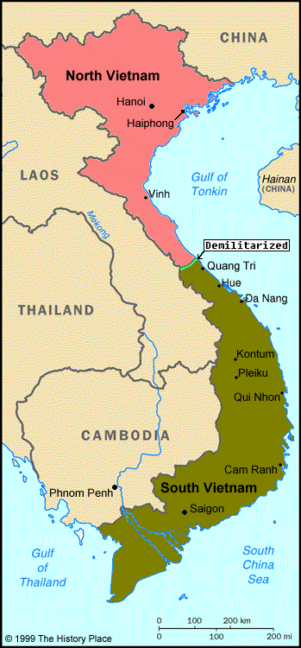**Vietnam**

* After WW2, the _________________ wanted to regain control of French Indo-China (_____________________).
* Vietnamese nationalists were led by __________________________ (___________________).
* Americans gave the French _______________ and ________________ to fight the __________________________ because of the fear of the ________________________________ (if one country fell, all countries in the region would be communist.)
* The _______________________________: the country is divided at the __________________________________. The __________________ is _______________________ (led by Minh), the ______________ is _______________________ (led by Ngo Dinh Diem).

**Vietnam**

* Diem’s government was _______________ and unpopular. Ho Chi Minh decides to _________________________________________________ to unite the country under ____________________.
* Beginning in 1955, the U.S. began sending ___________________ and _______________________ to ________________________________, and by 1963 there are 16,000 troops there.
* U.S. fought against the ______________________________ and the _______________________________ (communists in South Vietnam). These groups used _________________________________ (sneak attacks).

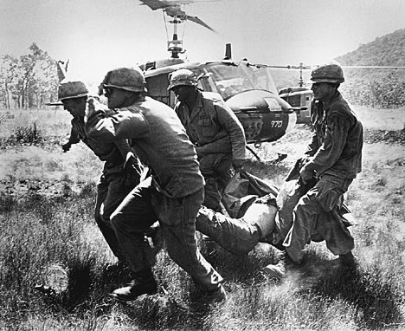**Vietnam**

* The U.S. could not win, so they ___________________________ in 1975.
* 58,000 American soldiers died. _________________ became communist, as well as ____________________________ and ____________________.

**The Cuban Missile Crisis**

* ________________________________ became the __________________ leader of ___________ in 1959.
* In 1962, a U.S. spy plane flew over Cuba and took pictures of _____________________________________ being assembled.
* _____________________________ ordered a ______________________________________ of Cuba.
* After 2 weeks of intense __________________________, the missiles were removed.

**Communism in Latin America**

* Castro begins attempting to _____________________________ throughout ___________________________ with the help of the Soviet Union in the 1970s and 1980s.
* _____________________ – Cuban and Soviet troops fight against troops helped by the U.S.
* __________________________ – rebels known as the _____________________________ overthrew the government with aid from Castro and the Soviets. The U.S. helped a group known as the “_____________________” (means “against” in Spanish) in the struggle with the Sandinistas.

**The Space Race**

* 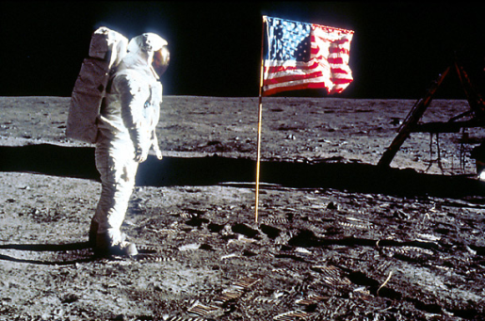The ______________________ were the first to launch a ___________________ (______________________) into space. (1957).
* In response, the U.S. placed an emphasis on ______________________ and _____________________ in schools, and __________________ (National Aeronautics and Space Administration) was created.
* Americans were the first to ___________________________________________ (1969).

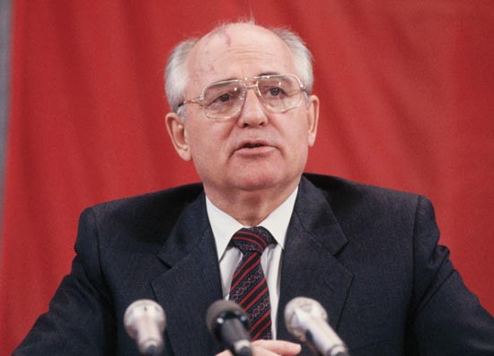**The Fall of Communism**

* _______________________________, the Soviet leader, began three new programs that ultimately led to the __________________________________________________.
  1. _________________________: Restructured the economy by allowing ______________________________________ and ________________________________________. Also created a ______________________________________ for the 1st time since 1918.
  2. _________________________: “openness” people are allowed to ______________________________________ what they want about the government without ___________________.
  3. ____________________________________: allowed for greater ___________________________________________; more than one person could run for public office.

**U.S. and Soviet Relations**

* __________________________________, elected in 1980, referred to the Soviet Union as the “__________________________________”.
* 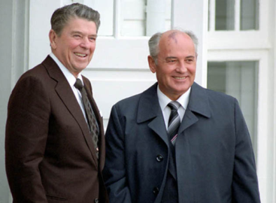In 1983, he proposed the ___________________________________________ (SDI) – also known as “________________________”, the program was intended to use _____________________________________________________to protect the U.S. from a possible ______________________ attack.
* In 1985, Gorbachev and Reagan meet for the first time and relations begin to improve.
* In 1987, they sign a treaty to reduce the number of _________________________________ they each had, putting an end to the _________________________________.

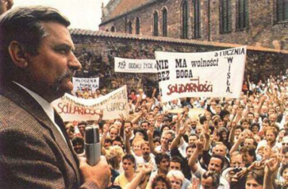**Resistance to Communism**

* Lack of _______________________________ and poor ________________________________ prompted resistance movements in many communist nations.
* Poland
  + Labor union “________________________________” opposed communism and demanded __________________________________.
  + Led by __________________________________, Solidarity used ________________ and __________________ to gain support.
  + ______________________________________ are held in April 1989, and Lech Walesa is elected _____________________________________.
  + Poland is the first ____________________________ to break free from the Soviet Union.

**Resistance to Communism**

* Hungary
  + Beginning in 1989, citizens cut a ______________________________ separating communist Hungary from the _________________________________.
  + As the hole got larger, more and more people from Hungary and East Germany _________________________.
  + Finally, the communist party was overthrown in _________________________.
* Some nations began resistance movements that were met with force by the Soviets, such as in Lithuania. Others will cause a renewal of _____________________________ in Eastern Europe. We will be discussing these in Standard 7-6.

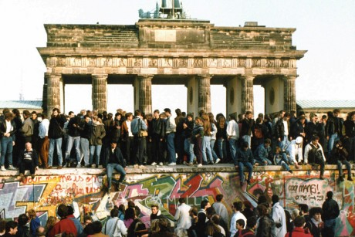**The Break-up of the USSR**

* The new freedoms in the Soviet Union encouraged _____________________________________ in ___________________, __________________________, ___________________, and _________________________ in 1989. Gorbachev promised the Soviet Union would stay out of these revolutions.
* On November 9, 1989, the _________________________________________ were opened in _____________________. People in East and West Berlin were finally able to move about freely, and the Wall was _________________________. _______________________ was _____________________ into one country in 1990.
* 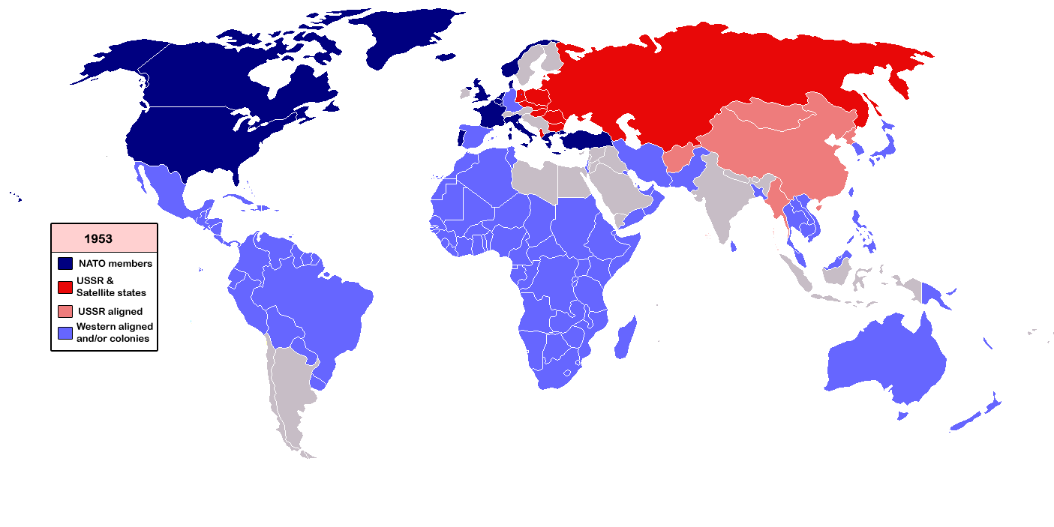All 15 ___________________________________ declared their ______________________. In December 1991, Gorbachev announced the ___________________________________________________ and the __________________________________________________.