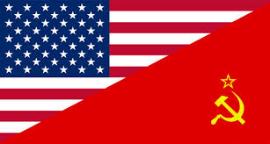
World Superpowers
- After WW2, the __________________ and the ___________________________ emerge as the leaders of the world.
- The U.S. wants to spread _________________________ (people ___________________________________________________) and __________________________________________________(businesses compete for ________________________ with _______________ government control). The Soviet Union wants to spread ___________________________ (the government controls every aspect of life).
- The U.S. wants ___________________________________________________!!!
- The differences between the two countries begin the ____________________________________________________.

The Cold War
- A “___________________________” is a war with ____________________________________________. The “_____________________________” was a competition between the U.S. and the U.S.S.R. to build up the biggest supply of ______________________, in addition to helping the _________________________ and _________________________ of ______________________________________ in order to get their _______________________.
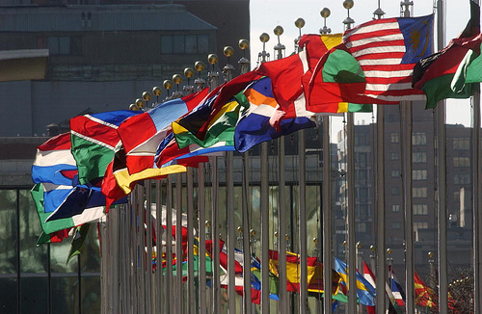
The Creation of the United Nations
- Created in 1945 after WW2 as a _______________________________________ (takes the place of the League of Nations).
- Consists of two main groups: the ______________________________________ and the ____________________________________. The General Assembly discusses and votes on issues (including ______________________and _________________________________ topics). The Security Council votes on the use of _____________________________ and _____________________ (penalties) against a country.
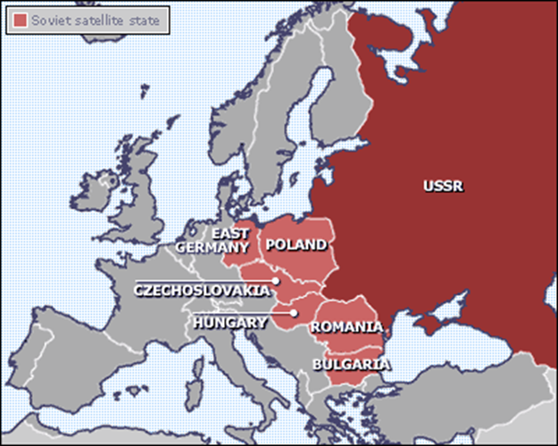
- The Security Council has ___________________________________ members (France, Soviet Union, the United States, China, and the United Kingdom) and _________________________________ members. The Soviet Union and the U.S. often blocked each other’s votes.

How the Cold War Begins
- After the war ends, the Soviet Union __________________________________________________________________________that had been used to kick out the Germans from countries in _____________________________________. (ex. Poland, Hungary, Romania, Yugoslavia, Albania, Bulgaria, Czechoslovakia).
- These countries become “__________________________” countries of the USSR – meaning they were ___________________________________________ and the Soviets controlled their _________________________ and _____________________.

How the Cold War Begins
- _________________________________ (1945) ended WW2. The “___________________________” meet there (_____________________________________________________) to determine what should happen with Germany.
- Germany is divided into 4 zones: _______________, ___________________, and _______________________ zones (becomes democratic ____________________________ in1949), and the ______________________________ zone becomes communist ________________________________.
- ____________________ (the former capital) was also divided into zones.

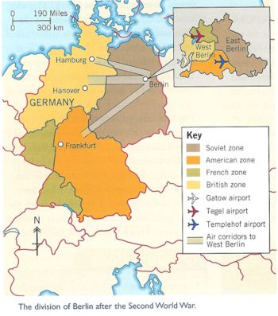
Containment of Communism
- __________________________________ (1947)– Promises to ____________________________________________________worldwide. The U.S. ______________________________ to help individuals _______________________________________ worldwide.
- _____________________________ (1947) – U.S. gives $13 billion dollars to help _________________________________ after the war because _____________________________was more likely to spread in places with ___________________________.
Berlin (1948)
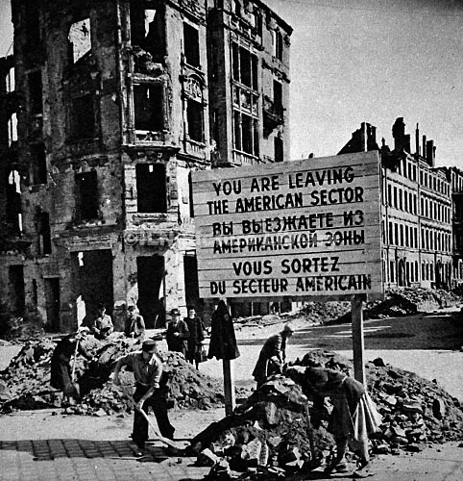
- Although _________________________________ is controlled by Americans, French, and British, the city is located deep into _____________________________________.
- Soviet Union creates a ______________________ of _______________________________, not allowing the Allies to bring _____________________ and other _________________________ to their sector of the city.
- _______________________________________ was an 11 month period when ___________________ had to ______________________________ from airplanes into the democratic sectors of Berlin.
- Created lots of ______________________ between the U.S. and U.S.S.R.

New Alliances
- NATO (_____________________________________________________ – 1949): _______________________________ among the U.S., Canada, and 10 European countries (____________________________ countries)
- _______________________________ (1949): military alliance between the _____________________________ and other ____________________ countries
- EEC (______________________________________________): alliance of countries who wanted to _________________________________________ among themselves

