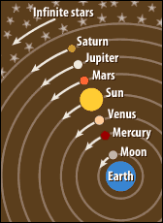
Old School Ideas
- During the Middle Ages (until the 1500’s), scientific ideas came from:
  - The writings of ancient Greece and Rome
  - The teachings of the ________________________________________________________
- Believed the earth was the center of the universe (_______________________________________________________) Ptolemy’s idea

Changing Ideas
- Beginning in the 1500’s
  - Explorers are _____________________________________________ the Earth
  - Translate the work of Arab scientists
  - Hindu-Arabic number system spread to Europe
  - Astronomers invented better tools for studying ___________________________________________________

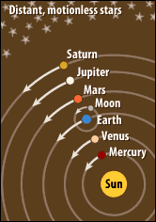
Copernicus (Poland)
- Sun centered universe (____________________________________) – planets revolve around the sun, moon revolves around Earth
- Worked in secret because he feared ______________________________________________ by the Catholic Church
- Published his ideas in 1543

Kepler (Germany)
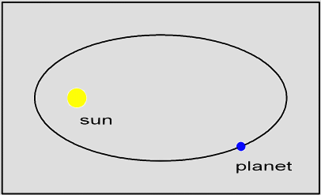
- Used math to show that planets moved in __________________________________ (oval orbits) not circles
- Planets moved faster when they got close to the sun
- _________________________________________ so he didn’t fear the church

Galileo (Italy)
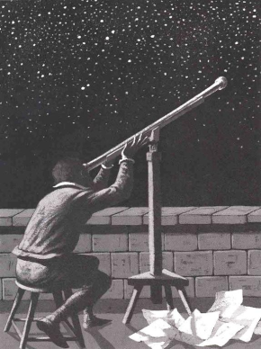
  - Built improved ______________________________, clock, and water thermometer
  - Discovered:
    - Mountains on the moon
    - Spots on the sun
    - Four moons of Jupiter
    - Evidence of __________________________________________ Universe
  - In 1532, charged with ________________________________ (anti-Church teachings)
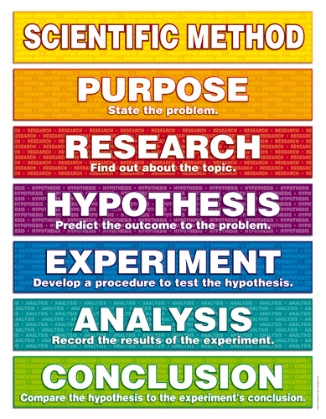
  - Lived under house arrest.

Francis Bacon (England)
- Thought you should throw out everything that hadn’t been tested
- Came up with the _____________________________________________

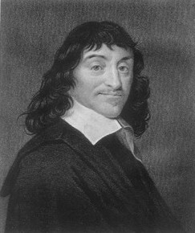
Rene Descartes (France)
- “I think, therefore I am.”
- Used math to prove scientific facts
- Founder of modern rationalism – all knowledge is based on _____________________________.

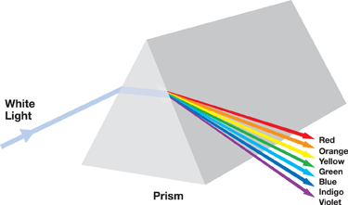
Isaac Newton (England)
- (1642-1727)
- White light is made of different colors (_____________________________________)
- Invented calculus (type of math)
- Theory of the ______________________________________________ – force of gravity holds the entire solar system together and keeps the planets in their orbits
  - What goes _________________________ must come _____________________________________

The Catholic Church and Science
- The Catholic Church served as the authority for ___________________________ and society.
- The viewed the ________________________ as the sole source of information.
- The Catholic Church viewed the new scientific research as a threat to their ________________________________.
- The challenges to authority through science and reasoning encouraged a group of philosophers to question and challenge __________________________________________________________. This is known as the Enlightenment, and leads to numerous revolutions that end absolute monarchies.

