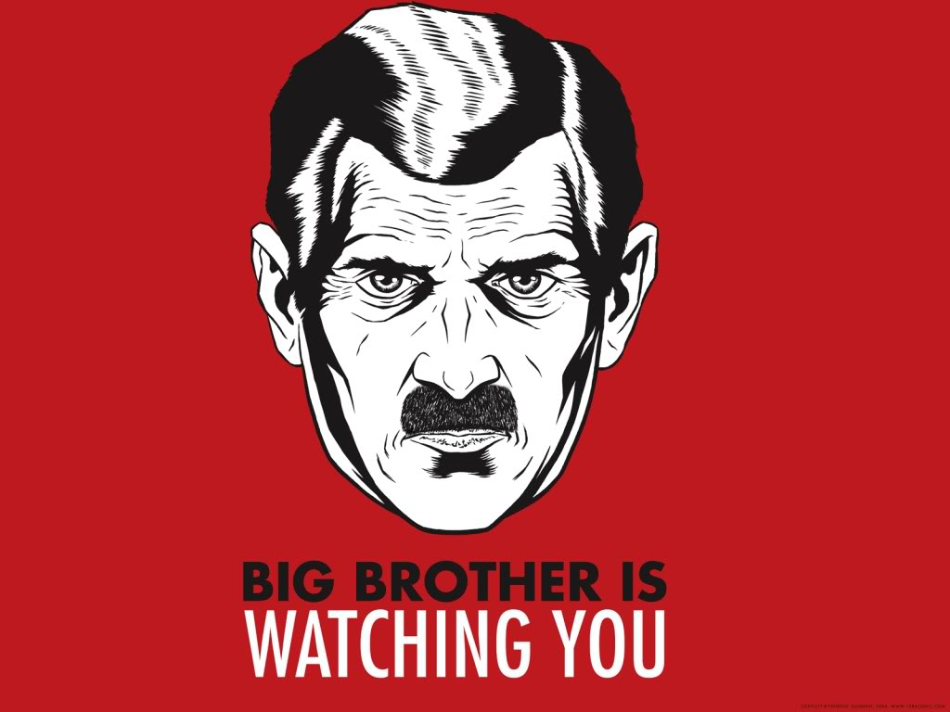
Changes in Governments
- _______________________________________ take over Europe!!! (When leaders control every aspect of your life…). Use _____________________, _____________________________, and ________________________________ to control the citizens.
- _________________________ – a form of government that is nationalistic to the extreme. _____________ is glorified. The government has ______________________________________________________, and is led by a ________________________ or a small group of people. Fascism allows individuals to have _________________________________________ and allows for ______________________________________ (lower, middle, upper) Ex. ______________, __________________________
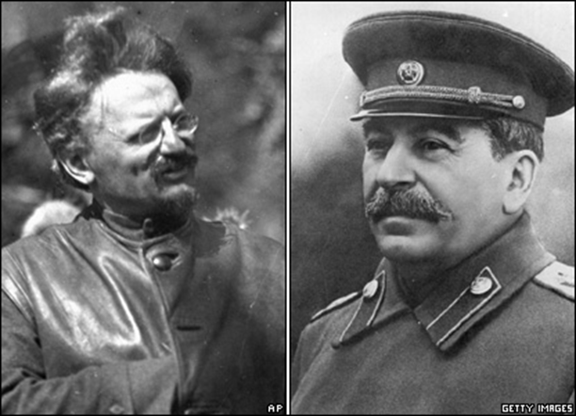
- _______________________ – a form of government where a ________________________ or small group of people control every aspect of your life. Under communism, there are ________________________________________________ (everyone is __________________) and you are _________ allowed to own private property. Ex. ______________________, __________________________
Rise of Stalin
- Vladimir Lenin dies in 1922. ____________________________________ is the head of the _____________________________ and _________________________________ is head of the __________________________ party.
- In 1928, ______________________ was in line to assume control of Soviet Union. Stalin accused him of wanting to break apart the Soviet Union and had him _______________________ to Siberia, and then later out of the country. He will later be killed in Mexico by a Communist with an ice pick!
- _________________________ takes control of the Soviet Union (1928) and kills anyone who opposes his rule during _______________________________________________________.
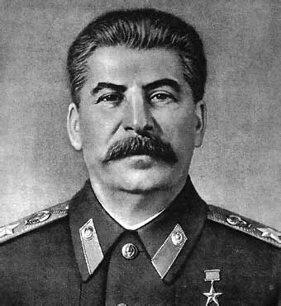
Rise of Stalin
- Country began to __________________________ again.
- Created a _____________________________________ to monitor everything ______________ or _______________________ (terrorized the people).
- ____________________ all sources of ________________________, used _______________________ to keep power, killed ___________________________________, outlawed ____________________________________.
Rise of Stalin
- Came up with the _________________________________ – change the country from ______________________ to _______________________.
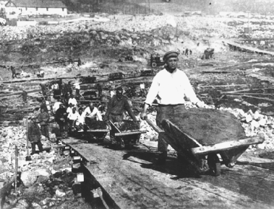
- Focused on __________________________________________________, so there was a shortage of regular ___________________________________.
- Started ______________________________________________: government took over all of the ______________________, forced the people to ___________________________. Increased ____________________________________.
- _________________________________ (kulaks) protested ______________________________ and were killed.
- Improved the ____________________ and ______________________, banned ______________________, people had ____________________________________.
- Anyone who disagreed would be ______________________.

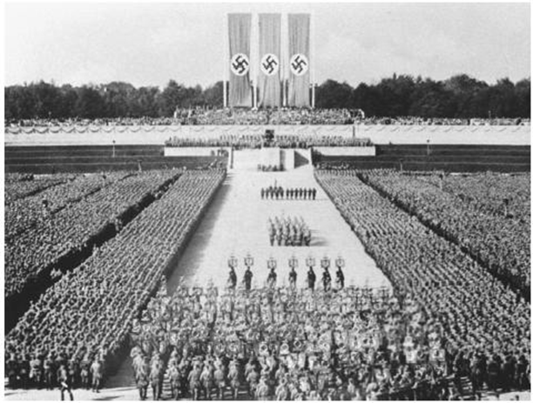
Fascism: A New Form of Government
- People in Italy and Germany blamed ____________________________________ for the problems that existed after WW1.
- They were willing to try new, _______________________ forms of __________________________ to try and improve the conditions in their countries.
- Fascism focused on ___________________________________. It included special ____________________, military steps and _______________________; holding ______________________ and __________________________________________ for the public; forming ___________________________________________ that used absolute power and terror tactics.

Rise of Mussolini
• Italy is___________________ because they ___________________________________________it was promised at the end of WWI, and their _____________________ is in the dumps due to the __________ and the _______________________ because of ______________________ and high ________________________.
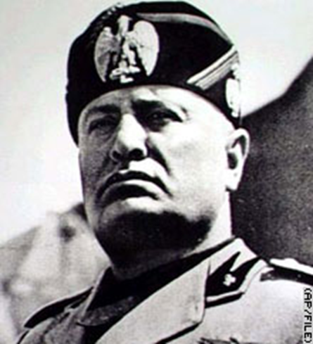
• ______________________________ starts the ___________________ party in 1919. Followers are the __________________________, and they use __________________________________________ to follow them.
• ____________________________________________ named Mussolini the _________________________________.

Rise of Mussolini
• After a corrupt election, Mussolini names himself ___________________, “__________________________”
• Banned all other ____________________________
• ____________________ anyone who ___________________________________
• Stopped ________________________________ from spreading to Italy
• ________________________________________ by increasing the ___________________
- To show anger over the ______________________________________, he invaded __________________________ in 1935.

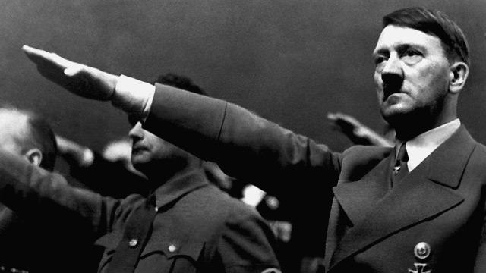
Rise of Hitler
- Germany owed the Allies ___________________________ dollars.
- Began ________________________________ (ex. Before the war, 4 marks = $1, after 4 trillion marks = $1)
- Hitler joins the ________________________________ (National Socialist German Workers’ Party) in 1919, takes control of the Party by 1921.
- After a failed attempt to start a revolution, he is thrown into jail. He writes ____________________________________ (My Struggle): he blames the __________________ and the __________________ for the loss of WWI, says the Germans (____________________) are a “____________________.”
Rise of Hitler
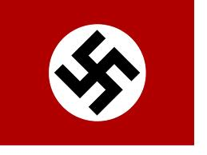
- Hitler’s ideas begin to become __________________ and the ___________________ take over the government.
- Hitler forces the German President to name him ____________________________________________________.
- Hitler banned ______________________________, ____________________, _____________________, and the _____________________.
- Passed the _______________________________: barred Jews from ________________, _______________________________________, holding _______________________________, and force the Jews to ______________ the ____________________________. Encouraged ______________________________________ (anti-Jewish feelings).
- Ignored the ______________________________ in the ________________________________________.
Japan
- Japan is a major ____________________________________________ after WWI.
- ___________________________________ cause ___________________________________, on top of the effects of the depression (___________________, ____________________)
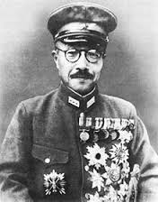
- The ______________________ blames the ____________________ for becoming too “__________________________.”
- Look for ________________________ to sell their products to and get ____________________ from.
- The _________________________ takes over the ___________________ (militarism). They focus on a policy of _______________________________ by invading ______________________ in 1931 and attacking _______________________ in 1937.
- ___________________________________ (military general) runs the nation – wants to create a ________________________________________________.

