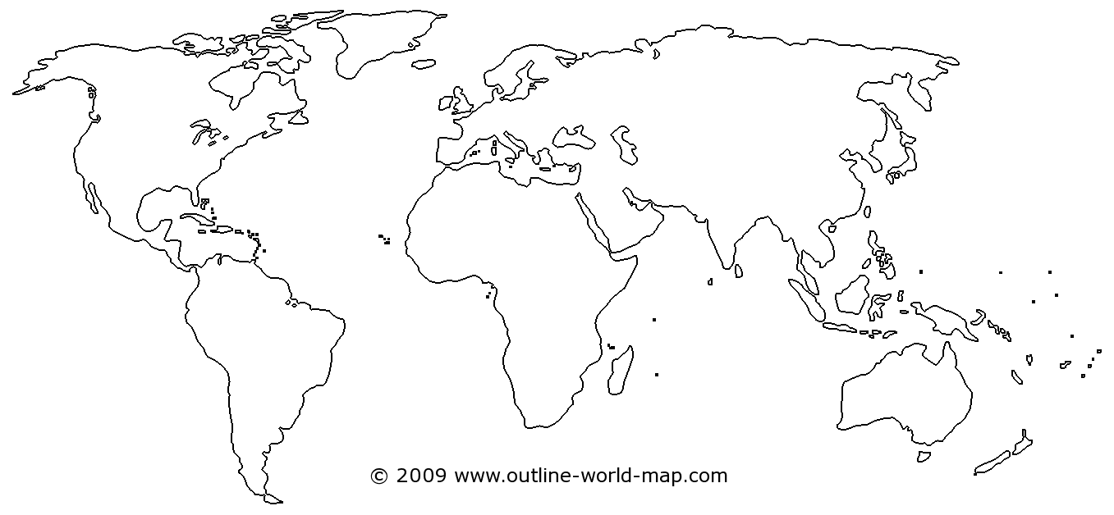

1. What are the five oceans on Earth? List them below & label them on the map.

- _________________________ 4. _______________________

- _________________________ 5. _______________________

- _________________________

2. What are the seven continents on Earth? List them below & label them on the map.

1. _________________________________

2. _________________________________

3. _________________________________

4. _________________________________

5. _________________________________

6. _________________________________
7. _________________________________

3. Color the oceans and seas BLUE.
4. Color the continents GREEN.
5. Draw a RED line along the Equator.
6. Draw an ORANGE line along the Prime Meridian.

On the Quiz, be prepared to do the following:
- Locate and identify the 7 continents.
- Locate and identify the 4 oceans.
- Locate on a map the divide between Europe/Asia, North/South America.
- Label the 10 European countries identified on your map (including England).
- Label the 4 Asian countries identified on your map.
- Know the difference between lines of latitude and longitude.
- Locate the Balkan Peninsula.
*CP will have a word bank!

