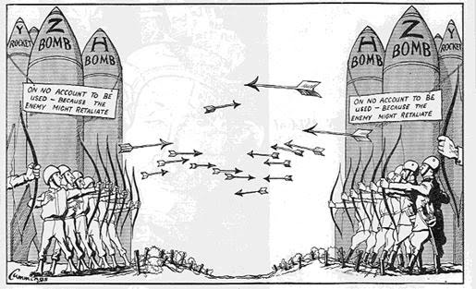
- Who are the two countries represented by the soldiers on either side of the image?

- Why are they shooting arrows at each other?

- In your opinion, what is the meaning of this cartoon? Provide evidence to support your answers.

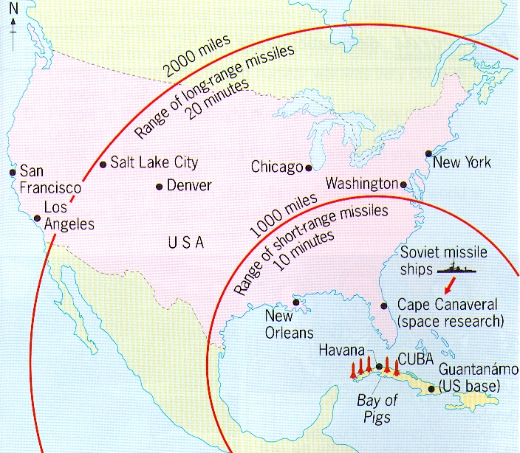
- What is the graphic of the map showing?

- What were some potential targets within range of a short-range missile shot from Cuba?

- Using what you know about the geography of the Southeastern United States, name three additional sizeable cities not listed on the map above which were in range of a short-range missile launched from Cuba.

- Were citizens of the United States justified in feeling threatened during the nuclear arms race? Provide evidence to support your answer.

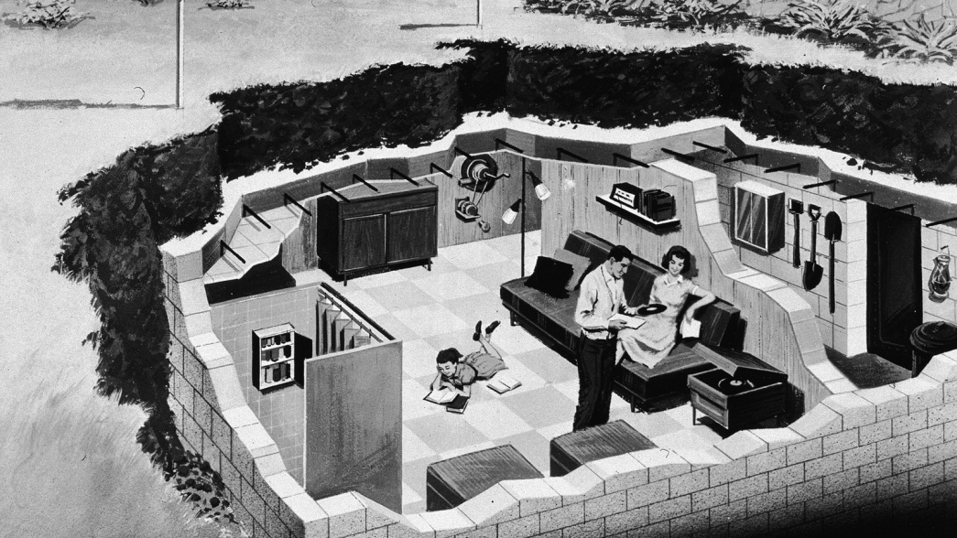
- What is this image showing?

- Why did the United States government use propaganda during the Cold War related to the nuclear arms race?

- Do you think that US government propaganda was an effective tool for preparing citizens for a nuclear attack? Provide evidence to support your answer.

