Document 1

“The history of every age proves that no people can attain a high degree of intelligence and morality unless its feeling of nationality is strongly developed. This noteworthy fact is an expected result of the laws that rule human nature…

Therefore, if we so desire the unification of Italy--it is not only that we may see our country glorious and powerful but that above all we may elevate her in intelligence and moral development up to the plane of the most civilized nations. . .

This union we preach is not so difficult to obtain…Nationalism has become general; it grows daily; and it has already grown strong enough to keep all parts of Italy united despite the differences among them. “

The Program of Count Cavour, 1846

Document 2

“We had to avoid wounding Austria too severely; we had to avoid leaving behind in her any unnecessary bitterness of feeling or desire for revenge; we have to keep the possibility of becoming friends again with our enemy for the moment, and in any case to regard the Austrian state as a piece on the European chessboard. If Austria were severely injured, she would become the ally of France and of every other opponent of ours [Germany]; she would even sacrifice her anti-Russian interests for the sake of revenge on Prussia. . . .The gaining of provinces like Austria Silesia and portions of Bohemia could not strengthen the Prussian state; it would not lead to an merger of German Austria with Prussia, and Vienna, Austria could not be governed from Berlin, Germany as a mere dependency. . . .Austria's conflict and rivalry with us was no guiltier than ours with her; our task was the establishment or foundation of German national unity under the leadership of the King of Prussia.”

Otto von Bismarck: 1866

Document 3
“O noble Thousand!... I love to remember you! Where any of our brothers are fighting for liberty, there all Italians must hurry! Such was your motto. Let him who loves his country in his heart, and not with his lips only, follow me.”

Garibaldi describes his “Red Shirts”, date unknown

Document 4

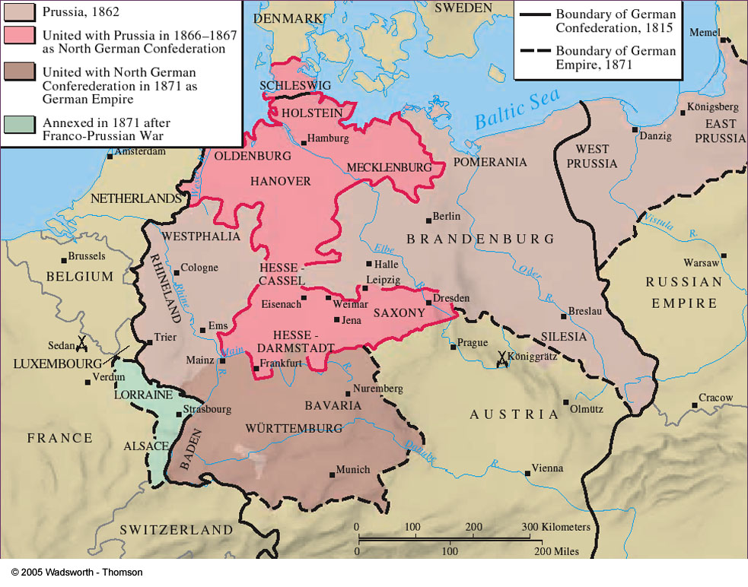

Document 5

“The war of 1866 [between Prussia and Austria] was entered on not because the survival of Prussia was threatened, nor was it caused by public opinion and the voice of the people; it was a struggle, long foreseen and calmly prepared for, recognized as a necessity by the Cabinet, not for territorial enlargement, for an addition of our area, or for material advantage, but for an ideal end--the establishment of power. Not a foot of land was exacted [taken] from Austria, but she had to give up all part in the control of Germany. . . Austria had exhausted her strength in conquests south of the Alps, and left the western German provinces unprotected, instead of following the road pointed out by the Danube. Its center of importance lay out of Germany; Prussia's lay within it. Prussia felt itself called upon and strong enough to assume the leadership of the German races…”

Field Marshal Helmuth von Moltke (Prussian army): 1866

Document 6

The “Sons of Garibaldi” Join the Union Army

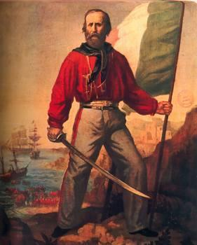

From Chapter 23
World History: Connections to Today

Document 7

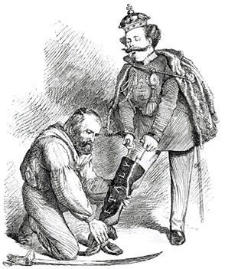

Right Leg in the Boot at Last
Giuseppe Garibaldi and the King of Italy

Document 8

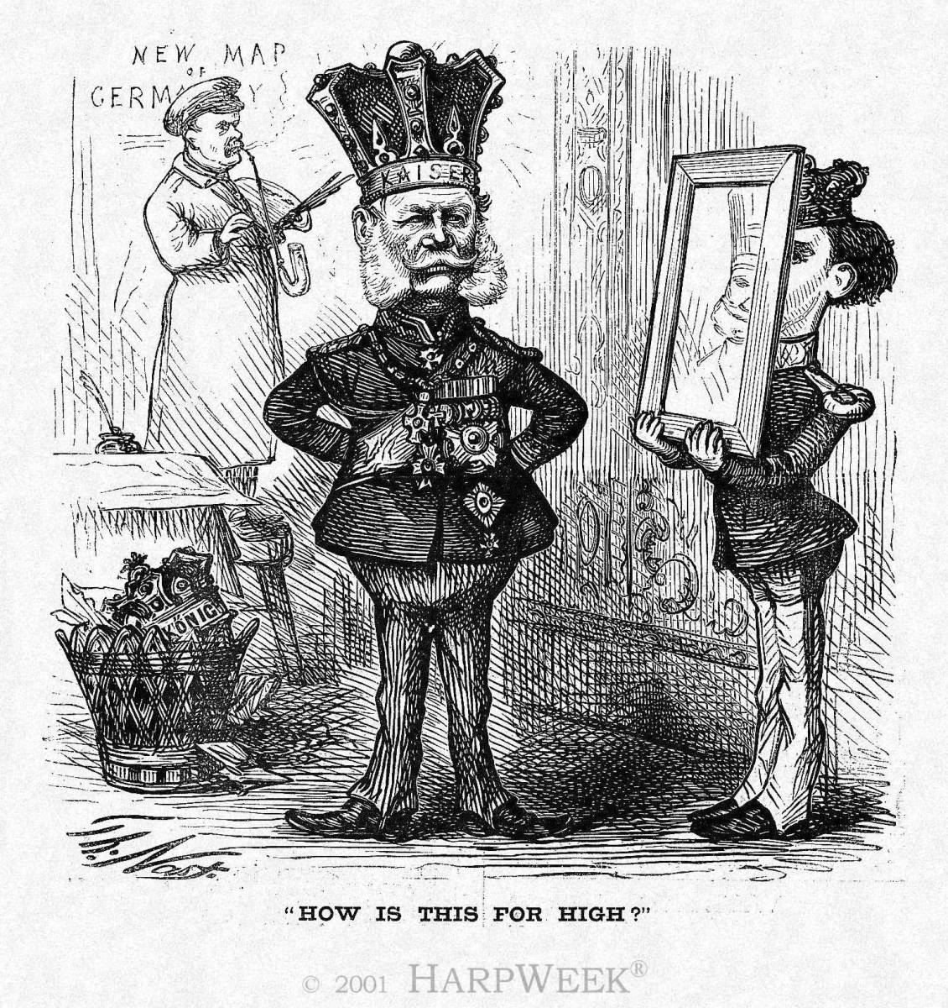

Document 9

“We passionately wish to free Italy from foreign rule. We agree that we must put aside all petty differences in order to gain this most important goal. We wish to drive out the foreigners not only because we want to see our country powerful and glorious, but also because we want to elevate the Italian people in intelligence and moral development.”

Taken from a speech by Count Camillo di Cavour

