Names: _________________________________________ Date: _______________

Napoleon’s Geographic Conquests and Mistakes
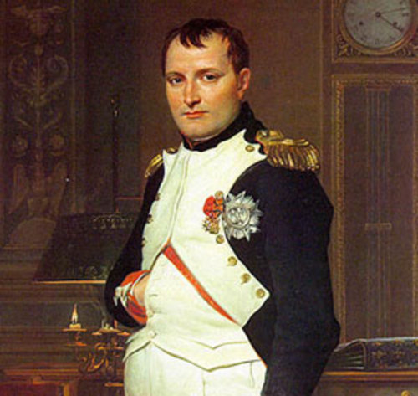
Aim: How did the geography of Napoleon’s empire influence his rise and fall?

Directions: Read the following information about the rise and fall of Napoleon’s empire with a partner. Complete questions 1-4 based on the reading. Complete the writing frame on your own.

Building the Empire: From 1805 to 1807, Napoleon defeated the Austrian, Prussian, and Russian armies. Napoleon now had the opportunity to create a new European order. From 1807 to 1812, Napoleon was the master of Europe. His Grand Empire was composed of two major parts: the French Empire, dependent states, and allied states. The French Empire was the inner core of the Grand Empire. It consisted of an enlarged France extending to the Rhine in the east and including the western half of Italy north of Rome. Dependent states were kingdoms under the rule of Napoleons’ relatives. These came to include Spain, Holland, the kingdom of Italy, the Swiss Republic, and the Confederation of the Rhine. The allied states including Britain, Prussia, Austria, Russia, and Sweden were against Napoleon and the French.
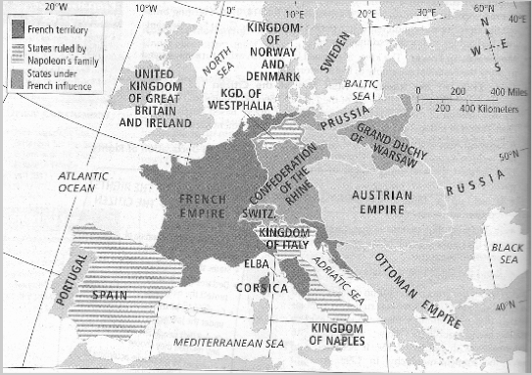

1. Examine the locations of the states that were allied against Napoleon in 1812. What geographic factors would have helped these states remain independent from Napoleon’s control?

The Fall of Napoleon: The beginning of Napoleon’s downfall came in 1812 with his invasion of Russia. Within only a few years, the fall was complete. Napoleon knew the risks in invading such a large country, however, he also knew that the Russians were a threat to his empire. In June 1812, a Grand Army of 600,000 men entered Russia. Napoleon’s hopes for victory depended on a quick defeat of the Russian armies. The Russian forces, however, refused to fight against Napoleon’s army. They retreated for hundreds of miles. As they retreated, they burned down their own villages and countryside to keep Napoleon’s army from finding food (scorched earth). When the remaining Grand Army arrived in Moscow, they found the city ablaze. Lacking food supplies, Napoleon abandoned Moscow late in October and began the “Great Retreat” across Russia. The retreat proceeded in terrible winter conditions. Only 40,000 out of 600,000 troops returned home to France.
Napoleon Suffers Defeat
• Britain, Prussia, Sweden, Russia, Austria join forces against Napoleon
• Napoleon raises another army, but meets quick defeat by allied powers
• Napoleon finally surrenders and is exiled to the island of Elba

Congress of Vienna: European heads of government were looking to establish long-lasting peace and stability on the continent after the defeat of Napoleon. The goal of the Congress of Vienna was to restore the European borders back to the time before Napoleon and restore monarchies back to their thrones.

- How did geography impact the rise and fall of Napoleon’s empire? Explain.

- How was Napoleon able to maintain control over his vast geographic empire?

- Why was Napoleon’s delay of the retreat form Moscow such a great blunder?

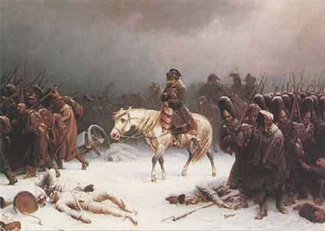

Instructions: Write a short story as if you were Napoleon retreating in Russia
- Describe in detail why you are in this situation and how geography influenced your decision

