Primary Source **A**

**An advertisement for Pears’ Soap from the 1890s, and one stanza of the British poet Rudyard Kipling’s poem, *The White Man’s Burden,* written in 1899 in response to the American take over of the Philippine Islands**

**Excerpt from Rudyard Kipling’s *The White Man's Burden*, 1899**

Take up the White Man's burden--

Send forth the best ye breed--

Go bind your sons to exile

To serve your captives' need;

To wait in heavy harness,

On fluttered folk and wild--

Your new-caught, sullen peoples,

Half-devil and half-child.



Primary Source **B**

**British cartoon “The Rhodes Colossus,” showing Cecil Rhodes’ vision of making Africa “all British from Cape to Cairo,” 1892**



Primary Source **C**

**Zulu workers at De Beers Diamond Mines in Kimberley, South Africa**

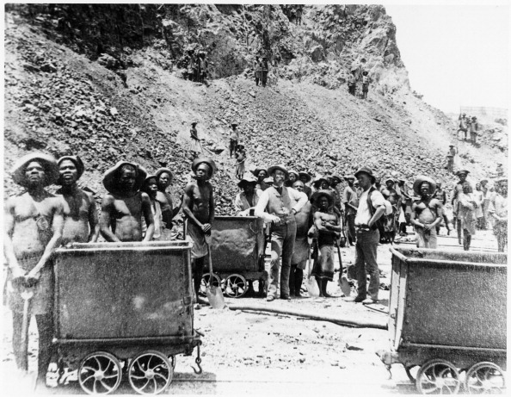

Primary Source **D**

**A Methodist Sunday School at Guiongua, Angola in 1925**

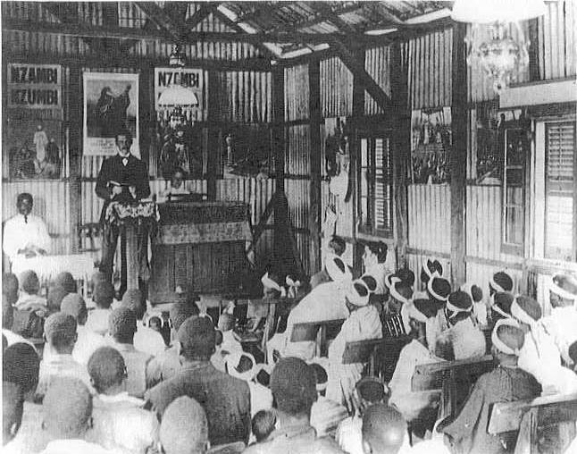

Primary Source **E**

**Quote from explorer Henry Stanley in 1882 – looking for the source of the Nile**

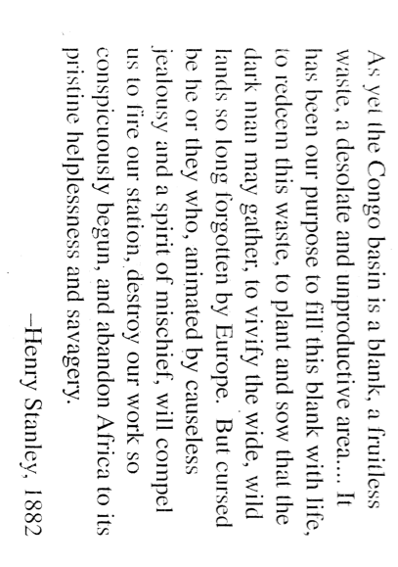

Primary Source **F**

**Germans taking possession of Cameroon in 1881**

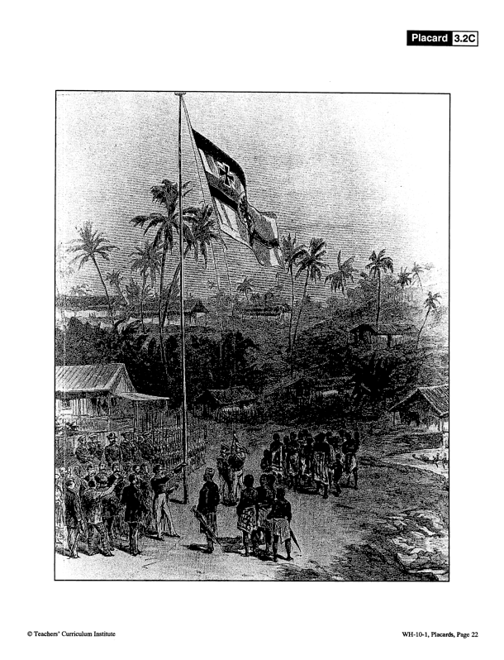

Primary Source **G**

**Sketch map of Central Africa, showing Dr. Livingstone’s exploration**

**(Dr. Livingstone’s goal was to find the source of the Nile River)**

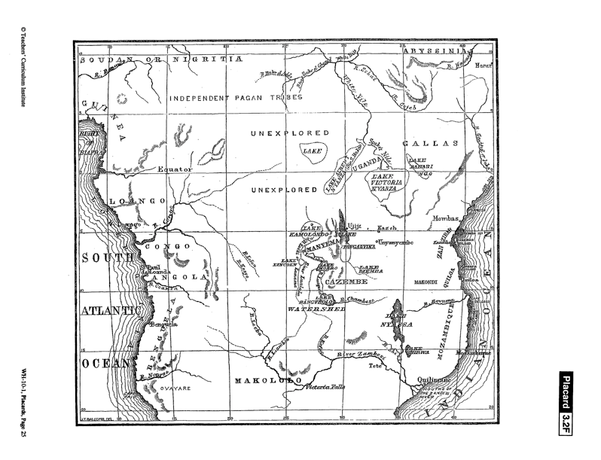

Primary Source **H**

**British Lipton Tea advertisement in the 1890s**

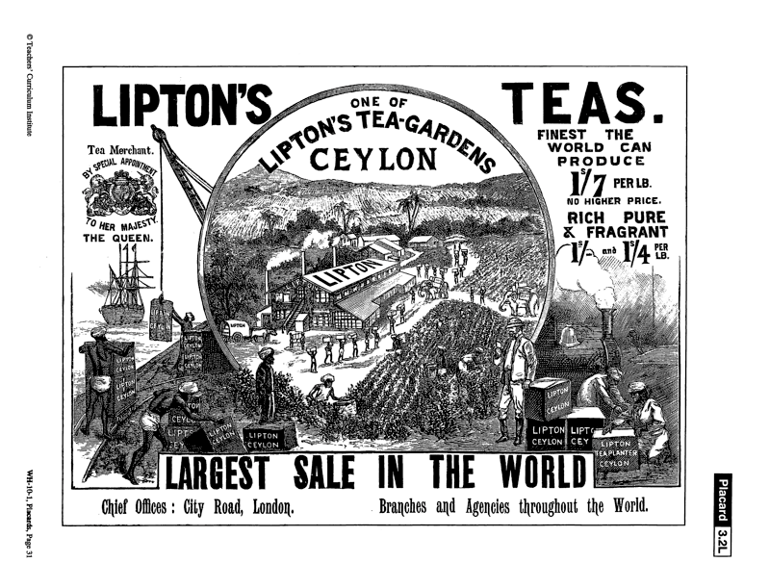

Primary Source **I**

**British cartoon showing the Chinese being savaged by European powers, and the poem *The Partition of China,* 1897**

