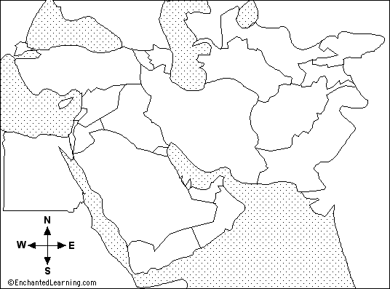
Please label the following countries:
Israel Egypt Saudi Arabia Iraq Iran Syria Jordan Lebanon
Pakistan Afghanistan Turkey Kuwait Oman Yemen United Arab Emirates
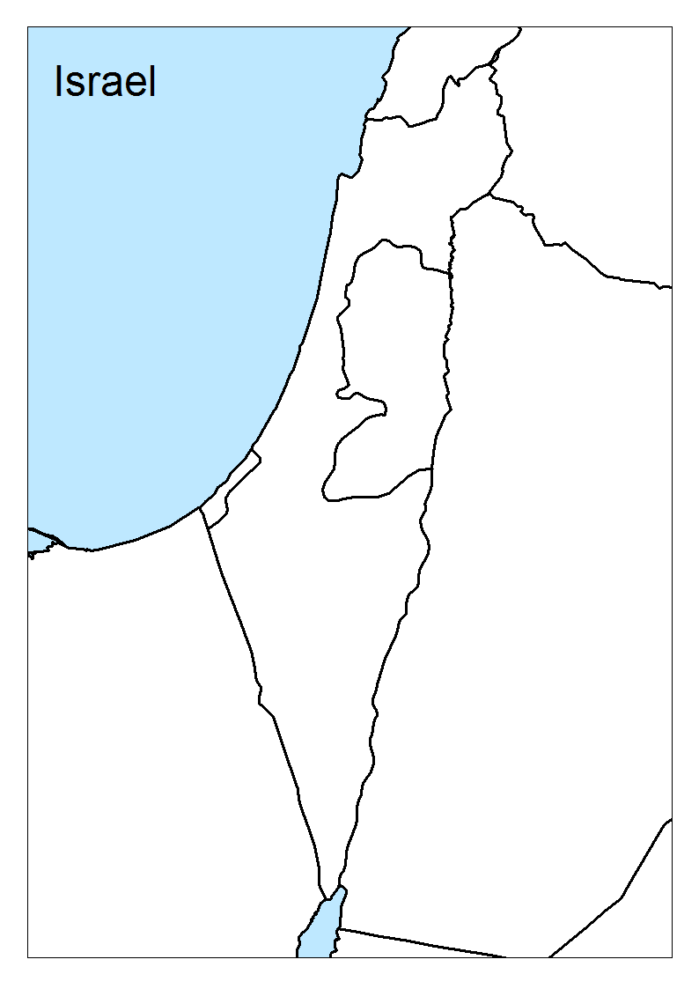
Label the following Palestinian areas:
West Bank
Gaza Strip

Label the following cities:
Jerusalem
Tel Aviv

