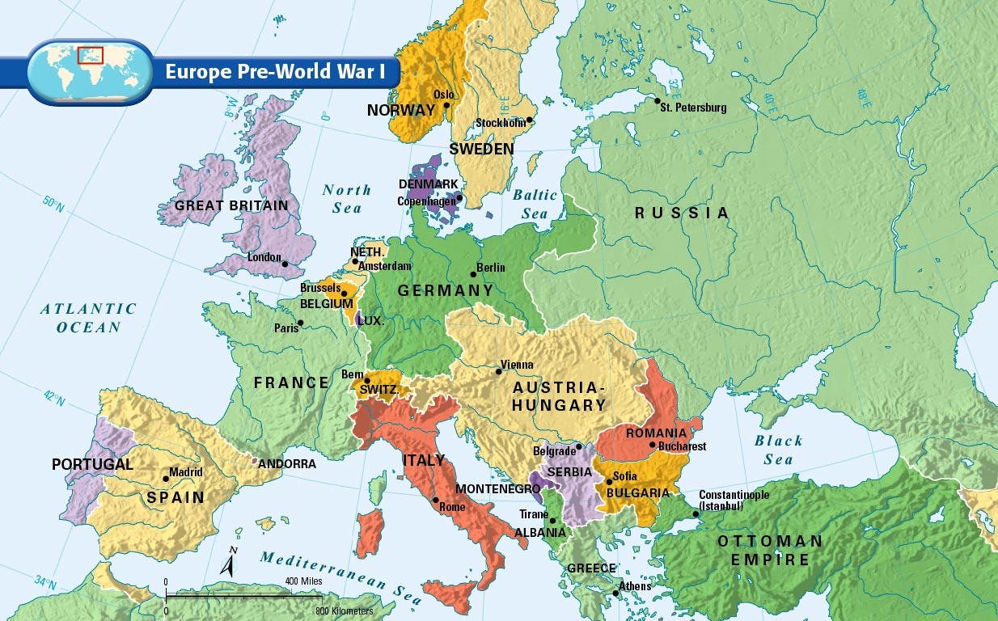
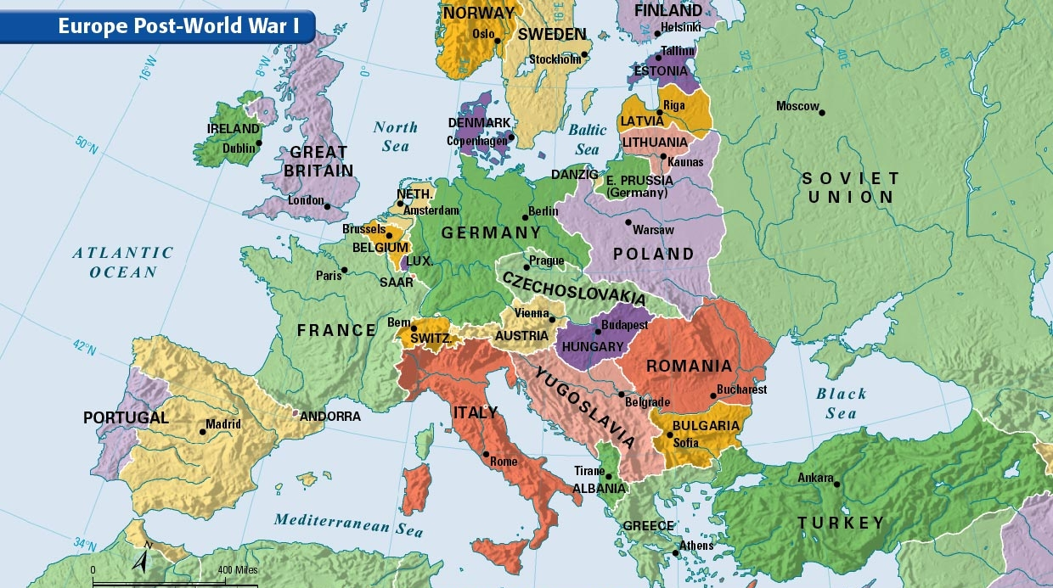

1-Write down the first thing you notice about the differences in the maps before and after World War I. (no right or wrong answer)

2-Name at least 3 new countries (nation states) that were formed after World War I.

3-What country is completely gone from the map of Europe after World War I?

4-Name at least 2 countries who lost a considerable amount of land after World War I.

5-Based on our study from World War I, why did Russia change it’s name to the Soviet Union?

6-Why did nations in Western Europe keep the same territory/land they had kept before the war?

