Louis XIV
Louis XIV of France really was as an unpleasant a fellow as he’s been depicted. In 1674, When he was visiting a school at Clermont, he heard from the school’s authorities that one of the children, a nine-year-old Irish lad named Francis Seldon had made a pun about the king’s bald head.
Louis was furious. He had a secret warrant drawn up for the child’s arrest, and young Seldon was thrown into solitary confinement in the Bastille. His parents, members of one of Europe’s richest merchant families, were told simply that the child had disappeared. Days turned to months, months to years, and Louis himself passed away. But Francis spent sixty-nine years “in the hole” for making fun of the kings’s baldness.
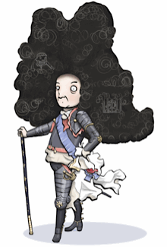
This story was often told by the people of France to illustrate Louis’ temper.
It’s a bit exaggerated, but not totally off. Seldon was actually 16 years old -not 9- and spent 31 years –not 69- in prison. The crime was drawings on a poster, not a pun (verbal joke). However, the point remains the same… Louis had a school boy thrown into jail for a joke, and his parents never knew what happened to him.

Peter the Great
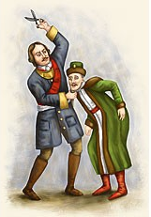
Peter the Great was Tsar/Czar (emperor of Russia in the eighteenth century. After touring many countries in Western Europe, Peter became convinced that Russia was too old-fashioned and lagging behind many countries like Germany and England. So he decided that many changes were necessary. He built new roads and canals and modernized many industries like mining. He also founded schools and encouraged science. But at the same he wanted to change Russian habits and customs. He wanted women to take more part in social life and thought that the men should give up wearing their traditional long coats and should shave off their beards. But how could he stop them? For Peter the Great, it was easy. He could do anything he liked because he was the Tsar and Tsars had unlimited power. Peter simply passed a law against beards and that was that.
As soon as Peter passed his law, the trouble began. Of course, many Russians shaved their beards for fear of getting into trouble. But the law was very unpopular as it was traditional for Russian men to wear beards – it did not seem right to be clean shaven. Even the Church was against the law. For this reason, many men simply refused to obey the law. Their beards were staying! Peter the Great was very displeased at this and ordered that all bearded men should be seized and have their beards shaved off in the street. This seemed to work because before too long, it was not possible to see any men with beards in public. … But things were not what they seemed. Many men who did not want to lose their beards were staying in hiding at home!
Peter realized that his law was causing problems. So he decided on a different tactic. He decided to put a tax on beards instead. This meant that men were allowed beards if they were willing to pay.
This worked very well and soon there were fewer beards in Russia than there had ever been. Although this was a better way to enforce this law, it didn’t mean that Peter the Great had become less of a tyrant. Several times during his reign as Tsar, there were rebellions against him by people who did not like the changes he was making. When his son, Alexis, spoke out against the reforms, Peter had him killed and he drove away his first wife for opposing him.
Many people today would say that Peter the Great had many good ideas. For example he did away with the old council of nobles and replaced them with clever or gifted men who would make good leaders. He improved Russian business and trade and was willing to learn from other countries. But, at the same time, he kept a lot of the profit for himself and grew very wealthy and made more people peasants (most slaves) than before.

