Limited and Unlimited Governments Guided Notes
Unlimited Governments
- The power of the government (king) is __________________________.
- Very few individual _______________________________________________.
- Citizens must give complete _____________________________ to the government.
- The government (king) makes all of the ____________________________.
Limited Governments
- The power of the government (king) is limited by the _______________________.
- Citizens have _________________________________.
- Citizens can _______________________ in government.
- ___________________________ limit the power of the king.
Absolute Monarchy
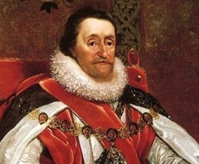
- The king believed in “_______________________________”, or the idea that their ____________________________________________ so they are only accountable to God.
- Had unlimited power over the country (____________________________ – absolute authority).
- People had few rights and freedoms.
- Monarch kept control by raising ________________________, dissolving the _________________________________ (elected representatives) body, and using the ___________________________ to enforce policies
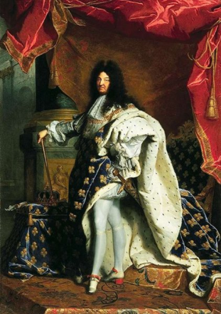
- (ex. France, Russia, Austria, and Prussia)
France
- Louis XIV (1643-1715): aka “________________________________”
- Lived for 95 years, became King as a child.
- Built the _______________________________
- Banned the Estates-General (French ____________________)
- Constant ___________________ and heavy ____________________ left France in major debt when he died.
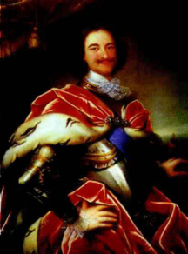
Russia
- Peter the Great (1689-1725)
- Head of the Russian Orthodox ____________________
- Controlled the __________________ (peasants)
- Wanted to “____________________” Russia, and improve its military, business, and science technology to make it more like Western Europe.
- Fought ___________________ to expand the borders of Russia.
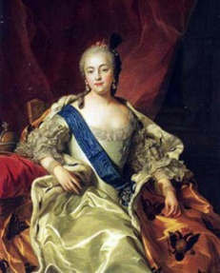
Russia
- Catherine the Great (1762-1796)
- Poisoned her husband to take the throne
- Thought about giving more freedom to the peasants, but after a rebellion, she changed her mind.
- Focused on expanding Russia’s borders.
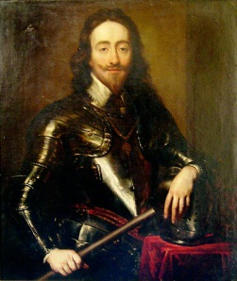
England
- 1215: ___________________________ signed, limiting the power of King John.
- 1200’s: King Edward establishes ______________________ (a group of elected representatives) to help him make laws.
- In the 1600’s, England’s kings struggled to hold absolute authority by getting rid of Parliament. This is known as the _________________________
- At one point during the English Civil War, the military takes control. When the king is restored to the throne, this is known as the __________________________ (1660).
- The _____________________________ was a bloodless revolution where King James II’s Protestant daughter, Mary, and her husband, William, return to England to take the throne.
- William and Mary establish a ___________________________.
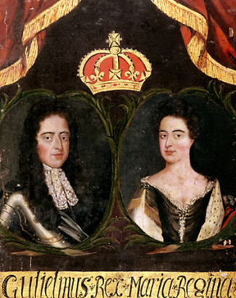
Constitutional Monarchy
- The king was ____________________ in their power by the ____________.
- Establishing _____________________ – where people participate in govt. by having the opportunity to ________________________________ to government.
- ___________________________________ – govt. power is distributed to different govt. branches: ______________________ (courts), ____________________ (representative body), and ___________________ (king).

