Name: ________________________________ Date: ______________________

**Why can’t we be friends?**

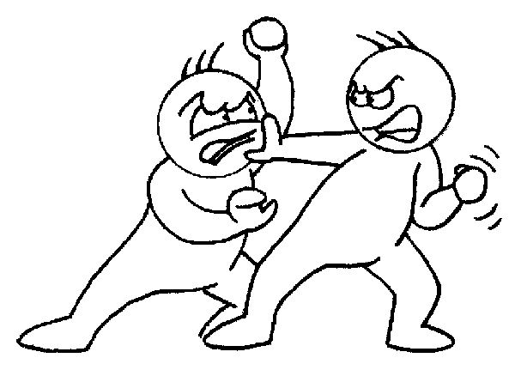

No conflict in the Middle East is as difficult to understand as the one that creates enemies between the Israeli’s and the Palestinians in what is now known as Israel. After WWII, the UN decided to divide Palestine (which was under British rule) into an Arab state and a Jewish state. Jews liked this plan but Arabs did not. Since the creation of the state of Israel in 1948, the Middle East has been an area of tension and change where Israeli’s and Palestinians have been fighting ever since. Sometimes, it is very hard to understand the conflict, but how would you solve the problem if you were there?

The **FOUR** main issues dividing the Israeli’s and the Palestinians today:

**ISSUE #1: FINAL STATUS OF JERUSALEM**

The Palestinians and the Israeli’s BOTH view Jerusalem as the capitol of their states. Both religions (Judaism and Muslim) were created in this area. Jerusalem is a holy city for Muslims because Muhammad spoke to Allah. Jerusalem is a holy city for Jews because it is the home of the ancient Temple of Solomon.

**ISSUE #1:**

***Final Status of Jerusalem:*** *Who will control the Holy City of Jerusalem?*

**Current Palestinian Position**

Jerusalem is and always has been the capitol of Palestine. Separating The Palestinian people from Jerusalem would be unthinkable. East Jerusalem is the largest Palestinian city in the area.

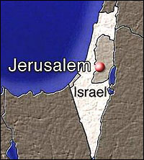

**Current Israeli Position**

Jerusalem is the physical and spiritual capitol of the Jewish people. The Jews of the world will never again be separated from the Holy City.

*Question: Who should control Jerusalem*

*Question: What evidence from the past makes you feel this way?*

**ISSUE #2: RETURN OF REFUGEES**

After Israel’s War of Independence, in 1948, the country was invaded by 6 neighboring nations. About some 900,000 Palestinians left their home in what became Israel. Today, many of these people and their decedents have lived in refugee camps still waiting for the final negotiation of their status. Israel argues that the Palestinians left voluntarily but the Palestinians argue that they were forced from their homes.

**ISSUE #2:**

***Return of Refugees***

*What will happen to the approximately 900,000 Palestinian Refugees?*



**Current Israeli Position**

They left their homes voluntarily and allowing them to return would greatly upset the political and social culture of Israel.

**Current Palestinian Position**

They must be granted the right of return and be allowed to go back to their homes if they choose.

*Question: Should the Palestinian refugees be allowed to return to their homes inside of Israel?*

*Question: What evidence do you have to support your position?*

**ISSUE #3: ASSURANCES OF SECURITY**

Israel has fought five wars with her Arab neighbors and has been the victim of countless terrorist attacks. Israel believes that the only reason that they have been kept safe since 1948 is the strength of their military. Before Israel can grant autonomy (self rule) to the Palestinians, Israel will need security grantees.

**ISSUE #3:**

***Assurances of Security***

*What are guarantees for Israel’s security?* 

**Current Israeli Position**

Israel has suffered from countless invasions and terrorist attacks since her creation. Israel has learned that the only way to stop terrorism is through intelligence and action. Firm concrete security guarantees are necessary for a lasting peace.

**Current Palestinian Position**

The best way to guarantee the safety of Israel is to give the Palestinian’s independence, and then we can live together as equals.

*Question: If the Palestinians are given their independence, what guarantees does Israel have of security?*

*Question: What evidence do you have to support your position?*

**ISSUE #4: WATER RIGHTS**

Much of the Middle East is made of large desert areas. Israel is one of these large desert areas. The issue of who controls the water is a major question throughout the entire area. It is also a problem for the Arab’s and Israeli’s. How can Israel and Palestine next to each other and divide a decreasing water supply?

**ISSUE #4:**

***Water Rights***

*How can two enemies share a decreasing water supply?*



**Current Israeli Position**

If the Palestinians get to control the water, they will take out their anger on us by not giving us enough.

**Current Palestinian Position**

They must be granted the same amount of water that the Israeli’s get.

*Question: How should the water supply be divided?*

*Question: Why do you feel your decision is just?*

**What do you think?**

Why is peace between the Israeli and Palestinian people so difficult to achieve?