Life Before the Industrial Revolution
There were many modes of production before the Industrial Revolution. Nothing was produced in factories. Everything was produced at home be individual craftsmen. Each craftsperson saw each item through the entire process, from raw material to finished product. This is a very long process. The craftsperson must earn enough to pay for the materials and the time. Prices were very high.

Tom and Anne Moore live in the village of Farmington. They have three children, ages six, four, and one. The Moore’s rent a cottage made of stone and clay. This cottage has only one room, with a big fireplace for heat and cooking. There are two beds, one for the parents and one for the two children, and a cradle for the baby. There is a small area behind the beds where the animals – a cow and ten chickens – are kept at night. They have no running water and no toilet. The cottage is on one acre of land, which the Moore’s use to grow their own vegetables.
A Day in the Life of the Moore Family
Tom Moore works as a farm laborer for George Thompson, who owns 200 acres of land. Tome helps with the plowing, sowing the seeds, and harvesting the grain. In the summer, especially, during the harvest, he works from dawn (4 or 5 A.M.) to dusk (8 or 9 P.M.). In the winter, when there is no regular work, Tom does odd jobs for George Thompson and other farmers.

Anne Moore is up at dawn every day to milk the cow. Anne makes most of the cow’s milk into butter and cheese. Using a hand churn, it takes her 2 ½ hours to make butter. Making cheese takes 8 to 10 hours. Some of the butter and cheese is taken to the market in another village, which is 10 miles away. Anne usually rides on a neighbor’s horse-drawn wagon. They must leave by 4 A.M. to reach the market when it opens at 6 A.M. Anne also grows vegetables in the garden, tends the chickens, cooks, takes care of the house, and makes the family’s clothes.

How Did Farming Change?
Viscount Townshend
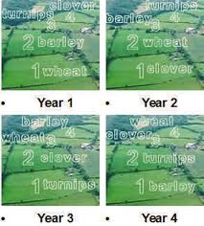
For centuries the chief way to keep a field fertile has been to let it lie fallow every two or three years. During those years, nothing was planted on the land Viscount Charles Townshend found the secret was just to rotate the crops. This was done by planting a different crop each year. While wheat and corn would wore out the land, turnips and clover would restore the field. Not surprisingly, the Viscount was nicknamed Turnip Townshend in honor of his favorite crop. The result: Hooray! Farmers could use their fields each year without letting them lie fallow. That meant they could get more crops from each field.

*Fallow – to leave a field unplanted for several years so that its nutrients can be restored.

How Did Farming Change?
Jethro Tull
Jethro Tull was one of the first scientific farmers. He realized that the usual way of sowing seeds by scattering them on the ground was wasteful. Many seeds did not take root. The seed drill, which he invented in 1701, allowed the farmers to sow seeds in well-spaced rows at specific depths. When his invention was used, a lagers share of the seed germinated. As a result, crop yields increased even more.

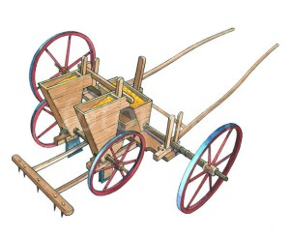
The Enclosure Movement
English farmers had raised crops and grazed their animals on open fields for centuries. However, during the late 17th century, English landowners began buying up village lands and fencing them in. They then began charged people for the use of the land. This was known as enclosure. They farmers were not happy. Suddenly, they had to make a little land do as much as possible. Here’s what happened.
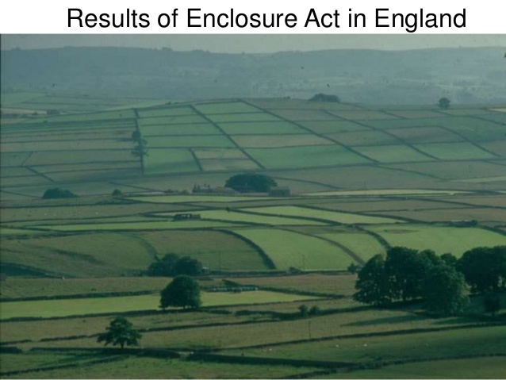

The Changing Lives of People
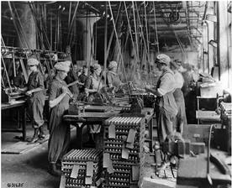
Most small farmers couldn’t stay in business. They didn’t have the money to buy machines. And they couldn’t produce as much as the farmers who did have machines. The same was true for tailors who couldn’t buy sewing machines. It was true for all people with small businesses. And so these workers moved to the cities. They moved there to get jobs in the factories. No longer did families work together. And no longer were there small shops close to people’s homes. Now a worker was one out of hundreds in a factory. People ran machines. Or they made just one part of a product. Often factory owners thought more about money than people. The lives of the people who could buy machines changed, also. The machines worked faster and made more products than people. Machine owners started making more money. That meant they could get nicer things for their homes. It also meant they could get educations.

Urbanization
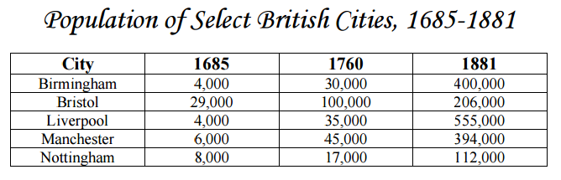
With the shift of work to factories, large numbers of workers moved from the countryside to the cities. This shift from rural communities to urban cities, known as urbanization, marked one of the greatest population shifts in history. As a result, many cities became crowded and unsanitary. This shift in population can be seen in the following table if British cities.
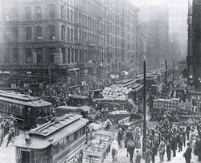

An Energy Revolution – The Steam Engine
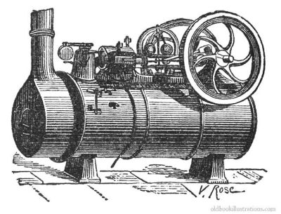
One factor that helped trigger the Industrial Revolution was an “energy revolution.” From the beginning of history, energy for work was provided by the muscles of humans and animals. In the 1700s, inventive minds found ways to use waterpower more efficiently. Giant water wheels powered machines in the first factories. People also used other sources of energy, such as coal. Coal was an important part in the development of the steam engine.

Factories were making cotton goods in greater qualities than ever before. However, there was a problem. Not all factories could be located near a source of water to run machines. Factory owners needed a new way to power their machinery. Steam engines offered a way to power machinery without relying on waterpower. Steam engines have been tried for years, but not one had built one that really worked well.
New Technology – Growth of Railroads
Steam engines powered locomotives. Railroads unified the economy of a region by linking cities, factories, towns, and the countryside together. At the same time, railroad construction required huge amounts of coal, iron, and steel, greatly stimulating the growth of heavy industry.

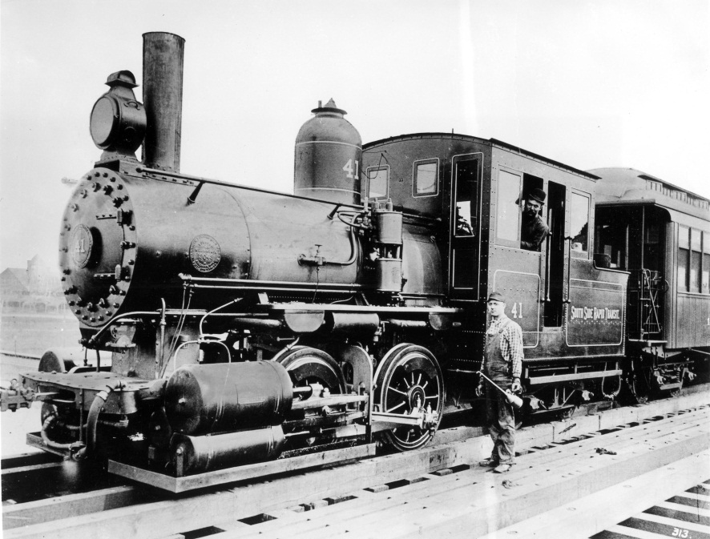
New Technology –Textile Revolution
Suddenly, farms were producing bigger crops. One of the most important of these crops was cotton. Cotton was used for everything from clothing to sails for ships. Now that there was more cotton, people wanted to find ways to turn it into useful products more quickly.

James Hargeaves (Spinning Jenny)
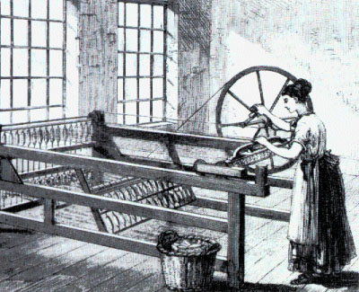
The spinners could not keep up with the weavers. A reward was offered to the person who could produce a better spinning machine In 1764, James Hargeaves invented a new spinning wheel. He called it the Spinning “Jenny” in honor of his wife. This simple machine allowed a worker to spin 6 or 8 threads at a time. Later models could spin as many as 80 threads.
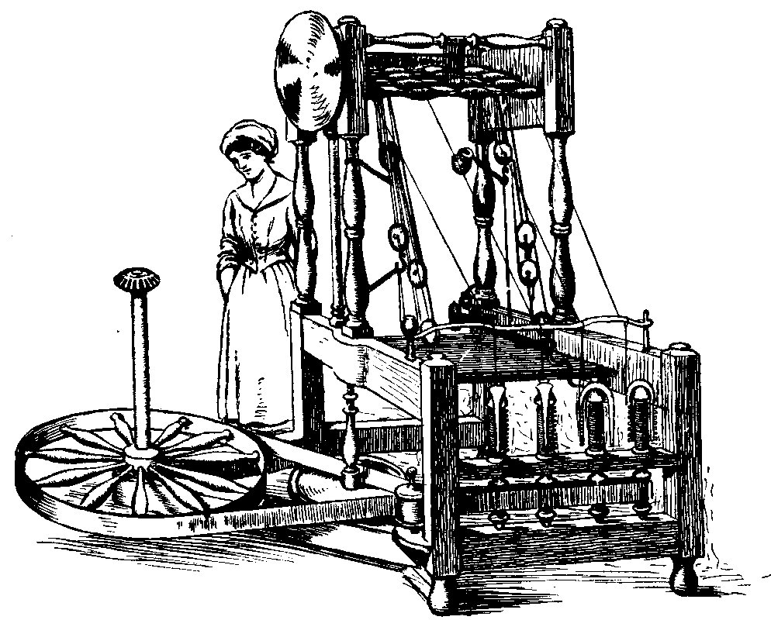
Richard Arkwright (Water Frame)
In 1769, Richard Arkwright invented the Water Frame. The water frame used water from a near-by stream to operate the spinning wheels. Results: spinning could be done by a machine instead of a person, so owners could spin more cotton.
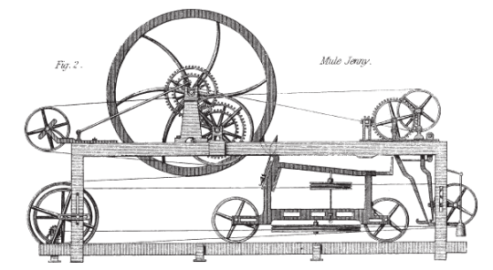
Samuel Crompton (Spinning Mule)
In 1779, Samuel Crompton combined features of the spinning jenny and the water frame to produce the Spinning Mule. It was so named because, just as a mule is the offspring of a horse and a donkey, this machine was the offspring of two inventions. The mule made thread stronger and finer than earlier machines.

Edmund Cartwright (Power Loom)
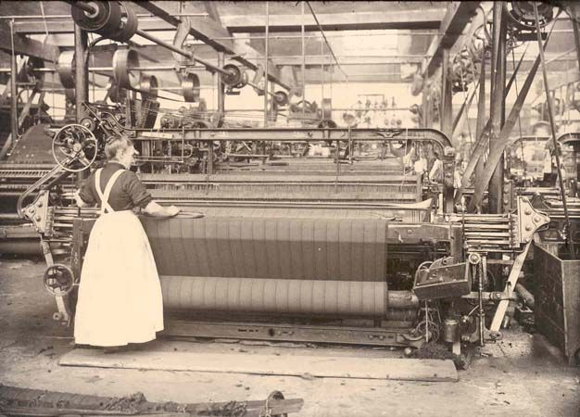
The water frame and the spinning mule were too large and expensive for people to use at home. Spinning and weaving slowly stopped as something families did at home. Factories began to hold these new machines. And Mr. Watt’s steam engine gave the factories a way to power their new machines. In 1785, Edmund Cartwright, invented the Power Loom which boosted weaving. In 1883, over 100,000 machines were in use. This meant that people were not working at home Instead they worked in factories. Big Change!

Eli Whitney (Cotton Gin)
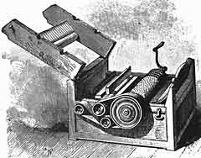
Well, everybody was working like crazy. Now, American factories had been built, and they needed more cotton. Removing the seeds was the most time consuming job on the plantation. In 1793, educator Eli Whitney made a machine to remove the seeds from the cotton. This allowed the workers to pick and clean ten times as much cotton as they had before. The increased productivity from the cotton gin fueled further advances in automating the production of cotton and other cloths.

A Population Explosion
The Agricultural Revolution contributed to a rapid growth of population. The population boom of the 1700s was due more to declining death rates than to rising birthrates. The Agricultural Revolution reduced the risk of famine. Because they ate better, women were healthier and had stronger babies. Some deadly diseases, such as bubonic plague, had faded away. In the 1800s, better hygiene and sanitation along with improved medical care further slowed deaths from disease.
