**The Agricultural (Farming) Revolution**

* 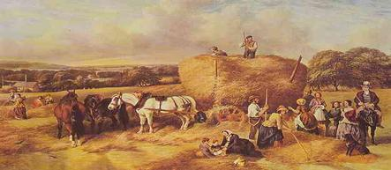_____________________________________ – Parliament passed new laws allowing land owners to _______________________________________.
* Forced villagers/peasants to move to the ___________________________
* Landowners were able to plant a _____________________________ (bigger profits) or turned the land into _________________________________________
  + Other farming changes:
    1. ______________________________ kept soil fertile – better crops
    2. Invention of the seed drill – ______________________________________________________
    3. Stronger ______________________, fatter ______________________________________________ for meat.

**Capital and Labor**

* Landowners were making more money off of the _________________, so they had more money (__________________) to invest in other _________________.
* More individuals living in the cities provide a ____________________________.
* Better farming and breeding animals _______________________________________________.
* Bigger _____________ supply = bigger __________________= bigger ______________________

**Natural Resources and Markets**

* 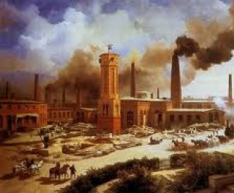Great Britain’s _______________________ provide _______________________ for trade.
* Huge supplies of _____________________________________________.
  + Coal – source of ____________________________________________
  + Iron – used to build ___________________________________________

**Rise of the Factory System**

***Old Style***

* Called the “____________________________”
* Merchants went from cottage to cottage dropping off ___________________.
* Works ____________________________ in their home with a spinning wheel.
* Merchant would return to pick up the ________________ and __________ it.

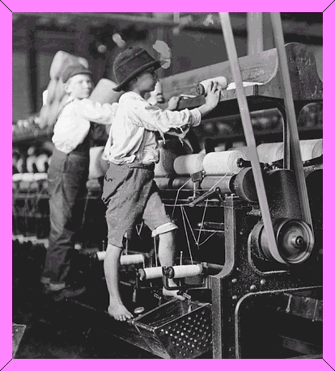

***New Style***

* Called the “______________________________”
* Factories were created where ______________________ aided in the production of goods at a ______________________________.

***Growth in Trade***

* 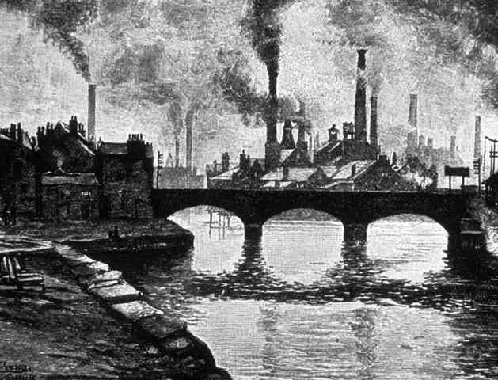__________________ produced ½ the world’s coal and ___________________________________________.
* Stiff competition from the _________________________, __________________, and __________________.

***Impact of Industrialism***

* Growth of Cities – _______________________, _______________________________________, and _________________________________________________.
* Industrial capitalism – ____________________________________, not the government, own ______________________________ (free enterprise).
* Partnerships in businesses – corporations form and profit sharing begins with ______________________________________
* Industrial Working Class – people work ___________________ a day, ________________________ a week in ____________________ conditions in factories
* ________________________________ form – workers join together to improve ________________________, _______________________, and __________________________________________.
  + Uses strikes (___________________________) to get their way.

**Capitalism**

* _________________ between businesses led to ingenuity.
* __________________ and __________________ determined prices.
* Supporters of capitalism against ____________________________________ and better working conditions.
* Big difference between the rich and poor.
* Laissez-faire – _____________________________________________________

**Socialism**

* 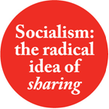The idea that ____________________________should own and control the factories, land, capital (money) and raw materials.
* More evenly distribute the wealth according to need to promote _________________________ and ___________________________________.
* _____________________________________ (*The Communist Manifesto*) – wrote that the workers should have a revolution to _______________________________________
* ______________________________ (workers)