**What Did India Want?**

* _________________________________________________.
* At first, India just wanted _____________________________, but eventually, India wanted to be free from __________________________.

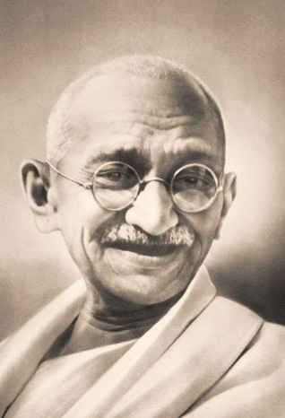

**Who Led the Independence Movement?**

* **___________________________________** stepped forward to lead India’s movement for independence. He focused on ___________________________ or non-violence to achieve independence.
* Gandhi called for **_________________________________________:** 
  1. Declaring a law _________________________
  2. ____________________________ to follow it
  3. Suffering the ______________________________

**How Did Gandhi Protest the British?**

* Gandhi and his followers defied British rule through _________________________________.
* Gandhi called this process **SATYAGRAHA**, Hindu for ________________ and ______________________.
* Other people, like ____________________________________________.would practice this behavior.

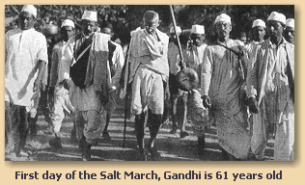**What Did Gandhi Go Through?**

* Gandhi suffered for his cause by:
  1. Leading the _______________________ in 1930 to protest British ___________________
  2. ________________________ the purchase of _______________________ to hurt the British economically
  3. Enduring life-threatening _______________________________
  4. Going to ____________________

**Who Supported Gandhi?**

* Thousands of people joined with Gandhi….even the ______________________ that were usually known as the “________________________” (lowest social class).
* Gandhi renamed these people the HARIJAN (_____________________________________)

**How Did the British Respond?**

* 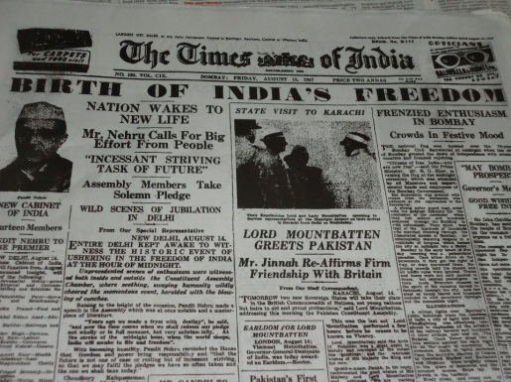The British slowly gave in to the demands of the Indian people such as allowing Indians to run for __________________________________.
* Higher offices still remained out of their reach.

**When Did Independence Come?**

* After _______________________________, the independence movement grew stronger
* *___________________* – Independence *finally* comes to India.

**Who Lived In India?**

* Before giving India its independence, the British tried to settle religious tensions between _______________________ and ________________________.

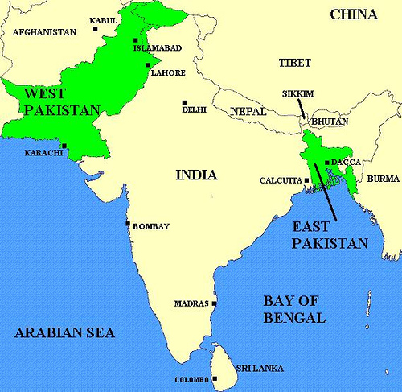

**How Was India Divided?**

* The easiest way to avoid religious issues was to divide India:
  1. **India**: *for the ______________________ people*
  2. **Pakistan**: *for the ______________________ people (Pakistan is divided into two regions: _______________________________ and _______________________________*

**Why Did Violence Break Out?**

* Many people moved according to their _________________________.
* *Muslims did not want to live in Hindu India*
* *Hindus did not want to live in Muslim Pakistan*
* During this time of migration – _________________ broke out between the two groups. Over _____________________ people were killed.

**Kashmir**

* Both India and Pakistan want control of the region of ______________________.
* ______________________ controlled the region, but most of the residents were ____________________.
* The ___________________________________ enforced a cease-fire and gave _____________________________ of the region of Kashmir. However, the two still disagree over ownership of the region.

**What Was Pakistan’s Problem?**

* **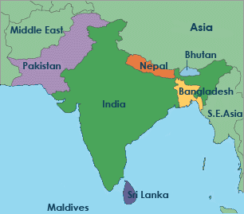***1960s* – Trouble occurs between East and West Pakistan
* ______________________________________ felt it had no power because the government of Pakistan was in West Pakistan
* *1971* – East Pakistan declares its ____________________________ …a ________________________ erupts.
* Today: West Pakistan = __________________________, East Pakistan = _____________________________________