Name:
Directions: Read the passage and answer the questions below.
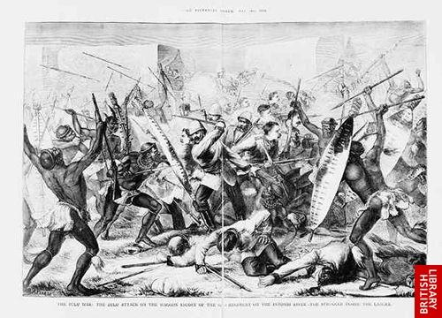
IMPERIALISM = STRONGER NATIONS WITH INDUSTRY TAKING OVER WEAKER COUNTRIES WITHOUT INDUSTRY!
SOME WEAK NATIONS FOUGHT BACK!!!! WHO WERE THEY!?
THE ZULU WARS IN AFRICA:
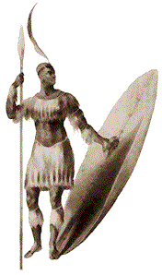
South Africa was a nation with LAND that everyone wanted! The Dutch, the British and the African tribe-the Zulus all wanted the land and resources in South Africa. In the early 1800s, Shaka Zulu of the Zulu Kingdom in South Africa created a united Zulu territory in Africa. Dutch settlers known as Boers, began trying to take the Zulu’s land. In a display of nationalism, Shaka Zulu led the South Africans in attacks against the Dutch Boers. However, the Zulu were unable to hold rule over South Africa. The British soon came to South Africa also wanted the Zulu’s land. Now the Zulu would have to fight the British! In the 1880s, the Zulu War was fought against the British as the Zulus sought to retain independence, illustrating their growing nationalism. The British had better weapons than the Zulus. The Zulu was defeated, and the Zulu nation became part of the British Empire.

1. What nation had LAND that everyone wanted?

2. What three groups wanted the land and resources in South Africa?

3. What man led the Zulu Kingdom of South Africa?

4. Shaka Zulu first led the South Africans against the ______________.

5. The Zulu then had to fight another group of people. The next Zulu war was between the Zulu and the ____________________.

6. What advantage did the British have over the Zulu?

7. In the end the Zulu were defeated and became part of the ________________ empire.
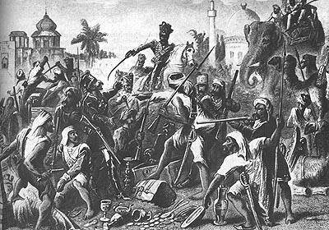
ANOTHER WEAKER NATION FOUGHT BACK!
The Sepoy Rebellion in India:
The British had taken control over most of India. The British East India Company dominated India during the late 1800’s. Great Britain would need men in India to keep the order in India, so they hired Indian soldiers known as sepoys to protect their trading interests. India was the “jewel of the crown” in the British Empire. As Britain continued to rule over India, the people of India had very little rights. While Britain did build railroads, modern communication systems, and schools in India, they also ignored the religion, culture and traditions of the Indian people. In 1857, rumors spread that the British made the Indian Sepoy soldiers use new gun cartridges which were greased with beef and pork fat (the cartridge ends had to be bitten off in order to be used). It was against the sepoy soldiers religions ( Hindu and Muslim) to bite into beef and pork. The Sepoys led a revolt known as the Sepoy Rebellion against the British. Following the uprising, which took a year to stop, the British government took back full control of India.

1. What nation had taken control over most of India?

2. Who did Great Britain hire to protect their trading interests?

3. Did Great Britain given the people of India rights?

4. What did the British ignore?

5. What were the new gun cartridges greased with?

6. What religions did the new gun cartridges violate?

7. In the end who still had control of India?

The Chinese strike back against imperialism!!
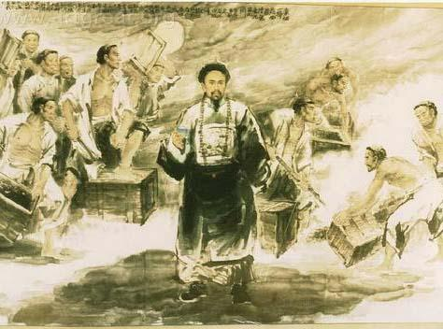
The Opium Wars and the Boxer Rebellion
The Opium War
The Opium Wars took place in China as a result of the imperial powers coming there. China was self-sufficient and isolated in the late eighteenth and early nineteenth centuries and therefore was not interested in buying goods from industrial nations. Great Britain, determined to open trade with China, found a product that the Chinese citizens willingly bought - opium. (OPIUM IS A DRUG!) China attempted to stop the opium trade, but was defeated. Their defeat in the Opium War signaled the beginning of the increase in foreign influence in China as the British forced the Chinese to sign a treaty allowing Britain to begin trade in China. At the same time, China was undergoing an internal rebellion, the Taiping Rebellion, in an attempt to establish a kingdom in which no one would live in poverty. This rebellion, combined with increasing Western influence, led to increased pressure on the imperial government to reform. Taking advantage of the internal struggles, Europe, Japan, and the U.S. increasingly gained economic spheres of influence in this region. In 1899, the United States declared equal trading rights with China with the Open Door Policy.

1. Where did the Opium Wars take place?

2. What product did the Chinese want to buy from Great Britain?

3. Was China able to stop Great Britain from selling opium?

4. What was the Taiping Rebellion?

5. Which three nations had spheres of influences?

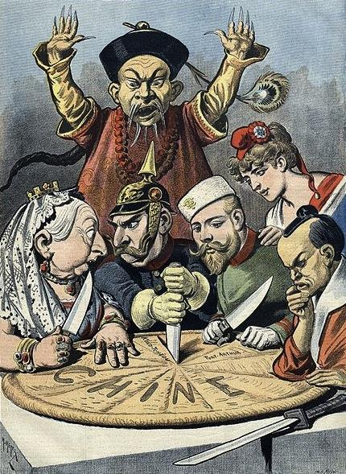
6. What policy did the United States create with China

The Boxer Rebellion
As a reaction to the new Open Door Policy. A group of Chinese people named the Boxers formed an organization which used martial arts to try to remove foreigners from Chinese soil. The Boxer Rebellion tried to rid China of all foreign influence. The Boxers did killing many foreigners and Chinese Christians, while also causing major damage to foreign owned shops and businesses. However, the Boxers were unsuccessful in removing foreign presence in China. The Boxers were defeated by an eight-nation alliance consisting of nations that had economic interests there. The Chinese government was forced to pay the nations involved for damages done by the Boxers in the rebellion, and the eight nations were allowed to maintain their spheres of influence. Although the rebellion was a failure, it did lead to an increasing sense of nationalism and need for reform in China.

1. What was the name of the Chinese organization who tried to remove foreigners from Chinese soil?

2. The Boxers used _________ arts.

3. The Boxers killed many foreigners and Chinese _____________________, while also causing major damage to foreign owned shops and businesses.

4. How many nations defeated the Boxers?

5. What did the Chinese government have to pay for?

6. Was the Boxer Rebellion successful?

Meiji Restoration
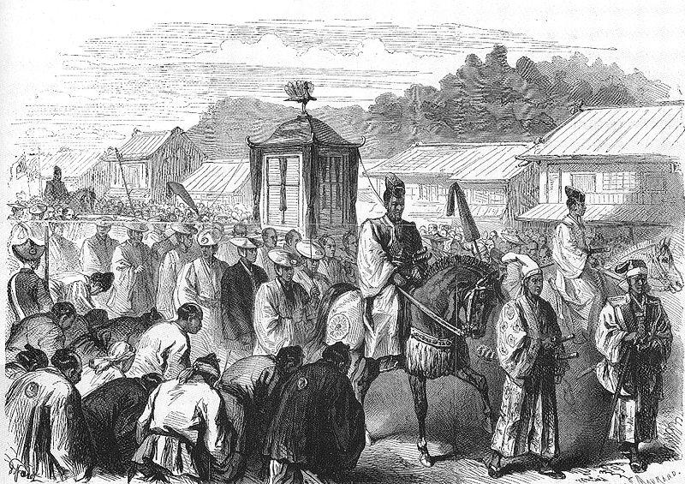
JAPAN DECIDES TO BUILD INDUSTRY AND
TAKE ON OTHER NATIONS!!

The Meiji Restoration in Japan was a response to Japan’s growing nationalism and desire to protect itself from imperial aggression it was witnessing. After being forced to open its ports to trade by the United States, the Japanese government decided to take progressive action in order to make its economy and military more like that of the Western powers. In 1868 the emperor of Japan took the title Meiji meaning “enlightened rule.” To respond to increasing imperial power in the region, the Meiji government decided to follow a Western model and even sent diplomats to study in Europe and the United States. These actions caused some negative reactions from conservatives in Japan, but the Meiji government continued its pursuits. Following these models, Japan was able to quickly industrialize and therefore began imperial conquests of its own.

1. Who was Japan forced to open trade with?

2. What powers did the Japanese want to be like?

3. What new title did the Emperor of Japan take?

4. Did Japan industrialize?

In 1894, Japan went to war with China in order to try to gain control of trade in Korea so that Japan could have access to raw materials and establish markets for their goods there. China had been in possession of Korea at the time. Japan was able to demonstrate to
China and the world its new industrial might by quickly defeating China in the Sino-Japanese War. Japan gained control of Korea as a result.

5. Why did Japan go to war with China?

6. What country did Japan gain control over?

Ten years later in 1904, Japan was once again able to show its power by quickly defeating Russia in the Russo-Japanese War. Russia wanted access to trade with Korea, but Japan was still in control of Korea. As the Russians sent a naval fleet headed to Korea, the Japanese navy met them at sea and destroyed much of the Russian naval fleet. After a short period of fighting, the Russians surrendered in 1905, acknowledging Japan’s sole right to Korea. The Meiji Restoration therefore successfully made Japan an industrial nation and changed its status becoming a world power with imperial claims and ambitions that rivaled European nations and the United States.

7. Who did Japan defeat in the Russo- Japanese War?

8. When did the Russians surrender? What did the Russians have to acknowledge?

9. Who was the Meiji Restoration successful?

*** Continue to next page

Imperialism: Good or Bad?
YOU DECIDE!

Directions: Read the following Pros and Cons about Imperialism. Choose whether you support imperialism or are against imperialism.
PRO (FOR) | CON (AGAINST)
In some places imperialism ended local wars. | Caused bitter feelings between imperial nations and the people they ruled.
Imperial nations set up schools and hospitals. | Native people were not typically allowed to hold high ranking jobs in the government or the military.
Imperial nations helped develop farming, industry and transportation. | Imperial nations thought they were superior to the native people.
Imperial nations spread Enlightenment ideas about human rights. | Manufactured goods brought in from imperial nations destroyed local industries.

Directions: Based on the information given above, are you for or against imperialism? Defend your answer. Answers should be at least a paragraph. You may write on the back.

________________________________________________________________________________________________________________________________________________________________________________________________________________________________________________________________________________________________________________________________________________________________________________________________________________________________________________

