**Sepoy Rebellion (India)**

* 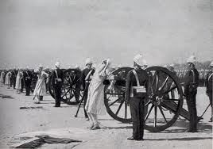______________________________________________ begins trading in India (1600), set up _______________________ for protection. Steadily built a ________________________ empire in _________________________.
* ________________________________________ were hired ______________________________________ for the East India Company.
* Didn’t like the British, felt they were fighting against their _____________________________________ and that the British were trying to _____________________________ them to ____________________________________.
* 1857, rumors that ___________________________________ were greased with cow and pig ___________________________. (__________________________ can’t touch pigs, _____________________________ believe animals are sacred).
* _______________________________ began, was put down by the British military in 1858.

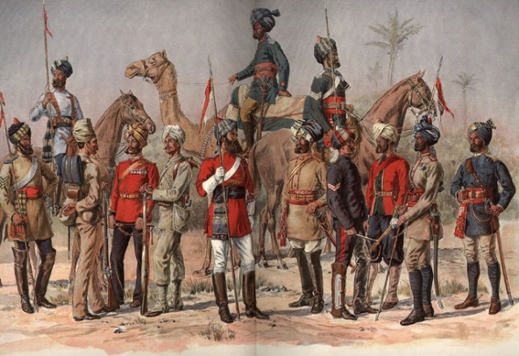**British Influence in India**

* British take control of __________________________ from the East India Company.
* __________________________ was sent to rule.
* India was called the _______________________________________ in the British Empire.
* To ease anger in India, the British built ______________________, _____________________________, ________________________, ________________________ lines, paved ____________________, and __________________________________ canals.
* British told the Indians to grow _________________________ (for the factories instead of ________________________)- leads to ________________________________________that kill millions.

**Africa During Imperialism**

* The race for Africa began when _________________________ claimed an area around the __________________________.
* Other Europeans joined the race to claim Africa.
* The _____________________________________________ of 1884-85:
  + 14 ____________________________________________ met to decide how Africa was going to be ________________________.
  + No _____________________________ representation
  + 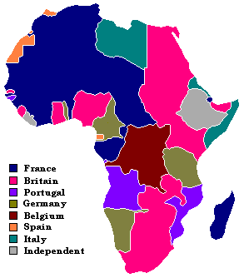Divided the continent with no regard to _____________________ or _____________________________ boundaries.
* Africa is easily dominated because the Europeans have _______________________________________________, and the Africans are not ___________ _______________________________________.

**Africa (North Africa):**

** Important natural resources include: ______________________________________

__________________________________________________________________________________

* ____________________________: Algeria, Tunisia, part of Morocco
* ____________________________: part of Morocco
* ____________________________: Egypt
* ____________________________: Tripoli
* Free: ____________________________________________________________________

***North Africa becomes important in World War II. This is where much of the fighting early in WW2 is centered.***

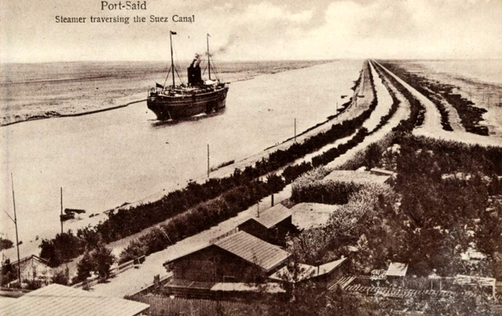**Egypt and the Suez Canal:**

* Europe needs a ________________________ route to trade with ________________________________
* _______________________ and ______________________ split the cost of the canal (52% vs 48%).
* Opened in 1869.
* Egyptians need __________________________ – sell their part to the ___________________________.
* The British navy ___________________________________ the French.
* Britain makes Egypt a _______________________________________.

**Zulu Wars (South Africa):**

* _________________________ take _____________________ port of Cape Town.
* The Dutch settlers (_____________________________________________________) moved inland onto Zulu land.
* Zulu _________________________________________ defeated the Boers in 1816.
* Zulu ____________________________________________________ stood up to the ___________________________________ in 1879, fought for __________ months (Zulu War).
* 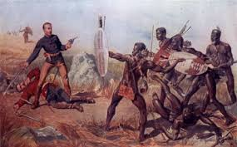British won, annexed ________________________________________________

______________________________________)in 1887.

**Opium Wars (China):**

* China had been _______________________________________ since the era of colonization.
* The British were determined to open _____________________ with China, so they began to trade the drug _________________________________.
* The Chinese ______________________________ outlawed the sale of Opium and the British _________________________________.
* There are two separate ________________________ (1839-1842), (1856-1860). The Chinese ____________________. They are forced to _____________________ with the British, and they lose the city of ____________________________________to the British.

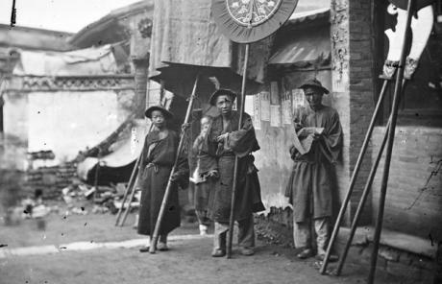

**China**

China was weakened by the following:

1.

2.

3.

4.

5.

* Leads to the_________________________________________________– an internal rebellion which attempted to establish a kingdom where no one lived in ________________________________________.
* Europeans want access to the _______________________________________ in China.
* U.S. proposes the _________________________________________________________, all countries have an ________________________ opportunity to ____________________ in China.

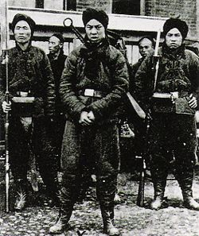

**Boxer Rebellion (China):**

* China started ____________________________________________________ to kick out Europeans (tired of Europeans trying to spread ______________________________).
* The Society of the ______________________________________________ (______________________) attacked foreigners in 1900.
* ______________________________________________________________________________

______________________________________ and ___________________________ sent troops to stop the rebellion.