**Motives:**

* Needed ____________________ to sell the _______________________ made in their factories
* Needed the ______________________________________ for their factories
* Establish _________________________________________________________
* Benefit smaller countries with _______________________________________
* ___________________________________ – idea of “survival of the fittest”; the ____________________ nations should survive while the weaker nations should be _____________________________

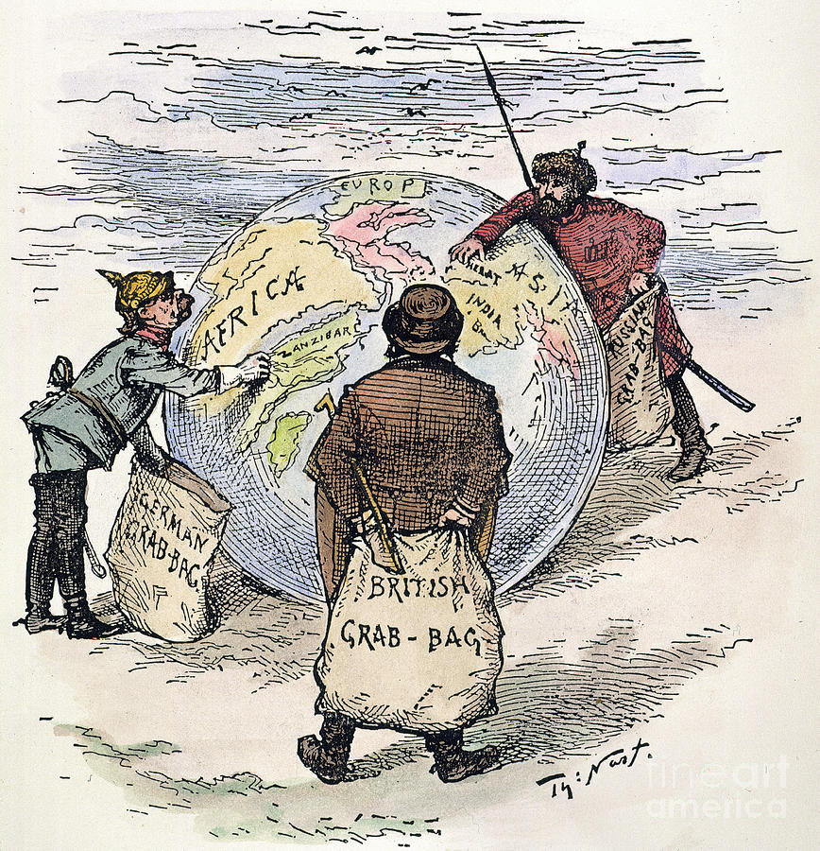**Imperialism Controversy:**

**Pros:**

* Ended __________________________________________________________________________
* Set up __________________________________________________________________________

__________________________________________________________________________

* Encouraged __________________________________________________________________________.

**Cons**:

* Others felt that the _________________________________________ had a duty to spread their_______________________________________________ __________________________________________________________________(Rudyard Kiplings “The White Man’s Burden”)
* Kept _________________________________________ from moving _________________________ in society.
* Imperial country thought themselves _______________________________.
* Destroyed ____________________________________________________.

**Types of Government**

* _________________________ – ____________________________ by the imperial nation
* _________________________ – protected by the imperial nation’s ____________________________
* ________________________________________ – imperial power was the only one that could _____________________ in the region

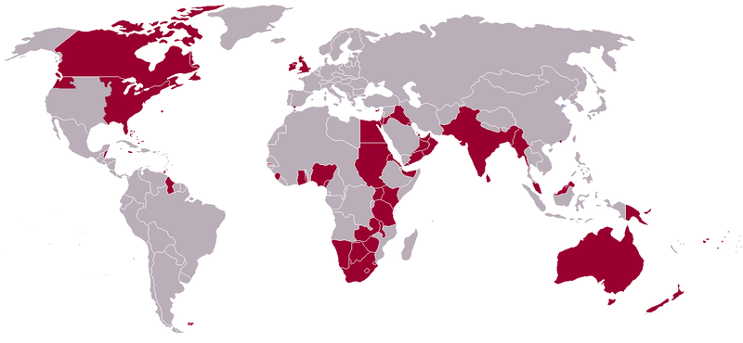

**European Nations In Asia**

**England:**

* Singapore (1819), New Zealand (mid-1800’s), Australia (1770), Burma, India (1600) – East India Company
* “The sun _________________________________________________________

________________________________________________________________.”

**France:**

* ________________________________ (1884): French Indo-China

**\*\*\****Siam (________________________): The only Southeast Asian country to remain ___________________________________.*