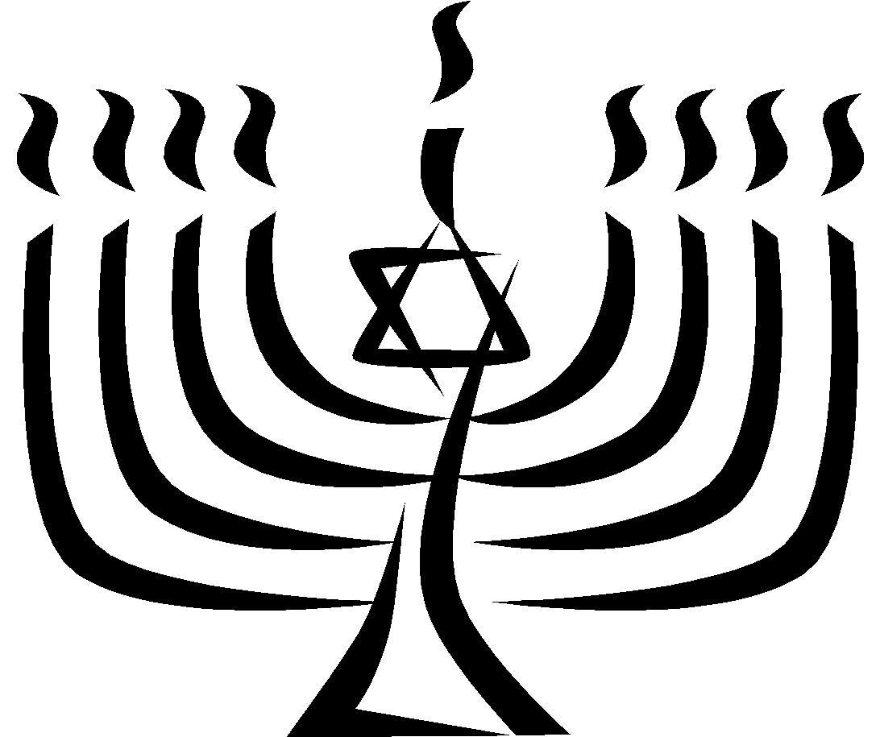
The Holocaust Memorial Project

You have a choice of two different projects that you will work on at home. We will have limited time where you can research in class. Here are the choices:

1. Create a Holocaust Memorial
You are a famous, successful architect or artist living in a city that wants to create a Holocaust Memorial. You are given the contract to CREATE a memorial to the 6 million Jewish people and 5 million others that perished during the Holocaust before and during WWII. The city has given you “creative license” to come up with any type of medium that can be displayed in public. You can create a monument, large painting, mural for a building or a design for a city park where there will be different spots honoring these people.
-You are to be very detailed with this memorial using any symbols that are appropriate for honoring these people.
-If you draw or paint, the drawing, painting or park plans need to be on poster-size “art paper.” Drawing can be a rubbed sketch with pencil but any other kind of drawing will need color to finish your creation.
-If you create a 3-D project, it should be larger than 12 inches all the way around. You may use whatever materials necessary.
This will be graded using an appropriate Art rubric.

2. Honor one of the “Righteous Among the Nations”
There were many people who helped during the Holocaust. These people saved Jewish people by hiding them, smuggling them out to other countries, getting them fake passports and rescuing and caring for Jewish children who were left behind. These people are honored in the “Yad Vashem Memorial” in Jerusalem, Israel. You will be given a name from their database and will need to research and write at least a 2-page typed paper (or 4 page handwritten) entitled “Why ________________Changed the World.” Your paper should include:
(name of person)

- Introduction paragraph
- 1st Body paragraph: The situation around the person where they lived in Europe. Where did they live? What was the situation there with the Nazis? Had the country been taken over…etc.
- 2nd Body paragraph: What the person did to help and provide lots of detail.
- 3rd Body paragraph: What happened to them during and after WWII? Did they get caught? Did they survive? How did they live their life after and where did they live?
- 4th Body paragraph: Why their actions still affect people today.
- Conclusion
- Bibliography with all sources used in MLA format (www.easybib.com helps)
- If there is a photo of the person available, please print and add it to the Title page of the paper so we can display it on our “Wall of the Righteous.”
This will be graded using the PASS Writing Rubric.
Typed: at least 2 pages, double-spaced, 12 point, Times New Roman font
Handwritten: at least 4 pages, single-spaced

Due on or before: Friday, March 31
Any late submissions will have 10 points taken off for each day it is late.

Option #1: Criteria for Grading Art Projects / Assignments

100 | 95 | 90 | 88 | 84 | 80 | 78 | 74 | 70 | 68 | 64 | 60 | 59 and below
A+ | A | A- | B+ | B | B- | C+ | C | C- | D+ | D | D- | F
Exemplary |  |  | Above Average |  |  | Average |  |  | Below Average |  |  | Unsatisfactory
Outstanding |  |  | Very Good |  |  | Good |  |  | Needs Improvement |  |  | Poor
Excellent |  |  | Effective |  |  | Acceptable |  |  | Barely Acceptable |  |  | Unacceptable

Concept:
The student:
A planned the project/assignment carefully, made several sketches, and demonstrated a strong understanding of the goals of the project/assignment.
B planned project/assignment adequately; demonstrated an adequate understanding of the goals of the project/assignment.
C completed the project/assignment marginally; project/assignment exhibits a lack of planning and little evidence that the overall goals of the project/assignment were addressed.
D completed the project/assignment, but showed little evidence of any understanding of the goals of project/assignment; no evidence of planning.
F completed a minimum of the project/assignment or the project/assignment was never completed.

Originality
The student:
A explored several choices before selecting one solution; generated many ideas; tried unusual combinations or changes in several ideas; made connections to previous knowledge; demonstrated outstanding problem-solving skills.
B attempted a few ideas before selecting one solution; or based his or her work on someone else’s idea; made decisions after referring to one source; solved the problem in a logical way.
C attempted one idea, and developed it adequately, but the assignment lacks originality; substituted “symbols” for personal observation; may have copied work.
D fulfilled the project/assignment, but provided no evidence of trying anything unusual.
F showed no evidence of original thought.

Craftsmanship
The student:
A completed the project/assignment beautifully and patiently.
B could have applied more effort to create a well-crafted artwork; lacks finishing touches.
C demonstrated average craftsmanship; adequate, but not as good as it could be; a bit careless.
D used below-average craftsmanship; lack of pride in finished project/assignment.
F used poor craftsmanship; evidence of laziness or total lack of understanding.

Option #2: Writing Rubric

4 points: Content/Development ________________________________________________
4 points: Organization ________________________________________________
4 points: Conventions ________________________________________________
3 points: Voice ________________________________________________

15: 100 14:94 13: 88 12: 82 11: 76 10: 72 9: 66

