King Henry VIII
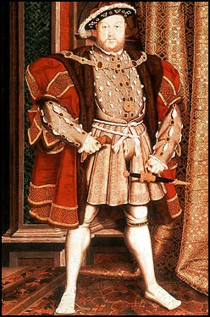
Objective
To gain employment as the King of Ms. Lasater’s classroom.
Experience
Second Monarch of the Tudor Dynasty
- Second monarch in the line of Tudor rulers in England.
King of Ireland
- Made king of Ireland and supreme head of Irish church in 1540 by an act of Irish parliament.
Accomplishments
Defender of the Faith
- Awarded this title in 1521. Authored a book attacking Martin Luther and supporting the Roman Catholic Church.
Naval Improvements
- Increased Royal Navy’s size from 5 to 53 ships during reign. Elizabeth I’s success over the Spanish Armada would not have been possible without these improvements.
Act of Supremacy 1534
- Cut off papal power and influence in England. King recognized as the head of the true Church of England, the ‘Anglicana Ecclesia.’ Dissolved monasteries during the English Reformation, improving Crown revenue by selling off land previously reserved for monastic use.
The Ten Articles 1536
- Articles relating to doctrine and ceremonies to unify the newly-formed Anglican Church. ‘The Ten Articles’ and ‘The Six Articles’ helped unify the Church and the religious ceremonies people participated in. Also allowed Thomas Cranmer to publish the English Book of Common Prayer- a collection of hymns and liturgy to use in the Anglican Church.
Captured Boulogne
- Joined Charles V, Holy Roman Emperor, in invading France in September 1544. Peace between England and France (because Charles V abandoned him after capturing Boulogne) was achieved in 1546.

References
Thomas Cranmer, Archbishop of Canterbury
- A leader of the English Reformation. Built a favorable case for Henry VIII’s separation from Catherine of Aragon. Supported the principle of royal supremacy- Henry VIII was had all power over the Church in his own realm (England).
Katherine Parr, Queen of England
- Reunited Henry VIII with his children. Appointed regent in Henry VIII’s absence when he went to invade France in 1544. Debated with Henry VIII over theology. Shaped and nurtured Queen Elizabeth I who ushered England into its Golden Age.

