**Russian Revolution**

* By 1917, Russia is in crisis:
  + 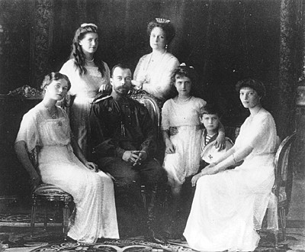Lack of _________________ and _______________ for peasants and workers
  + ___________________________ of men in WWI
  + High ________________________
  + Poor ________________________________
* March 1917 __________________________ (led by women), ______________ join them
* ____________________________________ (Romanov dynasty) abdicated

**Russian Revolution**

* _________________________________________ (Duma) is set up. They are pre-occupied with the war.
* Workers formed “_______________________” to represent their interests. Many were socialists: ____________________________________________________

_________________________________________________________________

* The most radical of the soviets were the ______________________.

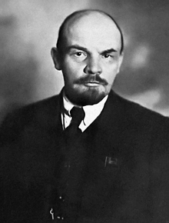**Russian Civil War**

* ___________________________________ is the leader of the ______________________________ (Communists).
* Promised to take Russia out of war. A ________________________ is arranged in December 1917.
* Russia signed the _________________________________________with Germany March 1918. The Russians are forced to __________________________________ to Germany, including land in ___________________________.

**The Russian Civil War**

* Bolsheviks (_____________________) took control by force.
* All ____________________ to Bolsheviks (_________________).
* _________________________________________ begins.
* Last for 3 years – killed _______________________ and burned _________________________
* ____________________ win in 1921, Russia becomes known as the ____________________________________________________________ (USSR) – Communist.

**The End of World War 1**

* ___________________________________- U.S. forces shatter the German army.
* _____________________________________ are thrown into _____________________.
* Germany signed an ________________________, cease-fire, November 11, 1918.

**The Big Four “Three”**

* 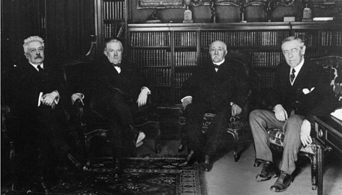Meet in ___________________ to decide the terms of the peace treaty (January 1919).
* President Woodrow Wilson (__________________________)
* Prime Minister David Lloyd George (____________________________)
* Premier Georges Clemencaeu (____________________________)
* Prime Minister Vittorio Orlando (______________________)

**Wilson’s Fourteen Points**

* Wanted a lasting peace and reasonable terms.
* His Fourteen Point proposal included ideas to __________________________. causes of WW1 (no ____________________________________, no secret _________________________, the right to _________________________________ (a country could determine its own political and economic systems).
* Didn’t want to __________________________ the Central Powers.
* The only part of Wilson’s plan to be adopted was the *___________________________________* – a peacekeeping organization of countries set up to __________________________________________.

**Treaty of Versailles**

* ________________________________________: Germany must ___________________________________ for starting the war.
* Pay _______________________________ (war damages)
* __________________________________________________ to 100,000 soldiers
* No ________________________________
* ___________________________________ of the _______________________
* Loss of _________________________________________________ (area bordering France and Germany)

**Changes of Territory**

German, Austria-Hungarian, and Ottoman Empires are ________________ up to create ________________________ in Eastern Europe and the Middle East. The nation of _____________________ is created in the Balkans that included many ____________________________, including Serbia.

**Ottoman Empire After the War**

* 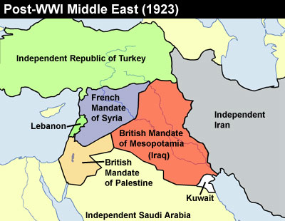The Treaty of Versailles broke up the _________________________, created ____________________ (territory _____________________________________)
* _______________________________ controlled _____________________________________
* __________________________ controlled ________________, ___________________, and _________________________.
* *________________________________* - The British promise the ________________ a new __________________ of their own in _________________________ (the area of the Jewish homeland during Biblical times)…the problem is there are Arab people who have been living there for many centuries!!!

**Problems With the League of Nations**

* Not all major powers ___________________ the League. (ex. ____________ didn’t join because we were afraid it would force the U.S. to fight future wars , _____________ and _______________ not allowed)
* Had ___________ real authority to ___________________ its ideas.
* Required ________________________________________ to do anything.

