Weapon | Impact
__________________ | First time in war. Used mostly for _____________________ on enemy troops. Eventually carried bombs and guns to fire on troops.
__________________ | Fired on enemy navy ships and merchant vessels. German subs called _______________.
__________________ | Took 4-6 men to operate. Could fire 400 bullets a minute (= to 100 guns).
____________________  ____________________ | Took up to 12 men to operate. Could shoot up to ______ miles away. Terrorized troops well __________________fighting lines.
____________________ | Used toward the end of the war. Could roll through ________________________. Provided ______________________ for attacking soldiers
____________________ | Shot fire at troops and into ____________________________
____________________ | _________________ gas: Suffocates a person; _____________________ gas: burns/blisters any exposed skin
Modern Weapons

Modern Weapons, cont’d.

- Factories were __________________________ weapons for the war.
- Increased deaths and casualty (__________________) rates for soldiers and civilians:

U.S. Entry Into War

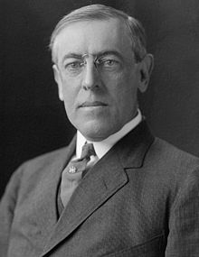
- President __________________________________ wanted to remain neutral. (_____________________________)
- At first, we ____________________ and made _________________ to both ___________________ and __________________________.
- U.S. supported a British _______________________ of Germany (_________________________________)
- Germans retaliated with _________________________.
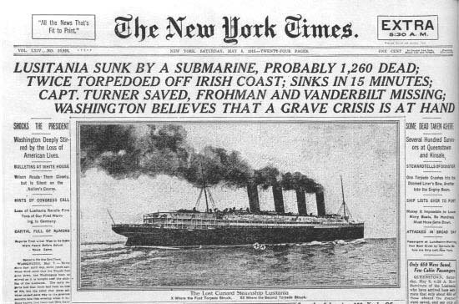
- In 1915, Germany fired on the British passenger ship, the ______________________.
- 1,200 people died, including ___________________________.
- Americans are angry, but Wilson ____________________________.
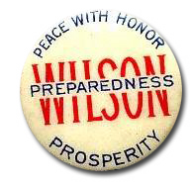
U.S. Entry: Zimmerman Telegram

- 1916: Germans promise to give _________________ to U.S. boats before _______________________them
- January 1917: _________________________________________ discovered. German official sends telegram to German ambassador in ___________________. If Mexico becomes __________________________ with the _______________________ and ______________________ the U.S., they would win back ______________________________________________________ once the war was over.
- February 1917: Germany starts ______________________________________ without warning.

U.S. Entry
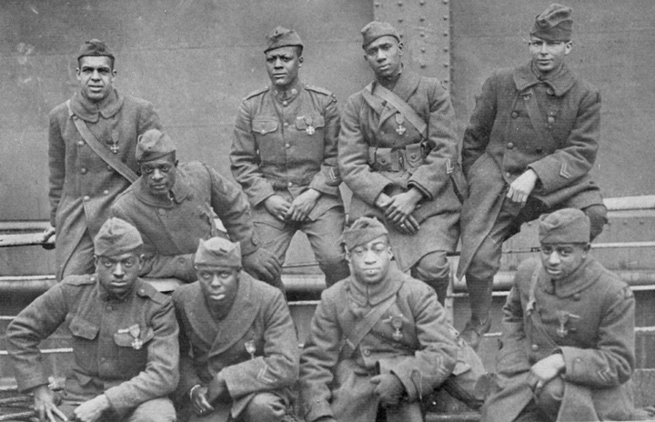
- U.S. declares _____________ April 6, _____________
- First soldiers, “_____________________” arrive in France in June 1917.
- May 1918: over __________________________ U.S. soldiers in _________________

