***World War 1 – also known as __________________________________ and __________________________________________________________

Causes of War: M.A.I.N.
- M – Militarism: ____________________________________________
- A – ________________________: Agreements among varying nations to help each other out
- I – Imperialism: Building ______________________________ and competition for _____________________________________________
- N – _____________________________: Loyalty to a nation

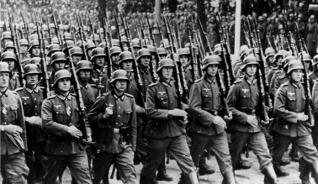
Militarism:
- A huge _____________________________ in the European countries – they were _____________________________________________during the time of Imperialism.
- Huge armies in ____________________, ___________________, and _________________.
- Naval buildup in ________________ and ______________________
- Many countries used “____________________” (a draft) to ________________________________________________________.
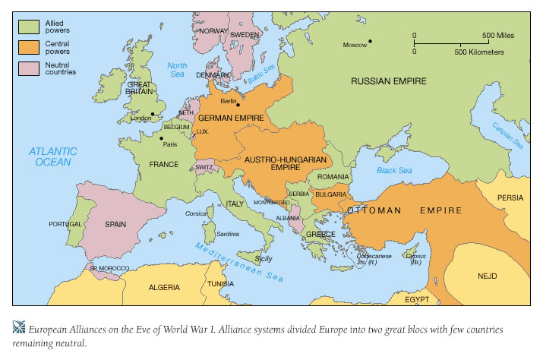
Alliances:
Allies: ______________________________________________________________________________________(a.k.a Triple Entente)
***(Belgium and Italy)

Central Powers: ________________________________________________________________________
***(Italy)
Imperialism:
- _____________________________________ around the world.
- Needed ________________________and new __________________ for trade.
- Led to huge _________________________, particularly in Europe!

Nationalism:
- Nationalism: ______________________________________________________
- Due to ____________________________, some individuals within a country’s borders felt more ___________________________________________________ than with the larger nation.
- _________________________________________________ among some European people/regions (ex. Serbia and the Slavs on the Balkan Peninsula)

“The Powder Keg” Ignites!
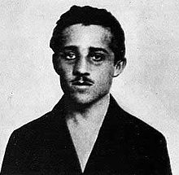
- The __________________________ was a Serbian Nationalist group committed to ________________________________________ from Austro-Hungarian control.
- Gavrilo Princip (19 years old) __________________________________________________________ (heir to the throne in Austria-Hungary) and his wife on a trip to Sarajevo, Bosnia.
- _____________________________________ declares ____________ on Serbia!

How are the monarchs of Russia, Germany, and Great Britain connected?

Austria-Hungary declares _______________ on Serbia.

_______________ mobilizes to support Serbia.

_______________mobilizes to fight _______________

_______________ declares war in support of _______________
________________ declares war on _____________ after ______________ is invaded
Outbreak
of War

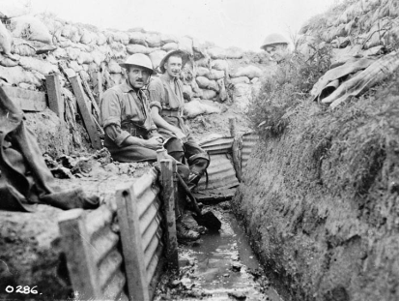
War Begins:
- Two front (line where opposing sides fight each other) war: _________________ Front on the __________________________ ___________________ , and the ______________________Front in _____________________ and ___________________.
- Western Front used _________________________________ (fighting in ____________________)
- Trenches stretched from the __________________________________ to _______________________________________

