***Congress of Vienna***

* 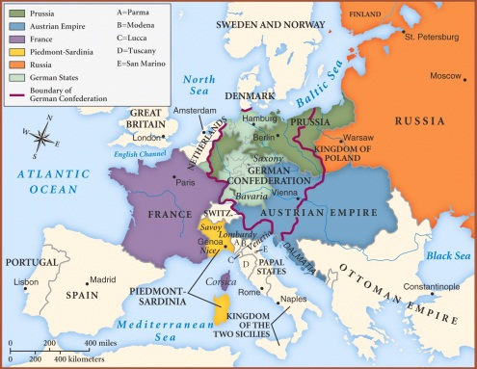The Congress of Vienna was a meeting of the _________________________ where:
  + All ___________________ taken by Napoleon were __________________ to the nation’s which they originally belonged.
  + Reinstated the ___________________________ of Europe back to the throne to _____________________ Europe.
* People wanted a change in government though, so it led to two things:
  + _____________________ (people of common culture from different states were joined together)
  + ________________________ (groups split from their current government to form one that reflected their own interests)

***Nationalist Movements***

1830’s

* _________________________ gets independence from the Ottoman Empire (1st __________________________________________________ in Europe).

* Belgium, Italy, and Russia attempt ________________________.

1848

* Italy begins _______________________.
* France overthrows the _______________ and establishes a ______________________: elected a president and established a parliamentary system (elected representatives).

***Italy***

* 1848- Italy divided into ____________________, most controlled by ___________________
* In Northern Italy, Piedmont was ________________________
  + 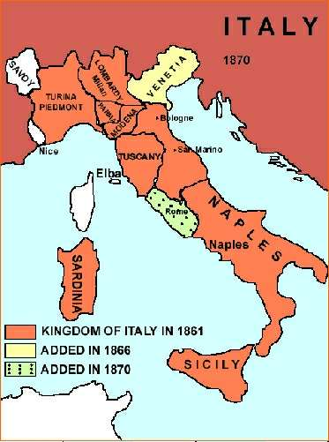_______________________________________ and ______________________________________ want to __________________ Italy
* France helped Piedmont get freedom for the northern Italian states in exchange for territory gained from Austria.
* Guiseppe Garibaldi (leader of the __________________________________) used _____________________________ (hit and run fighting) in southern Italy.
* 1861, the south votes to join the north – Italy is _______________________, except for _________________________ (controlled by the pope)
* 1870, Rome joins Italy.

***Germany***

* 1815- Germany made of _________________________________
* 1860’s – Many Germans want to unite
* ____________________ is the ____________________ and strongest __________________ state
  + 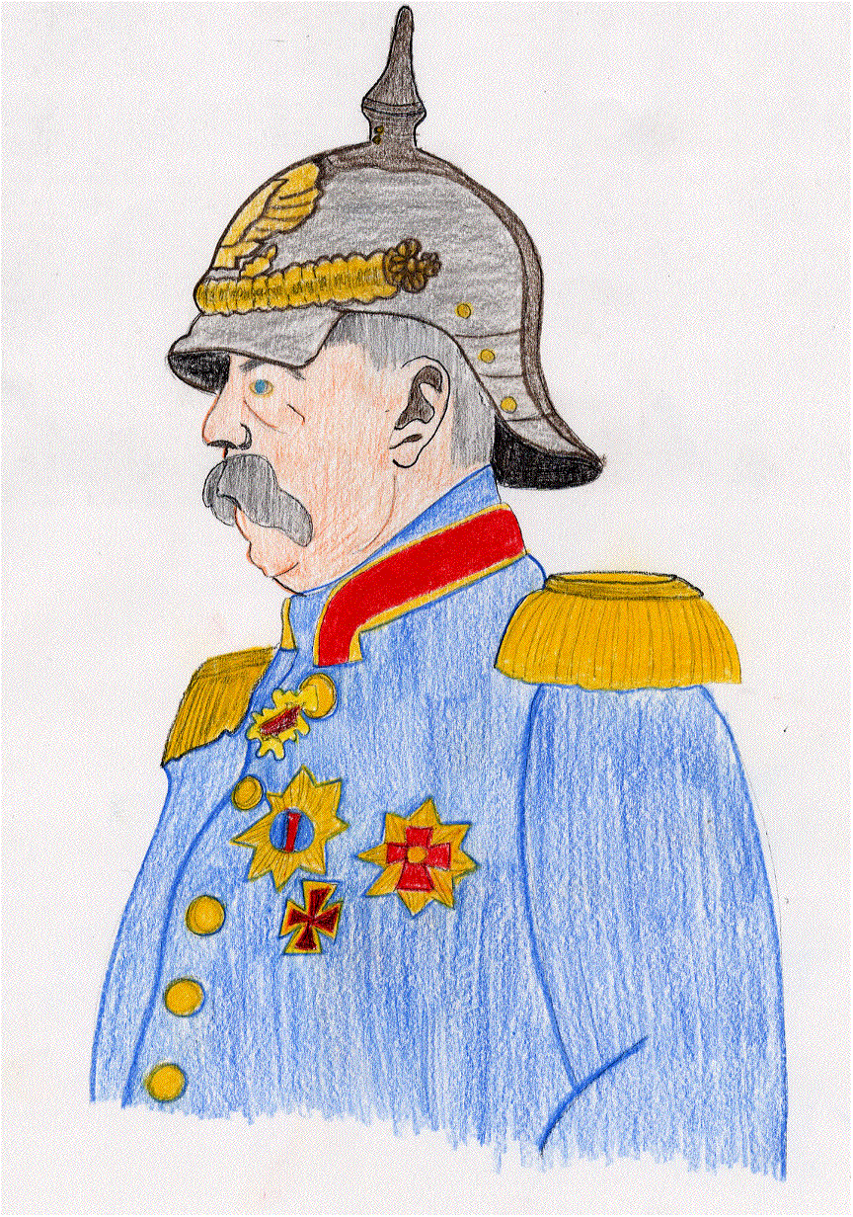______________________ appointed _________________________ as Prime Minister – goal to ______________________________________
* Bismark ruled under a system called “__________________________” – the politics of reality. (Decisions would not be made by _________________________ but through _______________________ strength and fighting).
* Used ___________________________________ (military) to unify Germany
* Bismark and Wilhelm led three wars:
  1. Defeated ___________________________ (Austria and Prussia formed an alliance to take land from Denmark)
  2. Defeated ______________________________ (created border conflicts so that Austria would declare war – ________________________________________)
  3. ______________________________________________ (against France) – Bismark changed the wording of the Ems Telegram to make it look like Wilhelm I had insulted the French ambassador to Prussia. ___________________________ declares war and __________________________.

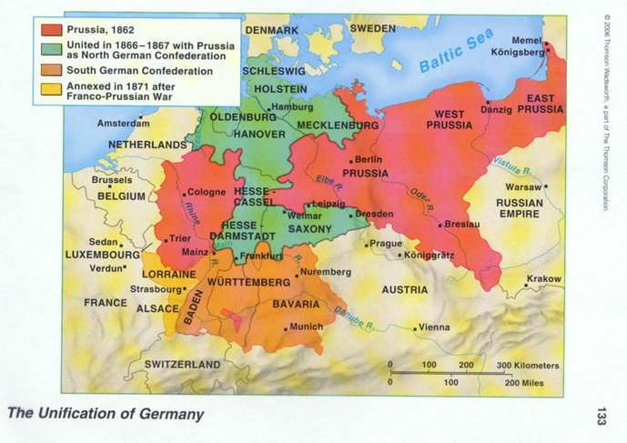

* ***Germany becomes the ____________________________________________________***