Building a Relationship
- Asia had strong _____________________with strong ________________, in addition to highly advanced and prosperous societies.
- Europeans viewed the Asians as their _________________________.
- Europeans were allowed to build ____________________________ along the coasts of Asia.
Trade
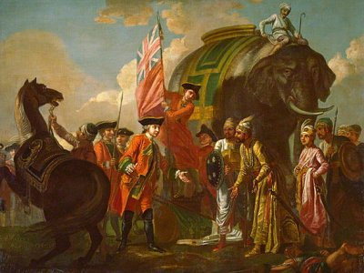
- Asian countries became dependent on ________________ with Europeans to make ______________.
- Asians wanted ___________________________, firearms, and ____________________________________________ from the Europeans.
- Trade with Europe also created a _________________________________________.
- _______________________________________ were built in Asia! It was all about __________________________!

Effects of Europeans in Asia
- Prior to the Europeans’ arrival, Asian countries had remained _____________________ (countries did not interact with one another).
- Trade prompted the sharing of _____________________________________________ between different Asian nations.
- Europeans began sending ____________________________________________ to Asia.
- This offended many Asian ______________________________, so eventually trade and contact with the Europeans was _________________________ and countries became isolationist again. (The _____________________________________ are allowed to stay!)
Summary Statement: ________________________________________________________________________________________________________________________________________________________________________________________________________________________________________________________________________________________________________________________

