The Americas: Who Came?

_________________ _________________

_________________ 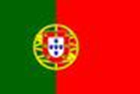 _____________________
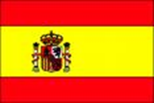 ______________________

American Colonies

The British, French, Dutch, Spanish and Portuguese established three different types of colonies:
- ______________________________ colonies
- ______________________________ colonies
- ______________________________(permanent settlement) colonies

The type of colony depended upon the:
- ________________________
- _______________________ location
- Time period
- The ___________________ available

The Spanish and the Portuguese
- Discovery of gold and silver combined with their social class system allowed the Spanish to dominate large parts of the Americas.
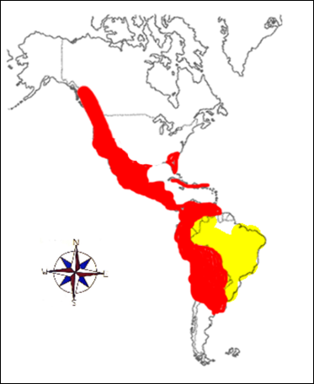
- Both Spanish and Portuguese mainly established _________________________________.
- Colonies established to grow and sell _______________________________________
- Grew “cash crops” – crops grown in large amounts to sell.

The Dutch and the French
- The Dutch were the first to colonize and set up trading posts in South America.
- These colonies were not successful.
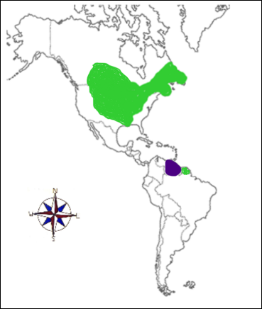
- Both French and Dutch established ____________________________________ Colonies.
- Established to _______________________________________ (trade).
- The ____________________ had a good relationship with the ______________________ and traded furs with them
- Their colonies were usually set up along water ways.

The British
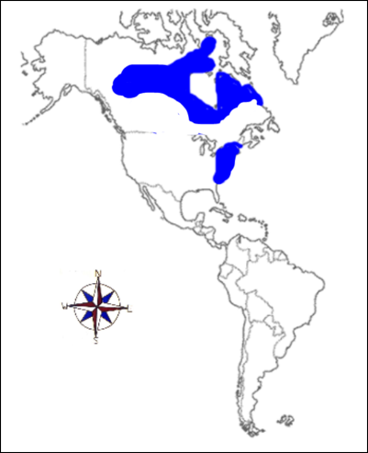
- Mainly established ____________________________________ Colonies. Established for _________________________ habitation (living).
- Geographic Location: North America and the Caribbean
- Started for trading, but eventually grew into ______________________. For example: _________________________________
- Many Europeans, such as the Pilgrims, came looking to start new lives and gain __________________________________________
- Some of these colonies had __________________________ systems which grew crops like ________________, ____________________, _____________________, and sugar.
Government in the Colonies
- _________________________________________________ – ruled the colonies with the monarchy. The king sent ___________________________________________ (royal representatives) to monitor the colonies.
- _______________________________________________ – were not strict and allowed the colonists choices in the political decisions.
- _____________________________ – set up ______________________________________________ where colonists could choose representatives to participate in the decision making.

