**Colonization in the Americas:**

* Unlike Asia, different types of ___________________________ were set up in the Americas.
* 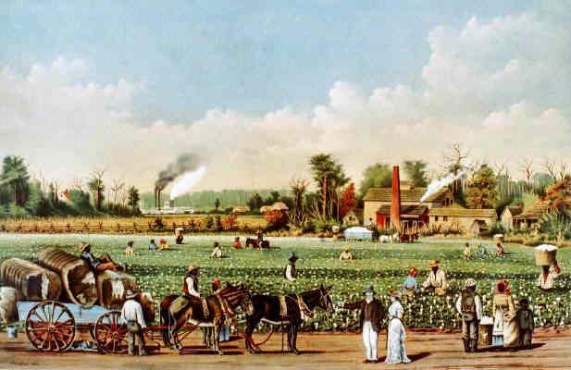______________________________________________________ set up _______________________________ colonies in Central and South America which grew _______________________________.
* The French and Dutch also set up some plantation colonies in the Caribbean.
* The ______________________________ set up plantation colonies in the _____________________________________________________ which grew _____________________________________________________________, and some sugar cane.

**Labor Shortage**

* The new colonies needed a great deal of ___________________.
* Labor was especially needed on the **plantations -** large estates that produced ________________________________.
* At first ________________________________ were used but this was unsuccessful for two reasons:
  1. They lacked **_____________________**- the body’s ability to resist infection, and they ________________ off by the thousands.
  2. Also they were more capable of _____________________ because of their familiarity with the land.

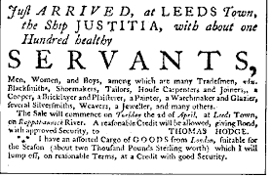

**Labor Shortage**

* Next Europeans tried the **___________________________________________** system.
* An **indentured servant** signed a ________________________to work for a set number of years to pay off __________________________________ to the New World.
* British indentured servants were known as **____________________________________**.
* 25% of indentured servants were ________________________ sent to the colonies to pay off their debts to society (ex. Colony of __________________, ________________________ were penal colonies).
* Not enough Europeans signed up to be **indentured servants**.

**Labor Shortage**

* With such a high demand for labor and lack of success with Native Americans and **indentured servants** Europeans began to _____________________________________.
* African slaves could be obtained at _____________________________________ set up on the African coast.
* This began what would be called the **__________________________________________** - the capture and transport of Africans into bondage in the Americas.

**Slavery Within Africa**

* Europeans did not invent slavery. In fact an active slave trade existed in Africa. More than _________ kingdoms took part in this trade. They sold ______________________

______________________________________________________________________.

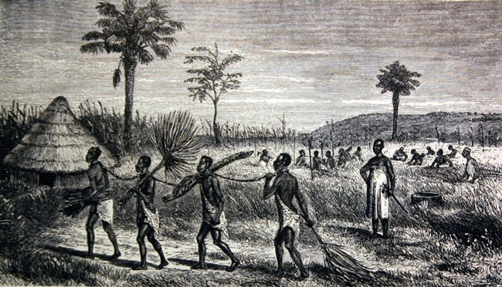**European Slave Trade**

* When the European’s got involved in the slave trade they did not go and _____________________________ on their own.
* Rather they dealt with cabocceers – special _____________________________________ appointed by the government to exchange enslaved people with Europeans.
* They met the Europeans along the ______________ and traded men, women and children for_____________________________________________________________.

**European Slave Trade**

* _________________________________ was the first country to begin trading for slaves.
* They used the slaves to work on their sugar cane plantations.
* By the 1500s Portugal was the world’s largest ______________________________ producer.
* The rest of Europe followed Portugal’s lead and soon all of the colonial powers would be using slave labor.

**Triangular Trade**

* The ____________________________________________ over the next two centuries became known as the **_________________________________________**.
* The trade routes formed three legs of a triangle.
  + 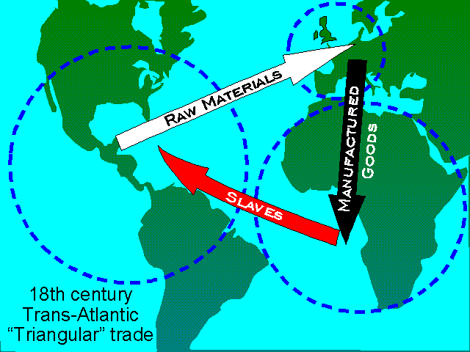1.From _____________________________ to __________________________ (traded __________________________ for a cargo of ______________________)
  + 2. From ________________________ to the ______________________________ (traded _________________________ for money and used money to buy goods such as _____________________________________________________________)
  + 3. From the _____________________________ to ________________________________ (traded the goods received in the America’s for a huge profit).

**The Middle Passage**

* The middle part of the Triangular Trade was known as the ________________________.
* 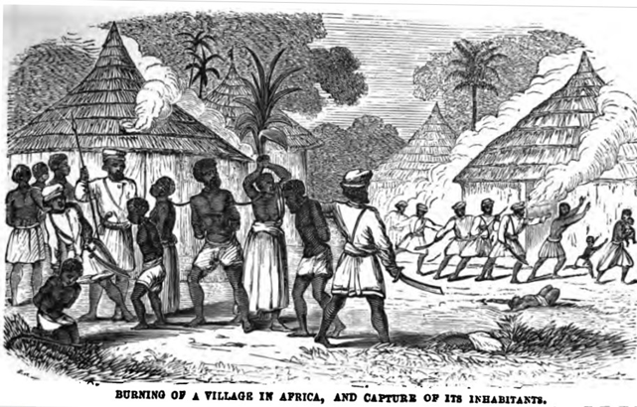This was the part where __________________ were brought from Africa to the Americas.
* They were crammed into the ship’s cargo hold and typically chained down.
* __________ out of ___________ who started the journey never made it to the Americas**.**

**Impact of the Slave Trade on Africa**

* Increase in ____________________________________
* Major _________________________________________
* __________________________________ led to dissolving of many African tribes and communities
* Families were separated

**Resistance**

* Some Africans began to oppose the slave trade.
* ___________________________________________________________ increased in Africa.
* In the America’s, enslaved __________________________________________ and formed runaway communities known as **maroons**.
* In 1840 and 1841 Africans led ________________________________________________________________, the ________________________ and the Creole.

**Trading Post Settlements**

* The Dutch established trading posts in __________________________ (northern South America).
* The _____________________________ established trading posts in North America with the Native Americans and _____________________________________.
* The French and the Indians got along because the French did NOT try to ________________________ the Native Americans to _________________________________ and respected the Native Americans’ ________________________________________________________.

**Permanent Settlements**

* The British establish permanent settlements along the east coast of North America.
* ____________________________________ is the first English permanent settlement.
* 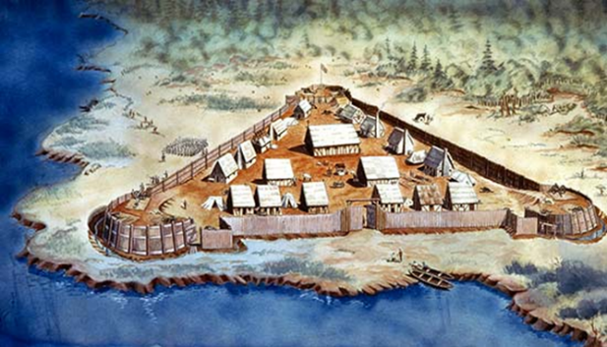They bring boat loads of people to _______________________ and _____________________ in the colonies.
* The British began to offend the Native Americans by:
  1. Trying to convert them to Protestantism (__________________________).
  2. Taking over their ____________________________________________.
  3. ____________________________________________________.

**Summary Statement: __________________________________________________________________________________________________________________________________________________________________________________________________________________________________________________________________________________________________________________________________________**