Columbian Exchange
- Europeans began trading with the world after the age of exploration.
- This began what would be called the ____________________________________________.
- Columbian Exchange- the movement of ________________________________________________________________________________________________________________ across the Atlantic.

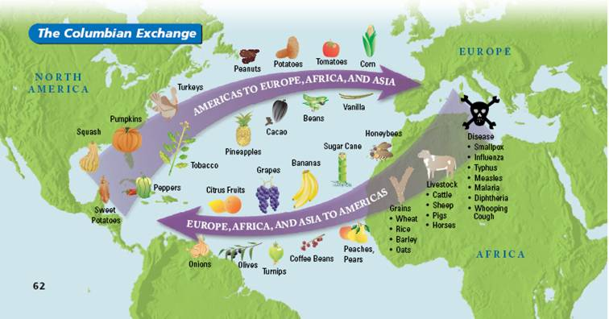
Commercial Revolution
- The Columbian Exchange led to what is called a commercial revolution.
- ______________________________- is the buying and selling of goods in large quantities over long distances.
- ______________________________________- refers to the amount of a product available for purchase and _________________________________- how many people want that product. (If supply is high and demand is low, a product is ________________________. If supply is low and demand is high, a product is more __________________________________.)
Capitalism
- Capitalism – ___________________________________________________________ and production for a profit. (People own a business to make their own money!)
- _____________________________ regulates _________________________ (_________________________), but _________________________________________________ that are doing the trading (capitalism).
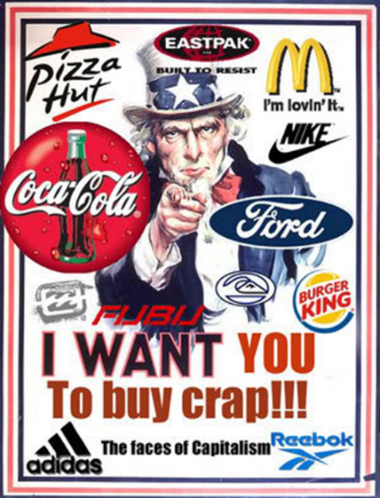
- This leads to a ______________________________________________________ of merchants and ship owners.
Risk
- Commerce led to the rise of the entrepreneur.
- _____________________________________- risks money in hopes of earning a _________________.
- Some risks were too large for one person so _______________________________________________ were created.
- Joint-stock company- allowed individual entrepreneurs to ______________________________________________, or shares, in a company.
- Wealth from trade brought about a new social class- a group of people who share similar position in society.
- ______________________________________________- group made up of _____________________________________________

