Mercantilism
- ______________________________________- was the new economic theory for how trading nations could earn wealth. The theory stated that a nation became more _________________________ by building up a large supply of ___________________, or gold and silver.
- Some gained bullion by taking over gold and silver mines but most achieved this through ______________________________.
Mercantilism: How it Works
Step 1: ____________________________________________________________
  - A country needs to ___________________________, or sell goods to another country, more than it _____________________, or buys from them.
  - Mother countries sought to create a more _____________________________________________________: the value of the exports is more than the value of the imports.
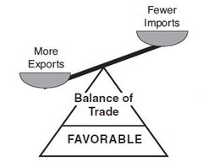
(Favorable balance of trade = export >import)
  - This allowed countries to build big supplies of ________________, thus making the country very ___________________________.
Step 2: ________________________________________!
  - Colonies were critical because they provided the Mother Country _______________________________________________________, and then the Mother Country could turn around and ________________________________________________________ back to the colonies for a _______________________________.
Step 3: _________________________________________ (taxes)
- Countries charged expensive ______________________ on products made in _________________ countries. This kept citizens from buying ______________________________________________, so the Mother Country could make more money.
Mercantilism Summary:
- Step 1: ______________________ more than you import.
- Step 2: Build _______________________
  - Source of inexpensive ______________________
  - Make the colonies buy the ______________________________ from the Mother Country
- Step 3: High _______________________ on _________________________
- Mother Country ____________________________________________________!!!

