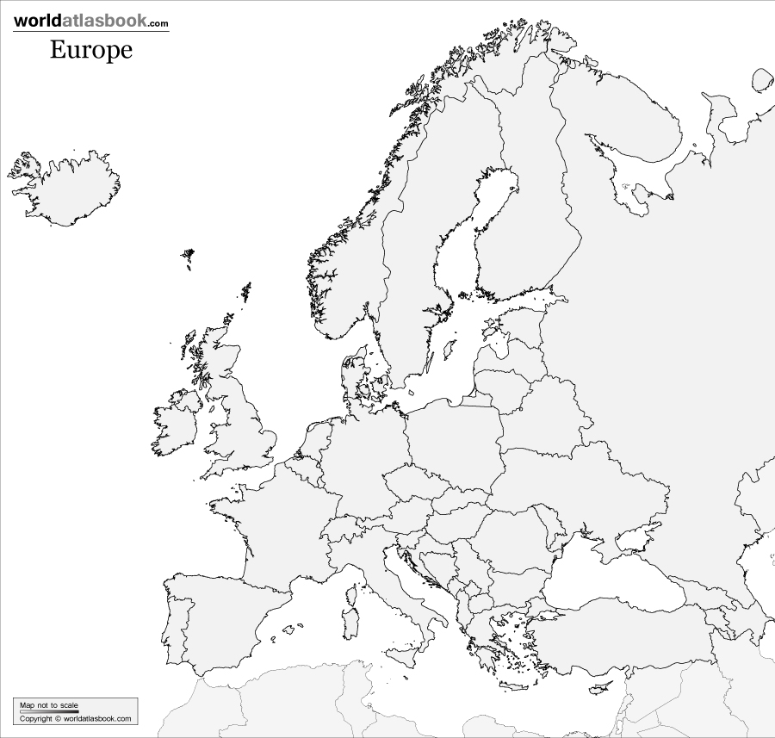
Label the following on your map:
France Spain Netherlands Portugal Russia
Italy Germany Poland Austria England

Worldatlasbook.com: Asia

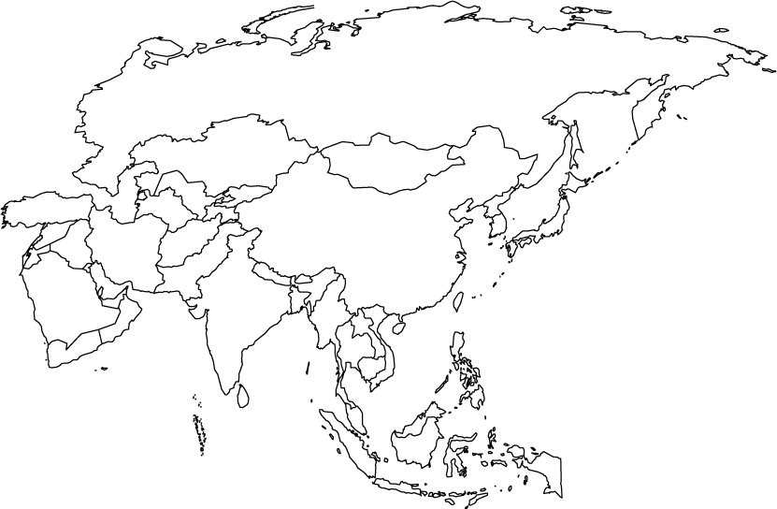
Label the following:
China
North Korea
South Korea
Japan

