Name: _______________________________ Date: __________________

Global Studies

***Enlightenment Thinkers***

The Enlightenment started from some key ideas out forth by two English political thinkers of the 1600’s, Thomas Hobbes and John Locke. Both men experienced the political turmoil of England early in that century. However, they came to very different conclusions about government and human nature.

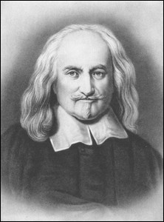

**Hobbes Social Contract**:Thomas Hobbes expressed his views in a work called *Leviathan* (1651). The horrors of the English Civil War convinced him that all humans were naturally selfish and wicked. Without governments to keep order, Hobbes said, there would be “war…of every man against every man,” and life would be “solitary, poor nasty, brutish, and short.”

Hobbes argued that to escape such a bleak life, people had to hand over their rights to a strong ruler. In exchange, they gained law and order. Hobbes called this agreement by which people created a government the **social contract**. Because people acted in their own self-interest, Hobbes said, the ruler needed total power to keep citizens under control. The best government was the one that had the awesome power of a leviathan (sea monster).In Hobbes’ view, such a government was an absolute monarchy, which could impose order and demand obedience.

|  |  |
| --- | --- |
| *Changing Idea: The right to govern* | |
| **Old Idea** | **New Idea** |
| A monarch’s rule is justified by divine right. | A government’s power comes from the consent of the governed. |

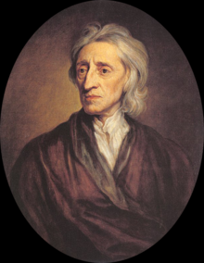

**Locke’s Natural Rights**: The philosopher John Locke held a different, more positive, view of human nature. He believed that people could learn from experience and improve themselves. As reasonable beings, they had the natural ability to govern their own affairs and to look after the welfare of society. Locke criticized absolute monarchy and favored the idea of self-government.

According to Locke, all people are born free and equal, with three natural rights – life, liberty, and property. The purpose of government, said Locke, is to protect those rights. If a government fails to do so, citizens have a right to overthrow it. Locke’s theory, which was published in *Two Treatises of Government* in 1689, had a deep influence on modern political thinking. His belief that a government’s power comes from the consent of the people is the foundation of modern democracy. The ideas of government by popular consent and the right to rebel against unjust rulers helped inspire struggles for liberty in Europe and the Americas.

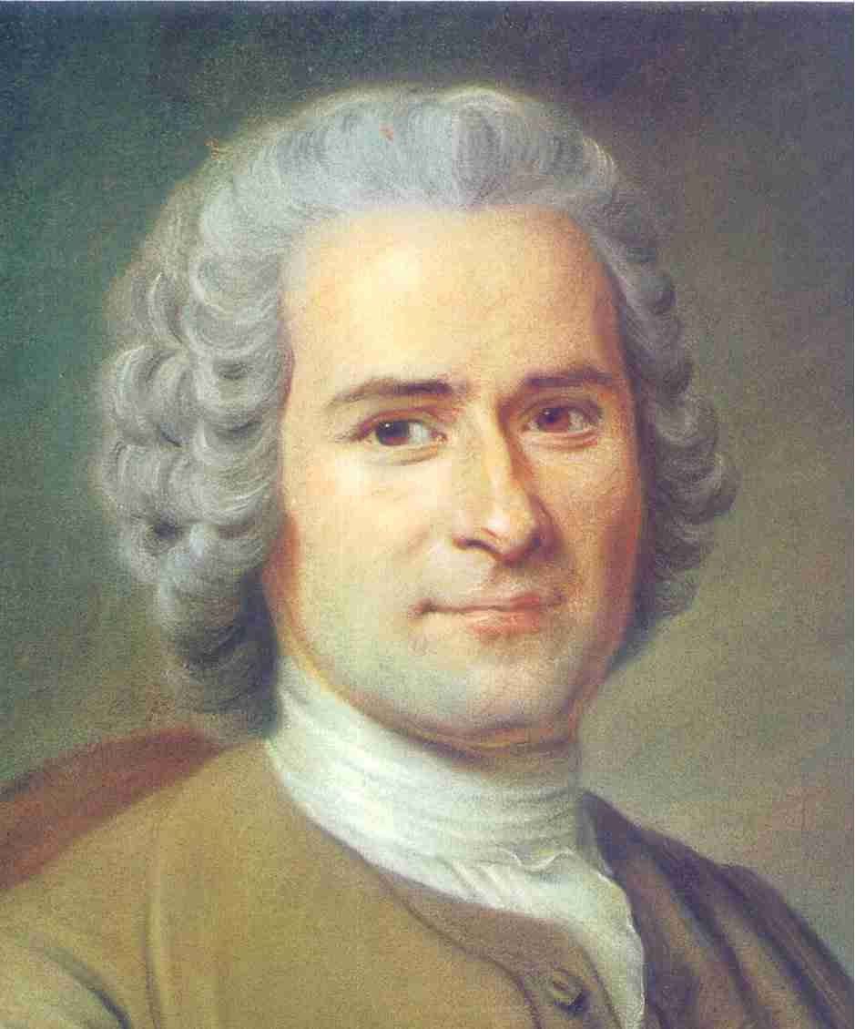

**Rousseau: Champion of Freedom**: A third great philosopher, Jean Jacques Rousseau, was passionately committed to individual freedom. The son of a poor Swiss watchmaker, Rousseau won recognition as a writer of essays. A strange, brilliant, and controversial figure, Rousseau strongly disagreed with other Enlightenment thinkers on many matters. Most philosophes, as the French Enlightenment thinkers were called, believed that reason, science, and art would improve life for all people. Rousseau, however, argued that civilization corrupted people’s natural goodness. “Man is born free, and everywhere he is in chains,” he wrote.

Rousseau believed that the only good government was one that was freely formed by the people and guided by the “general will” of society – a direct democracy. Under such a government, people agree to give up some of their freedom in favor of the common good. In 1762, he explained his political philosophy in a book called *The Social Contract.*

Rousseau’s view of the social contract differed greatly from that of Hobbes. For Hobbes, the social contract was an agreement between society and its government. For Rousseau, it was an agreement among the free individuals to create a society and a government.

Like Locke, Rousseau agreed that legitimate government came from the consent of the governed. However, Rousseau believed in a much broader democracy than Locke had promoted. He argued that all people were equal and that titles of nobility should be abolished. Rousseau’s ideas inspired many of the leaders of the French Revolution who overthrew the monarchy in 1789.

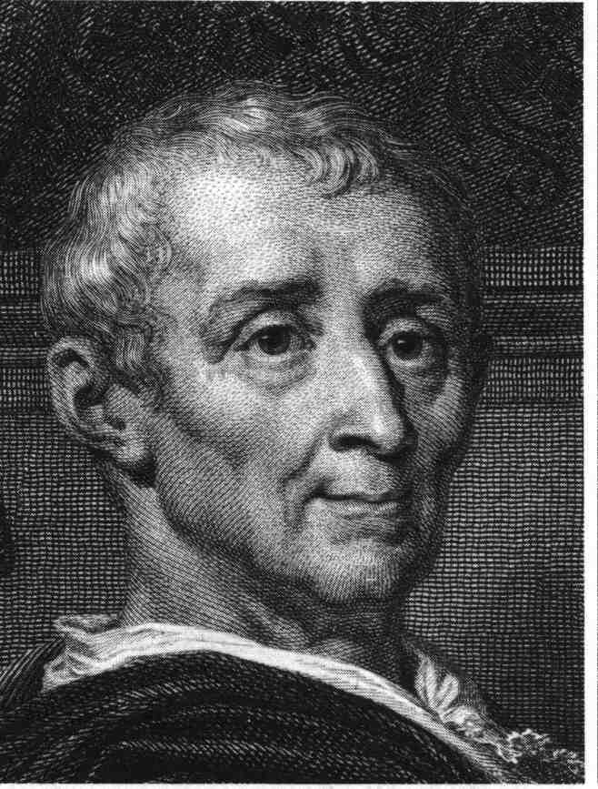**Montesquieu and the Separation of Powers**: Another influential French writer, the Baron de Montesquieu, devoted himself to the study of political liberty. Montesquieu believed that Britain had the best governed and most politically balanced country of his own day. The British king and his ministers held executive power. They carried out the laws of the state. The members of Parliament held legislative power. They made the laws. The judges of the English courts held judicial power. They interpreted the laws to see how each applied to a specific case. Montesquieu called this division of power amongst different branches separation of powers.

Montesquieu oversimplified the British system. It did not actually separate powers this way. His idea, however, became a part of his most famous book, *On the Spirit of the Laws* (1748). In his book, Montesquieu proposed that separation of powers would keep any individual or group from gaining total control of the government. “Power,” he wrote, “should be a check to power.” This idea later would be called checks and balances.

Montesquieu’s book was admired by political leaders in the British colonies of North America. His ideas about separation of powers and checks and balances became the basis for the United States Constitution.

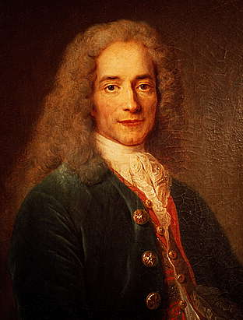**Voltaire Combats Intolerance**: Probably the most brilliant and influential of the philosophes was François Marie Arouet. Using the pen name Voltaire, he published more than 70 books of political essays, philosophy, and drama.

Voltaire often used satire against his opponents. His most famous work, *Candide* (1759), was a satirical look at government, religion, and philosophy. He made frequent targets of the clergy, the aristocracy, and the government. His sharp tongue made him enemies at the French court, and twice he was sent to prison. After his second jail term, Voltaire was exiled to England for more than two years.

Although he made powerful enemies, Voltaire never stopped fighting for tolerance, reason, freedom of religious belief, and freedom of speech. He used his quill pen as if it were a deadly weapon in a thinker’s was against humanity’s worst enemies – intolerance, prejudice, and superstition. He summed up his staunch defense of liberty in one of his most famous quotes: “I do not agree with a word you say but will defend to the death your right to say it.”