Name: __________________________________ Date: _____________
Directions: With your partner, complete the following graphic organizer based on the close reading of the five Enlightenment Thinkers
RANK | Philosopher | Dates | Country | Book(s) | How does this philosopher view the role of government?
 | Thomas Hobbes  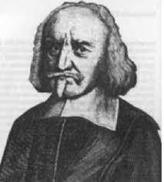 | 1588-1679 | Britain
 | John Locke  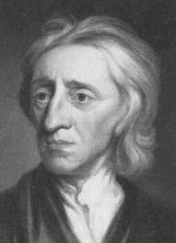 | 1632- 1704 | Britain
 | Jean-Jacques Rousseau  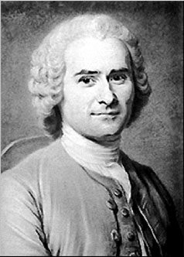 | 1689-1755 | France
 | Baron de Montesquieu  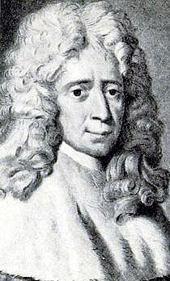 | 1694-1778 | France
 | Voltaire  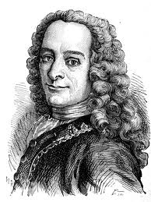 | 1712-1778 | France

