The Enlightenment

- The Enlightenment was an intellectual movement of the 17th and 18th centuries which sought to replace “____________________________” and apply “_____________________________” to society, in order to better understand society and improve it.
- People began to analyze ____________________________________ and politics and _____________________________________ the way things had been run for hundreds of years.
Absolutism

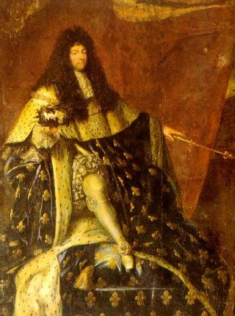
- Absolutism – a form of _____________________________________ government that places all power in the hands of the __________________________.
- Kings rule by “_________________________________________________”, the idea that rules received their power directly from God. Therefore, citizens were expected to willingly accept all decisions of the king.
- Citizens did not have any guaranteed ________________________________ because the king could do anything he wanted to.

Challenging Absolutism
- The Enlightenment challenged absolutism and brought about the development of _____________________________________ governments.
- A ____________________________was the name given to the meetings where artists, writers, and philosophers met to _________________________________ and promote the new ideas of the Enlightenment.

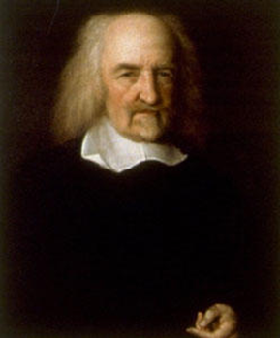
The Outlier: Thomas Hobbs (England)
- Huge supporter of ______________________ in England.
- Wrote a book, _______________________________, during the English Civil War.
- Argued that people were _______________________ and self-serving.
- Said that there should be a ______________________________________ – agreement between the government and the people that they should work together.
- His idea of the social contract was that you needed a strong _____________________________________________ in control. Without this, it would lead to _________________________ and ____________________ among the people.

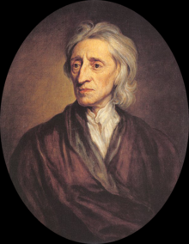
John Locke (England)
- Locke believed people had “_________________________________________________”: rights belonging to all people.
- “____________________________________________________”: Individuals are born with a ____________________________________, a person’s thoughts are shaped by ____________________________.
- Locke believed the ________________________________________________ was an agreement between the citizens and their government, and the government’s responsibility is to ______________________________________________________________ of the people.
- Locke said that if government did not protect these rights, then people had the right to ___________________________________ government and create a new one.
- Locke believed in “consent of the governed,” or the belief that govt. gets its ____________________________________________________________ from the people.
- Inspired ______________________________________________________________________ in the writing of the Declaration of Independence.

Jean Jacque Rousseau (France)
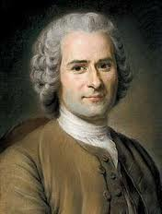
- Rousseau believed that society was corrupt, so government should protect the “general will” of the people.
- The government should implement policies beneficial to all people by basing decisions on ______________________________________________________________________.
- The social contract should create a government limited by what the majority of the people want.
- This idea forms the foundation of “___________________________________________________________” – government gets its power from what the _______________________________ want.
- Ideas are largely __________________________________ by the writers of the U.S. Constitution.

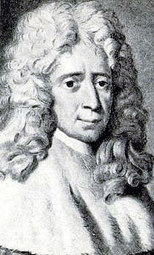
Baron de Montesquieu (France)
- Focused on the organization of government by creating a __________________________________________________ that allowed each branch to check the other’s powers. (_______________________________________________)
- Had the idea for the _____________________ branches of government: executive (monarch), legislative (Parliament), and judicial (courts).
- Influenced the _________________________________________.

Voltaire (France)
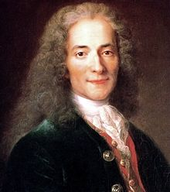
- He was concerned about the rights of citizens - focused on the freedom of _____________________ and freedom of _______________________.
- He advocated for the _________________________________ of church and state, meaning religion should be kept out of all government affairs, and government should stay out of religion. This is because of the power of the Catholic Church (_________________) in European govt.
- Inspired the U.S. Bill of Rights.

