PHILOSPHERS AND SCIENTISTS
Baseball Card Project

DIRECTIONS:
You will be creating baseball cards for each of the famous philosophers and scientists. On the front of your index card you will glue the picture of ONE man and write his name. On the back you will include the answers to the following questions.

If you have a Chromebook, you need to go to the link provided in class. You must make a copy of the template to use. To do this, go to File, Make a Copy, the rename the document with “Your Name – Baseball Cards.” If you do not have a Chromebook, you will receive a printed template to do. You must handwrite/draw your information using your class notes.

The Questions:

For Philosophers:
Locke, Rousseau, Voltaire and Montesquieu
- What were the main ideas presented by the philosopher?
- Which ideas were adopted by the Founding Fathers of the United States?

For Scientists:
Galileo, Newton, Copernicus, and Bacon
- What were the major accomplishments of the scientist?
- What were the effects of his accomplishments?

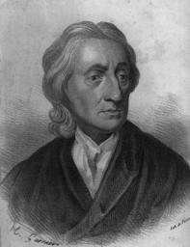
EXAMPLE
John Locke

- Answer to question one goes here

- Answer to question two goes here
John Locke

