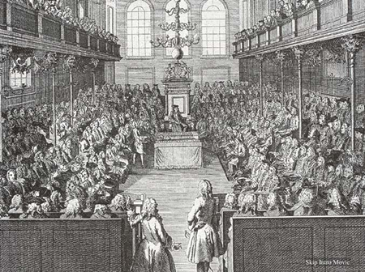
Let’s Start With England…
- England had a civil war against the absolute power of the monarchy.
- Why? Arguments over money, taxes, and power between ______________________ and the ____________________________.
  - ____________________________ – The legislative (law making) group representing the __________________________.
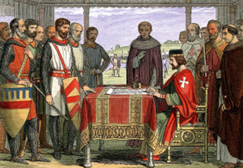
Why Was There a Civil War?
- Parliament and the King argued over _______________________, ________________________, and _____________________________.
- These problems began in 1215 when King John signed the ____________________________________ which limited his power as king.
  - Magna Carta (Great Charter) – An English document that states that the king is not ___________________________________
- 400 years after the Magna Carta was signed, _____________________________________ was ruling England with absolute authority and ignored Parliament’s requests for power.
  - He was basically pretending that the Magna Carta didn’t exist
The Road to War
- When _______________________________________ took the throne after his father, James I, he also refused to let Parliament have any power.
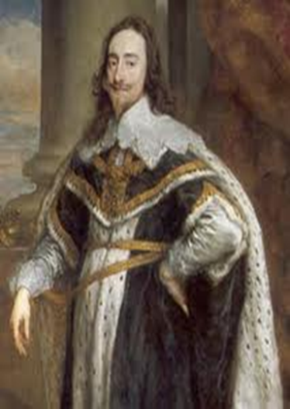
- In 1629, he ___________________________________________________ of their meeting place and refused to let them back in for Eleven Years! (They called it the _____________________________________________.)
The Road to War
- Charles I and Parliament often fought over money and raising taxes.
  - At one point Charles created a _________________________________________ and one of the members of parliament, John Hampden, refused to pay!
  - He was found guilty, but he was a __________________________ of standing up to the king.
- Over time, the fights got bigger and eventually Charles tried to ____________________ _____________members of Parliament.
War Begins
- Since __________________________________ represents the ___________________, many saw the arrests as an attack on the people of England.
- Civil war broke out between the supporters of Charles I (The ______________________________) and supporters of Parliament (______________________________________________) in 1642.
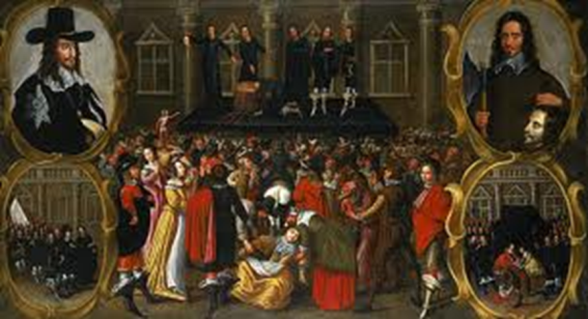
- The New Model Army was led by __________________________________________.
War Ends
- The New Model Army __________________________ Charles I and the Royalists
- Charles was tried, found guilty and was _____________________________!
After the War
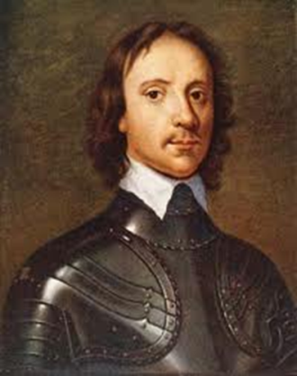
- After Charles I was executed, _______________________________________ became the leader of England
- He was a very strong leader and ruled with unlimited power as _______________________________________ (military dictator)
- Over time, the English citizens grew tired of Oliver Cromwell’s government because of his enforcement of strict ____________________________________.
- During the timeframe between the English Civil War and the Glorious Revolution, England was known as ______________________________________________________
Restoration
- When Cromwell died, his son took over, but he was so weak that he resigned after less than a year
- In 1660, ______________________________________ was invited to come back to the throne. (He was the son of the beheaded king, Charles 1).
- _______________________________________________- The time period when the monarchy was restored to England.
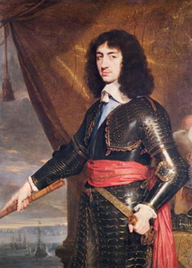
- Known as the “__________________________________________________.”
Charles II’s Reign
- Only three significantly bad events happened during the reign of Charles II
  - 1665: Thousands of Londoners were killed by the _________________________
  - One year later (1666), a ____________________________ destroyed the heart of London
  - 1667: the Dutch navy sailed up the Thames and burned part of the English _____________________
Problems in England Again…
- When Charles II died his son, ________________________________ took over.
- King James II (______________________________) and the British Parliament were fighting for power…like his grandfather!
England’s Glorious Revolution
- The English Parliament (the legislative body representing the people) joined together with _______________________________ of Orange and _____________________________ (his daughter) and forced James II to give up the throne
- This event was called the ___________________________________________________
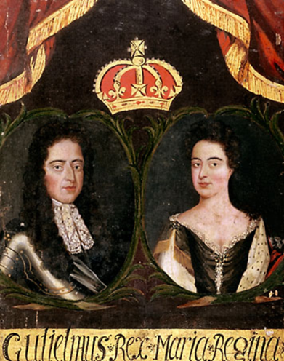
  - Glorious Revolution – established that a ruler’s power comes from _______________________________________ and not God this __________________________government in England.
After the Glorious Revolution
- William and Mary became king and queen but had little power.
- Most of the power was in the hands of the English Parliament .
- _________________________________________ were protected under the ________________________________________________
- England became a __________________________________________________
  - A government ruled by a king or queen that is limited by a constitution

