Dwight Eisenhower’s
D-Day Speeches

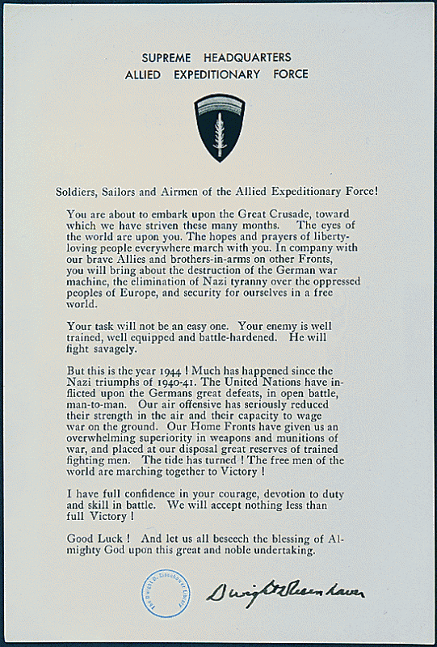
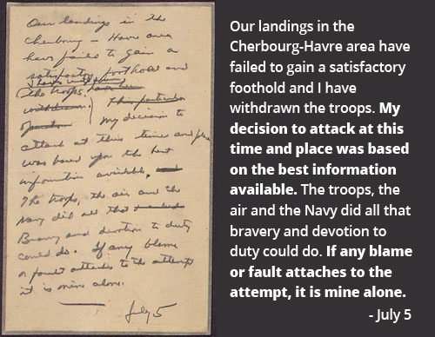

General Eisenhower wrote this message just prior to the invasion, to be read in case Operation Overlord failed. Either through stress or fatigue, he misdated it July 5, instead of June 5.

Directions: Use the text from Eisenhower’s Order of the Day and Eisenhower’s Failure Message to answer the questions below.

1. Who is Eisenhower addressing in his Order of the Day?

2. What words and phrases does Eisenhower use to convey the idea of teamwork?

3. If he is trying to motivate the troops, why does he say, “Your task will not be an easy one”?

4. What historical information about WWII can you learn from studying this document?

5. After reading Eisenhower’s D-Day failure message, describe his concept of taking responsibility.

6. Why do you think Eisenhower gives so little information about the attempted invasion?

7. Describe Eisenhower’s personality based solely on these two documents.

