**Europe After WW1**

* 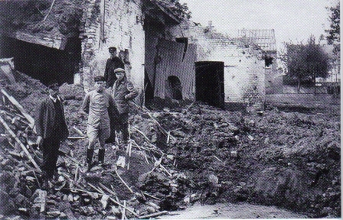European nations are faced with the massive _________________________________________ after WW1.
* ________________________ returning for war were looking for _______________ (high _____________________________ rate).
* Germany is in heavy ____________________ because of the _________________________________repayment; loses its ________________in the Ruhr Valley to _______________ which was where much of its ___________________ were located.
* _______________ begins ____________________________which devalues money all through Europe.
* Europeans _____________________ from ____________________.

**U.S. After WW1**

* After World War 1, U.S. is thriving economically because:
  + No _____________________________________ in the U.S.
  + 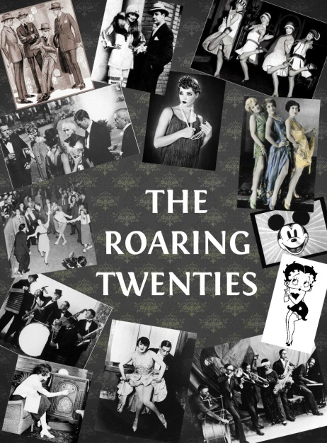Fewer ______________________________________ because of our ___________________________________________ to war.
  + Good ____________________ due to _______________________ allowed us to _______________________________ to Western European countries after the war.
* Growth in ____________________________ after the war due to the new ________________________: ex. Radio, automobiles, vacuum cleaner, refrigerator.
* Americans purchase these new items using _________________________.

**Underlying Causes of the Great Depression**

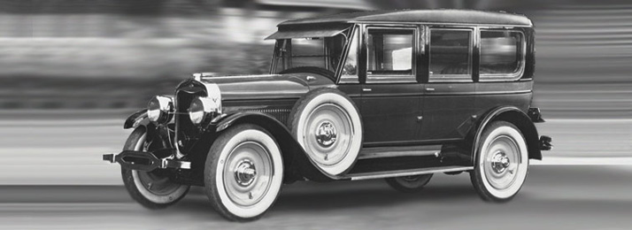

* 1. Farming prices _________________ due to ________________________________________
* 2. Made _________________________________ to European countries who could not repay them; Europeans stop buying ____________________________.
* 3. Wealthiest Americans were driving _______________________________ prices _______________________ and higher, well ________________ what something was actually _____________________.
* 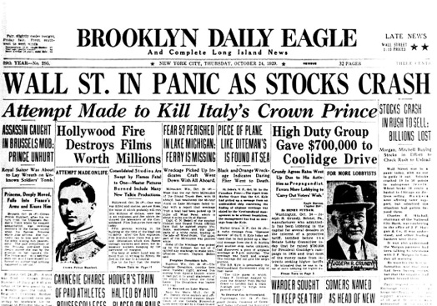4. Ordinary Americans bought stocks on “___________________” (credit) hoping to _________________________.

**Stock Market Crash of 1929**

* a.k.a. ___________________________: October 29, 1929
* ________________________ started to _____________________, so investors began _______________________________________________.
* Stocks lost between ____________________________________________ that day.

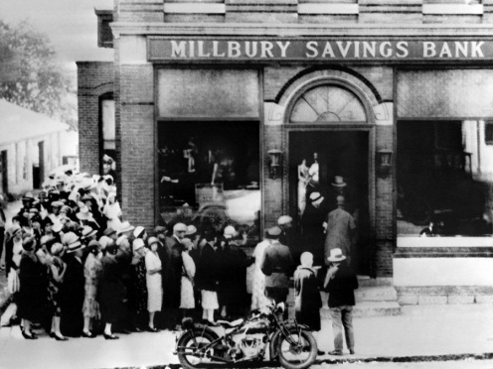**Effects of the Crash**

1. Banks _______________________ – “_______________________________” emptied out all the _____________________ banks held as people went to withdraw their money from the banks.
2. Businesses ___________________ = job ______________
3. Individuals lost their ________________________________ = lost _______________ and ______________________ because banks were demanding loans be ___________________________________ (leads to Hoovervilles)
4. ______________________________________ (major _____________________) causes farms to fail = widespread __________________________

**World-Wide Effects of the Depression**

* Western Europe is struggling _________________________after _____________________________________________________.
* The ______________________________________________ to many European nations to help them rebuild. In addition, the U.S. loaned _____________________________ money to help ______________________________________________________________.
* As the U.S. economy worsened, U.S. investors demanded ___________________________________________________ and stopped loaning any _____________________________. This crippled the economies of the European nations.
* ____________________________________________ began to suffer, so the depression spread around the world.

**Global Response to the Depression**

* Most nations turned inward and became ________________________ in order to solve their own economic problems.
* ________________________________ (U.S., Great Britain) – the governments worked to ________________________________ to improve economic conditions.
* Other nations turned to __________________________________________ (Germany, Italy) who used their __________________________ to begin imperializing to gain raw materials and markets to help boost their economy.

**U.S. Recovery**

* __________________________________________________ (FDR) elected president in 1932 on promises to help ________________________________.
* 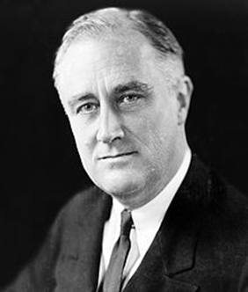______________________________________ – focused on __________________________________________ to increase ______________________________ and _________________________________________ on banks, the stock market, industry and farming production.
  1. Created the _________________________________________
  2. Created public works projects that built ____________________________________________________________________________________ around the country.
  3. The first time government creates _____________________________________________ in the United States.

**British Recovery**

* Enacted protectionist policies (policies designed to protect domestic industries and services from foreign competition).
  1. Included dropping the _________________________________
  2. Increase ________________________ ownership/management of key industries
  3. ___________________________________ to loan money to new businesses in the hopes of _______________________________________________.

**Response to the Depression in Europe**

* **Great Britain**: ________________________, ____________________ the budget, and controlled ___________________
* 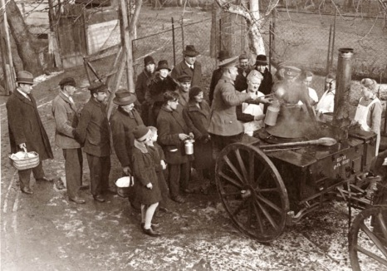**France**: ____________________________________________ called the Popular Front takes over. They started an aid program called the _________________________________, but it didn’t work.
* **Germany**: created the ______________________________________ (renamed Germany to reflect a new democratic government). Germany had problems of high _____________________________, ________________________ middle class, and major ______________________ (prices on goods _______________ because money is ___________________________ – the idea of “just print more money.”)