World War II

D-Day: The Invasion of Normandy
On June 6, 1944 the Allied Forces of Britain, America, Canada, and France attacked German forces on the coast of Normandy, France. With a huge force of over 150,000 soldiers, the Allies attacked and gained a victory that became the turning point for World War II in Europe. This famous battle is sometimes called D-Day or the Invasion of Normandy.
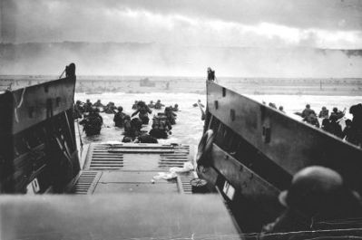
US troops landing during the Invasion of Normandy
Leading up to the Battle
Germany had invaded France and was trying to take over all of Europe including Britain. However, Britain and the United States had managed to slow down the expanding German forces. They were now able to turn on the offensive.
To prepare for the invasion, the Allies amassed troops and equipment in Britain. They also increased the number of air strikes and bombings in German territory. Right before the invasion, over 1000 bombers a day were hitting German targets. They bombed railroads, bridges, airfields, and other strategic places in order to slow down and hinder the German army.
Deception
The Germans knew that an invasion was coming. They could tell by all the forces that were gathering in Britain as well as by the additional air strikes. What they didn't know was where the Allies would strike. In order to confuse the Germans, the Allies tried to make it look like they were going to attack north of Normandy at Pas de Calais.
The Weather
Although the D-Day invasion had been planned for months, it was almost cancelled due to bad weather. General Eisenhower finally agreed to attack despite the overcast skies. Although the weather did have some affect and on the Allies ability to attack, it also caused the Germans to think that no attack was coming. They were less prepared as a result.
The Invasion
The first wave of the attack began with the paratroopers. These were men who jumped out of planes using parachutes. They jumped at night in the pitch dark and landed behind enemy lines. Their job was to destroy key targets and capture bridges in order for the main invasion force to land on the beach. Thousands of dummies were also dropped in order to draw fire and confuse the enemy.
In the next stage of the battle thousands of planes dropped bombs on German defenses. Soon after, warships began to bomb the beaches from the water. While the bombing was going on, underground members of the French Resistance sabotaged the Germans by cutting telephone lines and destroying railroads.
Soon the main invasion force of over 6,000 ships carrying troops, weapons, tanks, and equipment approached the beaches of Normandy.
Omaha and Utah Beaches
American troops landed at Omaha and Utah beaches. The Utah landing was successful, but the fighting at Omaha beach was fierce. Many US soldiers lost their lives at Omaha, but they were finally able to take the beach.
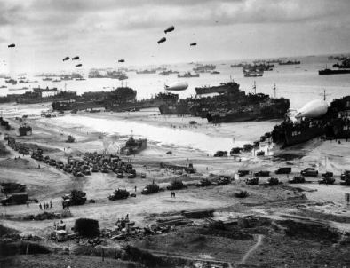
Troops and supplies coming to shore at Normandy
After the Battle
By the end of D-Day over 150,000 troops had landed in Normandy. They pushed their way inland allowing more troops to land over the next several days. By June 17th over half a million Allied troops had arrived and they began to push the Germans out of France.
The Generals
The Supreme Commander of the Allied Forces was Dwight D. Eisenhower of the United States. Other Allied generals included Omar Bradley from the United States as well as Bernard Montgomery and Trafford Leigh-Mallory from Britain. The Germans were led by Erwin Rommel and Gerd von Rundstedt.
Interesting Facts about D-Day
- The troops needed the light of a full moon to see to attack. For this reason there were only a few days during a month when the Allies could attack. This led Eisenhower to go ahead with the invasion despite the bad weather.
- The Allies wanted to attack during high tide as this helped the ships to avoid obstacles put in the water by the Germans.
- Although June 6 is often called D-Day, D-Day is also a generic military term that stands for the day, D, of any major attack.
- The overall military operation was called "Operation Overlord". The actual landings at Normandy were called "Operation Neptune".

