**The Space Race: The Cold War in the Skies**

The United States and the Soviet Union competed not only in terms of military strength, but also to see which country could make the most scientific progress and advancement. Rivalry in the field of space was particularly significant because the two nations were thinking of military applications, and how advancement in space could be used in the arms race and military operations. Also, being the winner in the space race would help improve the spirits of whichever country won and show that the ideology the country was upholding was superior to the other one.

[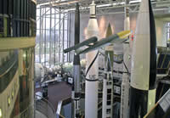](http://www.nasm.si.edu/exhibitions/gal114/SpaceRace/sec200img/SI2004-60151_640.jpg)After World War II, the rocket foreshadowed a new style of warfare in which nuclear bombs could be delivered quickly across the world. War might begin--and end--suddenly, decisively, without warning. The United States initially favored bombers, but the Soviets preferred missiles and thus took an early lead in rocket technology. During the early years of the Space Race, success was marked by headline-making "firsts": the first satellite, first robotic spacecraft to the Moon, first man in space, first woman in space, first spacewalk. To the dismay of the United States, each of these early feats was achieved by the Soviet Union. These events triggered a drive to catch up with--and surpass--the Soviets.

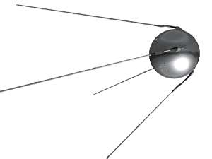On 4th, 1957, the Soviets launched an artificial satellite, **Sputnik I,** which means the ‘**Traveler**’ in Russian. Sputnik was a metal sphere about 23 inches across with four antennas. It sent out signals that could be heard and picked up from around the world. When Sputnik was launched, the entire world was surprised at what the Russian engineers had managed to do and they were also afraid. This event caused fear in the world because it meant that if the Russians had rockets that were powerful enough to launch satellites, then they had rockets powerful enough to launch atomic bombs. It also meant that the Russians would have power over **Space**.

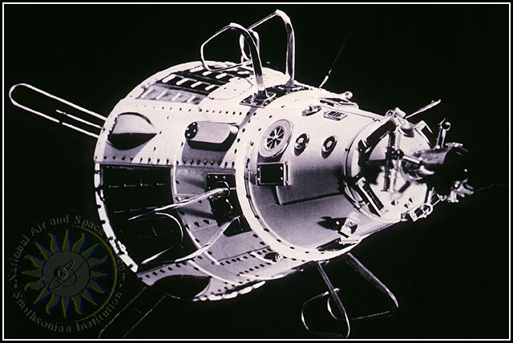Only a month after its "October surprise," the Soviet Union launched another satellite. **Sputnik 2** was larger and demonstrated a growing Soviet advantage in launching heavy payloads and hinted that the Soviets might soon put a human in space. By the end of December, the United States tried to launch its first satellite but it failed, ending up in an explosion. In 1958, the U.S. successfully launched its first satellite called **Explorer I**. In addition, the National Aeronautics and Space Administration (**NASA**) was created by Congress to carry out space exploration. The successful launch of Sputnik I started a contest between the United States and the Soviet Union to see which country could put people on the moon first. These efforts became known as the “space race”.

In 1959, NASA selected the first seven astronauts and the Soviet Union launched the first probe to hit the moon. It was called **Luna 2**. On April 12, 1961, **Yuri Gagarin**, a Soviet cosmonaut, which is the term used by Russians to mean astronaut, was the first person in space and the first to circle Earth. Less than a month later, **Alan Shephard Jr**. became the first American astronaut in space. In 1962, **John Glen** was the first American to orbit Earth in a capsule that named **Friendship 7**. The Soviet Union was considered to be the first in the Space Race and the U.S. ranked second. In 1963, Soviet 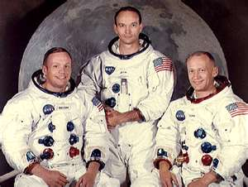cosmonaut **Valentina Tereshkova** was the first woman in space.

In December 1968, the U.S. launched Apollo 8, which was the first human mission to go around the moon. This success gave the U.S. rank number one in the space race. In July, 1962, the U.S. sent astronauts Neil Armstrong, Edwin "Buzz" Aldrin and Michael Collins to the moon. **Neil Armstrong** was the first man to walk on the moon.

**Michael Collins, Neil Armstrong, Buzz Aldrin**

The U.S. having reached the moon and having its astronauts walk on the moon first won the Space Race. When the Cold War ended, the U.S. and Russia started working together on building a space station and collaborating on space projects.

What were the United States and the Soviet Union trying to prove to the world?

**Name: _________________________________**

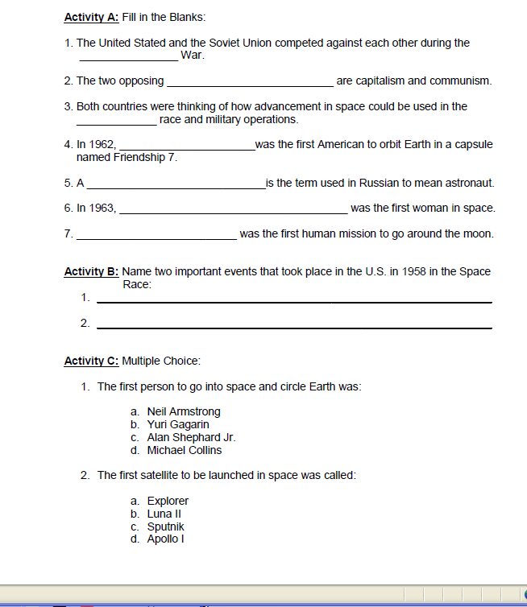

**ACTIVITY D: Document Based Questions:** Use the Documents below to help you answer Questions 1 and 2. Use complete sentences to answer both questions.

**Document # 1**

*"I believe that this nation should commit itself to achieving the goal, before this decade is out, of landing a man on the Moon and returning him safely to the Earth. No single space project...will be more exciting, or more impressive to mankind, or more important...and none will be so difficult or expensive to accomplish...."*

**- President John F. Kennedy, 1961**

**1. Based on the text make an inference as to why you think President Kennedy believed that landing a man on the moon was so important and why were Americans willing to spend so much on the space program?**_________________________________________________________________________________________________________________________________________________________________________________________________________________________________________________________________________________

**Document # 2**

## PUBLICITY VERSUS SECRECY

The Space Race became a symbol of the broad ideological and political contest between two rival world powers. The way the two competitors organized to achieve their goals in space highlighted their basic differences. The United States had separate civilian and military agencies, and only the military space programs were secret. Civilian space activities--especially the race to the Moon--were openly publicized for the world to see. In the Soviet Union, all space programs were integrated into a secretive military-industrial bureaucracy. Launches were not announced in advance, and only the successes were publicized.

**2. How does America’s openness about the space program and the Soviet Unions secrecy about the space program illustrate their ideological and political differences?______________________________** ____________________________________________________________________________________________________________________________________________________________________________________________

**Document # 3**

**Source:** **Robert D. Launius, *Sputnik and the Origins of the Space Age.*** On that same evening of 4 October, Senate Majority Leader Lyndon B. Johnson ...heard the announcement of Sputnik 1's launch on the radio...Johnson's mind kept returning to the heavens as he pondered the Soviet triumph. He recollected, “Now, somehow, in some new way, the sky seemed almost alien. I also remember the profound shock of realizing that it might be possible for another nation to achieve technological superiority over this great country of ours.” ...One of Johnson's aides, George E. Reedy, summarized the feelings of many Americans: “the simple fact is that we can no longer consider the Russians to be behind us in technology. It took them four years to catch up to our atomic bomb and nine months to catch up to our hydrogen bomb. Now we are trying to catch up to their satellite.”

**3. Why were American citizens, including Senate Majority Leader Lyndon B. Johnson so concerned about the success of Sputnik?________**__________________________________________________________________________________________________________________________________________________________________________________________________________________________________________________